**1/11 Climate Friday Materials**

**Suggested hashtag:** #ClimateFriday

**High-res graphics:** [**HERE**](http://materials.actonclimate.com/search/?q=&search_folder=&folders_include=1&tags_include=172&extensions_include=&extensions_exclude=&published_start=2019-01-10&published_end=2019-01-10)

**AMERICA’S PLEDGE**

* Despite @realDonaldTrump’s inaction, states, cities, and businesses across the nation are #StillIn when it comes to fulfilling #AmericasPledge to find clean energy solutions. #ClimateFriday <https://www.e2.org/cleanjobscities/>
* Ex-coal lobbyist @EPAAWheeler’s nomination as the head of the @EPA underscores the importance of states, cities, and businesses across the nation fulfilling #AmericasPledge to find clean energy solutions. #ClimateFriday <https://www.e2.org/cleanjobscities/>

**CARS**

* We must #StopWheeler if we want to protect #CleanerCars standards that keep our air clean, create jobs, and save us money at the gas pump. #ClimateFriday <https://n.pr/2LSV28p>
* Let’s be clear - building #CleanerCars in the U.S. is integral to our clean energy future. #ClimateFriday <https://bit.ly/2LWyctU>
* #CleanerCars standards spur technological innovation, catalyze competitiveness, and support jobs. #ClimateFriday (via @Automotive_News) <https://bit.ly/2LWyctU>
* Big Oil’s insidious ploy to roll back #CleanerCars standards will stump American innovation and job growth. #ClimateFriday <https://nyti.ms/2Bi5oXS>
* Unlike Big Oil, the clean energy industry encourages innovation and ingenuity when it comes to building #CleanerCars. #ClimateFriday <https://nyti.ms/2Bi5oXS>

**METHANE**

* Our families deserve air that’s safe to breathe. Standards that #CutMethane help get us there. #ClimateFriday<https://nyti.ms/2GQti2P>
* .@EPAAWheeler’s rollback of standards that #CutMethane would allow oil and gas companies to pump tons of dangerous pollution into our air. Our families can’t afford dirty air. #ClimateFriday #StopWheeler<https://nyti.ms/2GQti2P>
* When we #CutMethane, we help keep our air safe to breathe and protect our kids and our climate. #ClimateFriday<https://nyti.ms/2GQti2P>

**JOBS**

* More than 3.2 million people across the country work in the clean energy industry, helping fulfill #AmericasPledge to address climate change. #ClimateFriday<https://www.e2.org/cleanjobscities/>
* For communities across the country, #AmericasPledge is still on track thanks to the more than 3.2 million people working in the clean energy industry. #ClimateFriday<https://www.e2.org/cleanjobscities/>
* Fulfilling #AmerciasPledge to find clean energy solutions means creating reliable, high paying jobs in everything from engineering to manufacturing. #ClimateFriday <https://www.e2.org/cleanjobscities/>
* The 3.2 million Americans working in the clean energy industry can’t afford ex-coal lobbyist @EPAAWheeler’s toxic agenda. #StopWheeler #ClimateFriday <https://www.e2.org/cleanjobscities/>

**EA GOVERNOR’S REPORT**

**TWITTER:**

* New @EnvAm report: with new governors taking office across the country, there’s never been a better time for states to fulfill #AmericasPledge to find clean energy solutions. #ClimateFriday<https://bit.ly/2AHxQmu>
* New @EnvAm report: with new governors taking office across the country, it’s time for states to commit to #ActOnClimate<https://bit.ly/2AHxQmu>
* States swearing in new governors this year are responsible for 45% of US climate pollution. It’s time for state leaders to fulfill #AmericasPledge to cut pollution and #ActOnClimate. #ClimateFriday<https://bit.ly/2AHxQmu>
* New @EnvAm report: governors can take state action to fight @EPAAWheeler’s toxic agenda and fulfill #AmericasPledge to cut pollution and develop clean energy. #ClimateFriday<https://bit.ly/2AHxQmu>
* From working towards a clean energy future to capping dangerous pollution, new governors have many opportunities to #ActOnClimate. Learn more:<https://bit.ly/2AHxQmu> #ClimateFriday (via @EnvAm)
* .@[TAG GOVERNOR]: congrats on your swearing in! [STATE] is counting on you to #ActOnClimate to protect our health and environment. #ClimateFriday<https://bit.ly/2AHxQmu>
* [STATE] can’t afford @EPAAWheeler’s toxic agenda. @[TAG GOVERNOR], it’s time to #ActOnClimate to protect our health. #StopWheeler <https://bit.ly/2AHxQmu>

**SOLAR FARM IN FL**

* As @EPAAWheeler continues to push his toxic agenda at the @EPA, Floridians are working to #ActOnClimate and move towards a clean energy future. #ClimateFriday <https://bit.ly/2QAt2EJ>
* Florida’s newest solar farm is just the latest way our state is fulfilling #AmericasPledge to find clean energy solutions. #ClimateFriday <https://bit.ly/2QAt2EJ>
* Florida can’t afford @EPAAWheeler’s toxic agenda. That’s why our state is working to #ActOnClimate and implement clean energy solutions. #StopWheeler #ClimateFriday <https://bit.ly/2QAt2EJ>

**STATE LEG WELCOME**

* Welcome [back] to [CAPITAL CITY], @[TAG ELECTED]! Now that you’re sworn in, it’s time to make climate and clean energy a priority. #ActOnClimate #ClimateFriday
* .@[TAG ELECTED], congratulations on being sworn in! We’re counting on you to stand up for [STATE]'s health by pledging to #ActOnClimate and fight for clean energy. #ClimateFriday
* .@EPAAWheeler’s toxic agenda is putting the health and safety of [STATE] families at risk. @[TAG ELECTED], can we count on you to stand up for a clean energy future? #ActOnClimate #ClimateFriday
* .@EPAAWheeler and @realDonaldTrump are putting their polluter pals ahead of [STATE DEMONYMS]’ health and environment. @[TAG ELECTED], are you ready to #ActOnClimate? #ClimateFriday #StopWheeler

**LCV SOCIAL**

**Clean Energy Economy**

* The demand for clean energy means 3.2 million Americans have high-paying clean energy jobs in everything from engineering to manufacturing. #ClimateFriday #CleanEnergyForAll<https://bit.ly/2pC19RF>
* Earth to @realDonaldTrump: when energy efficiency jobs outnumber fossil fuel jobs in more than 40 states, it means people in America want #CleanEnergyForAll. #ClimateFriday<https://bit.ly/2CXVTiU>
* Since 2010, tech companies have invested more than $15 billion in wind and solar technology because they know clean energy is good for business, public health, jobs, and the environment. #ClimateFriday [#CleanEnergyForAll https://bloom.bg/2RfPHeB](https://bloom.bg/2RfPHeB)
* The demand for clean energy means that solar installation and wind turbine technician jobs are among the fastest growing jobs in the U.S. #ClimateFriday #CleanEnergyForAll<https://bit.ly/2o3YMrh>
* With clean energy jobs outnumbering fossil fuel jobs nearly 3 to 1, #ItsTime for @realDonaldTrump and @EPAAWheeler to get on board with #CleanEnergyForAll. #ClimateFriday<https://bit.ly/2pC19RF>
* The 3.2 million Americans working to provide #CleanEnergyForAll do everything from installing solar panels to operating windmills. #ClimateFriday<https://bit.ly/2pC19RF>
* In the U.S., jobs in the clean energy industry are:

✅Growing rapidly

✅Paying more than the national median income

✅Supporting public health  
#CleanEnergyForAll #ClimateFriday<https://bit.ly/2pC19RF>

**General**

* Clean energy wins! This past November, from New Mexico to Michigan, Maine to California, when candidates backed by Big Polluters went up against clean energy champs, they lost. #CleanEnergyForAll #ClimateFriday
* Across the country people want clean energy solutions for their homes, vehicles, and businesses. This past November, candidates heard the call and committed to #CleanEnergyForAll. #ClimateFriday
* While the Trump administration gives Big Polluters free rein, state and local leaders are stepping up and supporting #CleanEnergyForAll! #ClimateFriday

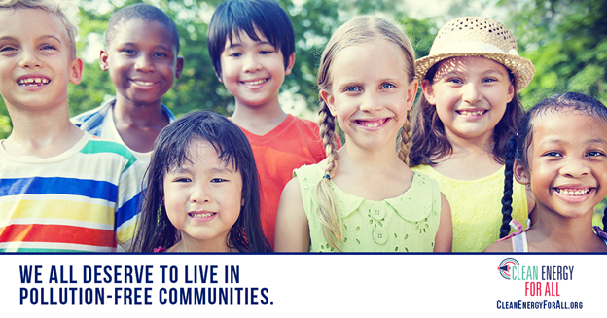

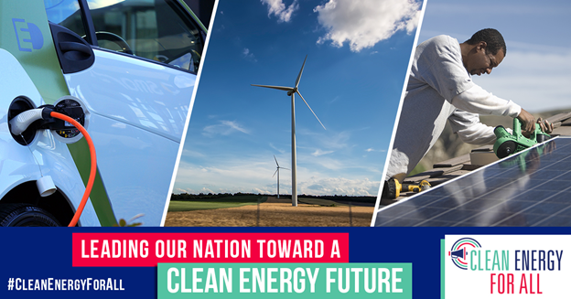

**Good Governors**

* This November, voters in California, Colorado, Connecticut, Illinois, Maine, Michigan, Nevada, Oregon, and Wisconsin elected governors who support 100% clean energy. #CleanEnergyForAll #ClimateFriday

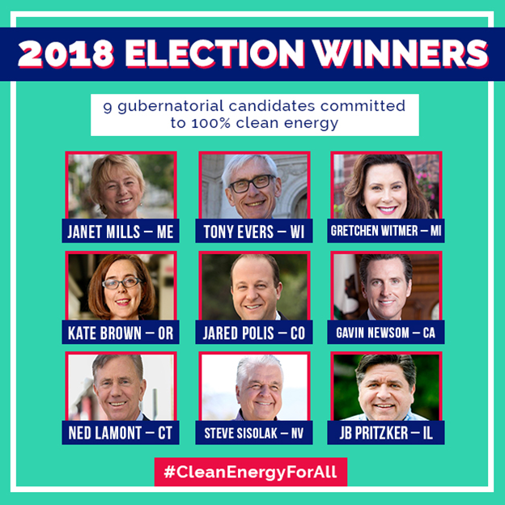

* Last week, clean energy leader Gretchen Whitmer officially took office as Michigan’s new governor. She’s putting Michigan on the path to 100% clean energy! #CleanEnergyForAll #ClimateFriday

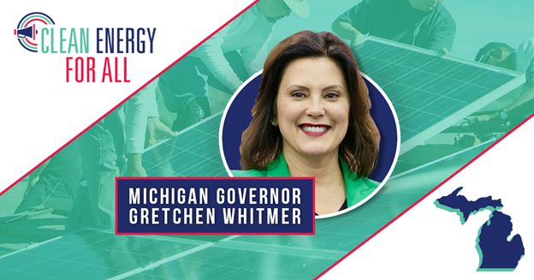

* Maine Governor Janet Mills is a clean energy leader. "Our new administration will embrace clean energy; change our modes of transportation; weatherize homes & businesses” and get “our electricity coming from Maine renewable resources.” #CleanEnergyForAll #ClimateFriday

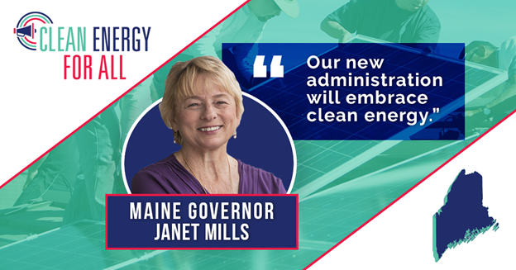

* New York Governor Andrew Cuomo is making New York a #CleanEnergyForAll leader with the goal of making New York’s electricity 100% carbon neutral by 2040, and ultimately eliminating the state’s entire carbon footprint.” #ClimateFriday

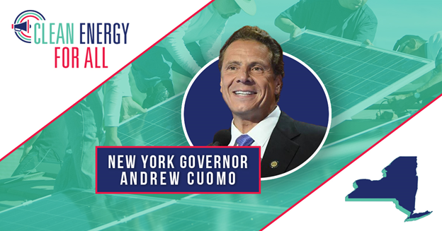

* New Mexico Governor Michelle Lujan Grisham in her inaugural address outlined her plan to set New Mexico’s course for a #CleanEnergyForAll future to “make good on our promise to leave our great outdoors greater than we found them.” #ClimateFriday

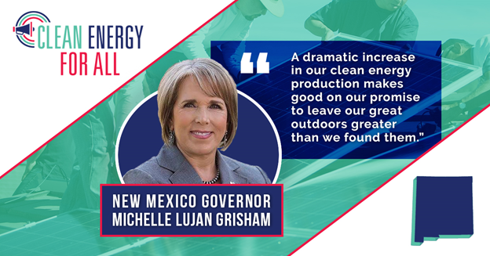

* California has long been a leader in the transition to clean energy. Governor Gavin Newsom will continue that tradition and help achieve #CleanEnergyForAll for Californians! #ClimateFriday

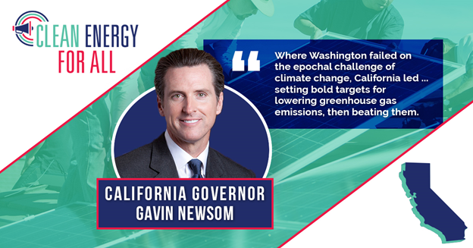

* Wisconsin is invested in the next generation, and that’s why Governor Tony Evers is driving the state to #CleanEnergyForAll. #ClimateFriday

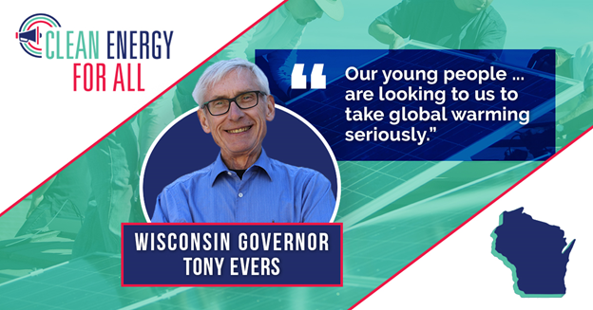

* Nevada’s clean energy future is bright under the leadership of Governor Steve Sisolak, who is driving the state toward #CleanEnergyForAll. #ClimateFriday

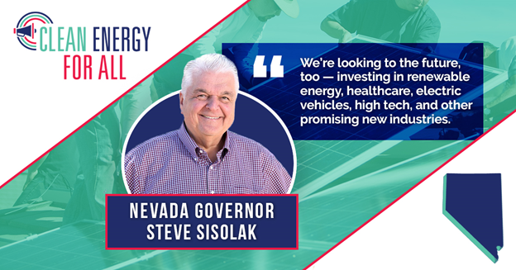

* Colorado Governor Jared Polis is wasting no time in protecting what matters most to Coloradans -- and that means moving forward with #CleanEnergyForAll. #ClimateFriday

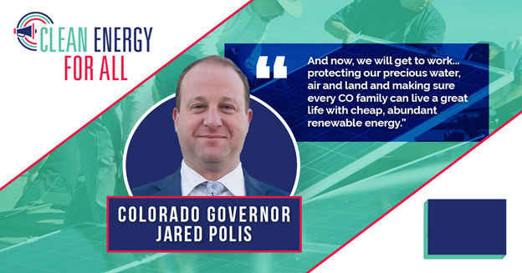

* Connecticut Governor Ned Lamont is committed to moving Connecticut toward 100% renewable energy by 2050! Thank you for your leadership, Governor Lamont! #CleanEnergyForAll #ClimateFriday #ClimateFriday

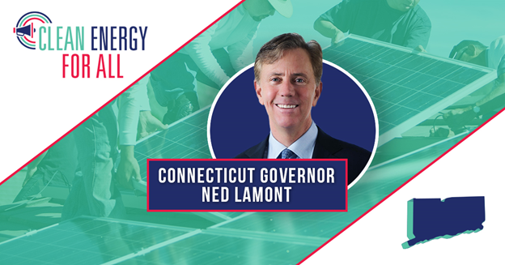

* Amazing: 56 of the new House members made LCV’s #CleanEnergyForAll commitment, supporting 100% clean energy by 2050.