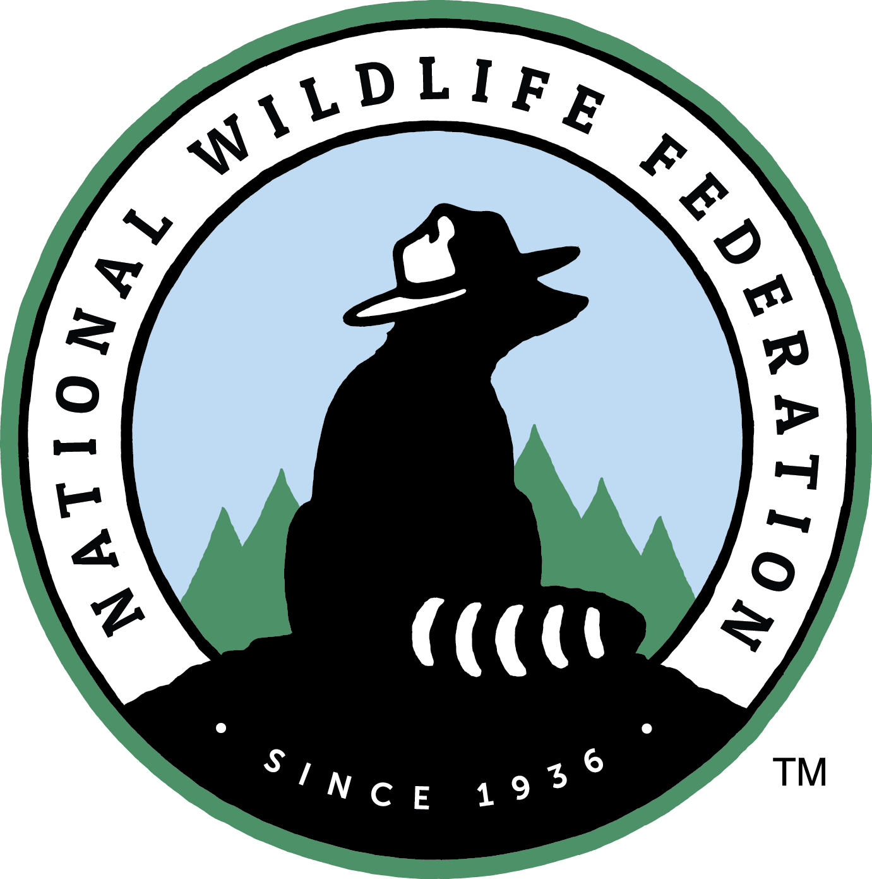

**Western Regional Field Director**

The National Wildlife Federation is one of America's largest and most trusted grassroots conservation organizations, with more than six million supporters and 51 state-level affiliate organizations throughout the U.S. and its territories. NWF’s programs focus on conserving wildlife, restoring habitat and waterways, expanding outdoor opportunities for all, connecting children with nature, and addressing the causes and consequences of climate change.

The Western Regional Field Director will manage field organizers and lead efforts to build and expand conservation power in the Western U.S. to win lasting victories for wildlife and communities nationwide. As the primary contact for 8-10 state-based organizers, contractors, and affiliate staff engaged in outreach, education, and advocacy, the Western Regional Field Director is responsible for strengthening and expanding NWF’s grassroots and grasstops reach, connecting and leveraging NWF’s national and regional program work, leading advocacy trainings, and delivering results for federal campaigns in targeted states in the West, from Alaska to Arizona.

This position reports to the National Field Director based in Washington, DC, in works in close coordination with the Rocky Mountain Regional Center Executive Director based in Denver, CO. The Western Regional Field Director will be located in NWF’s Rocky Mountains Regional Center in Denver, and will spend significant time in the field, expecting approximately 25 percent travel.

**Key responsibilities:**

Campaign Strategy and Leadership

* Provide leadership and initiative for the implementation of NWF priority federal field campaigns, which may include combating climate change, protecting public lands, defending clean water, and helping wildlife in priority states
* Develop campaign plans and deploy campaign tactics, advocacy techniques, and materials to generate earned and opinion media, identify and mobilize grasstops leaders and grassroots activists, and engage with and influence elected and appointed officials in their home states and districts.
* Lead trainings on key advocacy skills and provide ongoing skills coaching for organizers and affiliate partners working with our team in the West.

Field Organizer Management

* Recruit, on-board, and orient field organizers, consultants, partners, and/or staff to work on campaigns in priority states;
* Supervise each organizer or contractor and work with affiliate staff by setting clear goals, developing work plans, setting timelines, creating state-specific strategy, providing tactical support, relevant intel and information, and offering feedback and recognition.
* Ensure that field organizers, consultants, and partners are engaging strategically and reporting on important campaign intelligence and activities in a timely manner using regular check-in calls and campaign tracking and reporting systems
* Collaborate with communications, digital, policy, and lobby teams to provide ongoing support and resources to organizers and affiliate partners at the state level and to ensure strong two-way communication between the field and DC.
* Administer contracts and partner agreements, track and approve invoices and expense reimbursements, and monitor budgets
* Engage in on-the-ground field organizing efforts in key states as needed, implementing campaign tactics, generating earned media, organizing town hall meetings, etc.

Movement-Building/Connecting

* Serve as a network builder, connector, and facilitator for the work done in NWF’s Rocky Mountain Regional Center, including identifying, creating, and fostering networks with groups and individuals that will increase NWF’s conservation impact, level of support, and visibility throughout the West.
* Represent NWF with national and regional coalitions, and at conferences, meetings, and other public events, as assigned
* Identify emerging issues and seek opportunities for additional funding and capacity-building, for national campaigns and the western regional offices.
* Position yourself as a regional conservation leader with key political players, opinion leaders, allied organizations and coalitions to build NWF’s base of support in the West.

**Qualities we’re looking for include:**

* Demonstrated success in organizing for social/policy change
* At least five years of relevant/related professional experience, including community organizing, issue advocacy, campaign management, and/or managing organizers, canvassers, or volunteers
* Success implementing core tactics of organizing, including: grassroots mobilization, grasstops engagement, earned and opinion media generation, phone banking, and coalition-building
* Experience using social media and digital advocacy tools to meet campaign goals
* Proven ability to work successfully with internal and external partners
* Familiarity working with chapter or affiliate organizational structure a plus
* Strong interpersonal skills and an effective communication style, both face-to-face and in writing
* Flexible, innovative, and self-motivated to identify priorities and complete work independently
* Shares thevaluesof the National Wildlife Federation: collaboration, mindfulness, empowerment, inclusivity, and dedication to wildlife conservation
* Willing and able to work a flexible schedule, including evenings and weekends
* Licensed driver with access to a vehicle

If you meet most of the qualifications of this description and are passionate about change-making and movement-building, we support your application.

**Salary Range and benefits:**

$75-$80,000. Salary negotiable.

The National Wildlife Federation offers excellent benefits – 401(k) plan; health/dental/vision insurance; health and dependent care Flex Spending program – and a family-friendly, flexible work environment.

**To Apply:**

Please submit both a cover letter and resume, here: <https://recruiting.ultipro.com/NAT1047NWF/JobBoard/1ca8346a-33cc-401d-90d9-d7f752fdfd7d/OpportunityDetail?opportunityId=d909dadd-a506-407b-990b-fc7a9a2b2172>

If you have a disability and require an accommodation or assistance with our online application process, please tell us how we can help. Send us a message at [hrhelp@nwf.org](mailto:hrhelp@nwf.org) or call 703-438-6244.

The National Wildlife Federation strives to increase diversity, equity, inclusion, and justice in all elements of our work and with our partners to support the interdependent needs of wildlife and people in a rapidly changing world. We are better collaborators and will only achieve our mission if our staff and partners reflect the full diversity of our country, including but not limited to: race, gender, ethnicity, sexual identity, socio-economic status, age, ability, religion, and political philosophy. We encourage candidates from all backgrounds to apply.