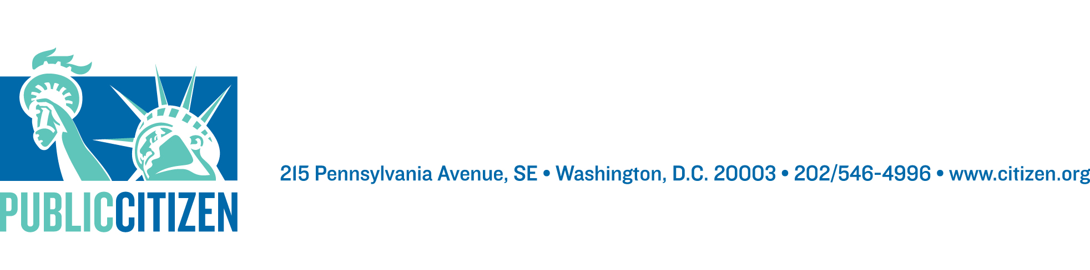
Position Available – Declaration for American Democracy Campaign Director
Housed within Public Citizen’s Congress Watch Division

Public Citizen is a national, non-partisan, public interest group with more than 500,000 members and supporters. The Congress Watch division conducts public education campaigns and advocates before Congress and administrative agencies on money in politics, open government, corporate accountability, financial regulation, public health and safety, and access to justice.

GENERAL DESCRIPTION OF POSITION:

Our democracy is under threat as never before, but we’re also in the middle of a once in a generation opportunity to fix what’s broken. The conflicts of interests are piling up, as are the attacks on the press, the judiciary, and the intelligence community. It is not a far-fetched notion that we could face a constitutional crisis of unprecedented magnitude. At the same time, supported by our coalition, the House of Representatives just prioritized and overwhelmingly passed a historic package of ethics, voting and money in politics reforms, local and state governments are leading the way with their own democracy reform efforts, and presidential candidates are beginning to make these issues a central part of their campaigns.

Public Citizen – along with more than 130 other organizations in the Declaration for American Democracy campaign – is part of leading the work to ensure that our democracy emerges from this “change moment” stronger than it was. This is not the time for small change and incremental solutions tailored to specific abuses. The public is demanding sweeping reforms that speak to the deep and widespread problems with our democracy,

We are seeking a proactive, strategic Campaign Director who can help us seize the opportunity inherent in such a moment to win far-reaching democratic reforms. The Director will join a team of incredibly hard working, creative and dedicated campaigners, lobbyists, researchers and communications staff, who are committed to this project (both inside Public Citizen and external partners.)

The Director will help widen the circle of engaged groups and drive the project forward, and will be responsible for working with allies to schedule and plan meetings and convenings to keep up project momentum, spearheading a field campaign to connect our federal goals with ongoing state democracy work, tracking and developing content, facilitating and doing outreach to organizations (state, local and national) as well as communications professionals, and benchmarking our overall progress.

The position will include a shifting combination of the below critical duties:

Campaign Strategy and Implementation:
The Director will be responsible for creating campaign strategies, inclusive of aggressive outside game work, that take advantage of all the resources the coalition has at its disposal. This will require creativity, campaign know how, as well as the ability to roll up your sleeves and deliver some serious campaign product.

Outreach and Engagement:
The Director will play an essential role in organizing groups, spending a significant amount of time pulling new allies to the collaborative work plan, and thinking through any missing constituencies, as well as the different needs for engaging folks at a local, state, and national level. In addition, the Director will serve as the liaison to any consultants or hired communicators for the campaign.

Policy Assistance:
The Director will spend time working with and guiding the policy development team to think through what substantive reforms best fit in the proactive legislative agenda, what research needs to be done to better shape and support the chosen policies, what legislative drafting needs exist, and then driving the work to accomplish these goals.

Materials Creation:
The Director will be responsible for creating or facilitating the creation of both outward and inward facing documents. That could include factsheets, one-pagers, talking points, policy briefs, website content, as well as social media, op-eds and blog content.

REQUIREMENTS:

Education and Experience: College degree required. At least ten years of advocacy, organizing or field experience or a comparable mix of relevant experience, such as communications, public policy, or campaign work preferred.

Knowledge: Significant knowledge of the legislative process and advocacy; social media prowess; knowledge of online communication, organizing and advocacy tools preferred.

Coalition Skills: Deep and demonstrated experience working in coalitions with multiple and diverse stakeholders – including with senior staff and heads of organizations. Experience working with state and local group strongly preferred.

Skills: Excellent and demonstrated writing, computer (including spreadsheet) and web skills; solid online research and investigative skills required. Desire and ability to make complex policy accessible and compelling to a variety of audiences. Some digital graphic design skill desirable.

Capabilities: Highly motivated, well organized and able to multi-task under pressure; able to work well with a wide range of people both in a team-based environment and within the overall organizational structure as well as outside it with other organizations; adaptable to different work processes, styles and sometimes fluid work agendas; ability to carefully follow direction; winning attitude and sense of humor required.

SALARY AND BENEFITS:

The salary for this role will be between $76,715 to $99,235 depending upon experience. The exact salary will be determined using a salary schedule that is part of a collective bargaining agreement. Thus individual salaries will not be subject to negotiation. This is a grant contingent position.
Benefits include:
- Great medical and dental coverage, including full coverage for children
- Three weeks paid vacation for new employees, plus five personal days
- 401K plan with a 5% contribution from PC after one year of employment
- 12 weeks of paid parental leave after one year of employment
- Student loan reimbursement program
TO APPLY: Please send letter of interest, resume and writing sample to Lisa Gilbert at lgilbert@citizen.org. Please no phone calls.

