**VOTE NO ON AMENDMENT #70 THAT BLOCKS PROTECTIONS FOR THE CRITICALLY ENDANGERED NORTH ATLANTIC RIGHT WHALE!**

**There are less than 420 individual right whales left – science has confirmed that losing just one more North Atlantic right whale risks dooming the species to extinction.**

**Amendment #70**, introduced to H.R. 3055, the Commerce, Justice, and Science appropriations bill, would block funding for NOAA to use a vital science-based model to help reduce risks of ship strikes and entanglement in fishing gear – the two major threats to the whales’ survival.

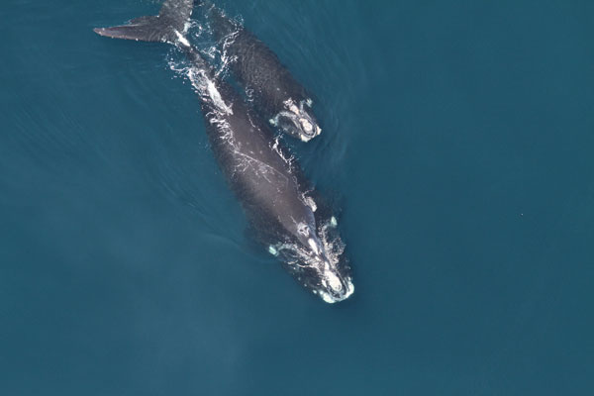

**Scientists – NOT CONGRESS –** should make decisions about North Atlantic right whale protections and what is needed for their continued survival.

The amendment could result in the extinction of the whaleand undermines the science-based implementation of the Marine Mammal Protection Act and the Endangered Species Act.

**Please Vote NO on Amendment #70**

[Groups]