**Miami Presidential Debate Toolkit**

**Please note: all of our debate materials have a c(4) legal designation. Please check with your organization before posting.**

**Suggested Hashtags:** #MakeNoiseForClimate, #ActOnClimate

**High-res Graphics:** [**HERE**](http://materials.actonclimate.com/search/?q=miami+debate&search_folder=&extensions_include=&extensions_exclude=&published_start=2019-06-01&published_end=)

**Sample images:**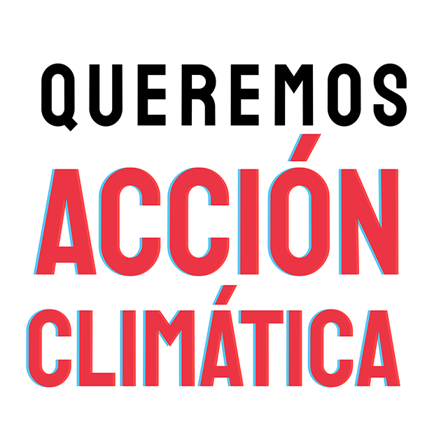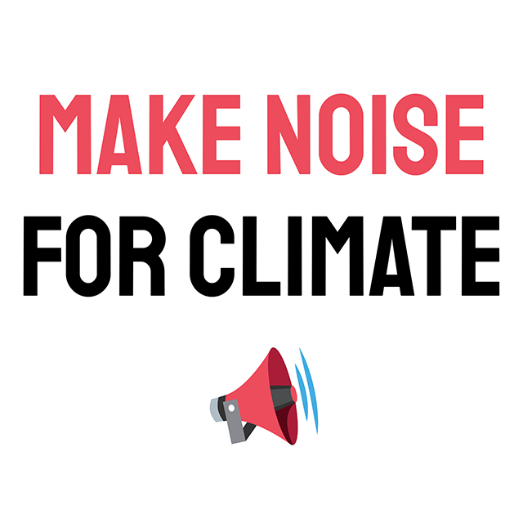



**Climate Debate Social (Direct to Moderators)**

**NBC Moderators:**

**Savannah Guthrie:** @SavannahGuthrie

**Rachel Maddow:** @maddow

**Lester Holt:** @LesterHoltNBC

**Jose Diaz-Balart:** @jdbalart

**Chuck Todd:** @chucktodd

**Networks broadcasting the debate:** @NBCNews, @MSNBC, and @TelemundoNews

**Suggested Links:**

* <https://psmag.com/environment/the-last-democratic-debate-had-no-climate-change-questions-this-year-that-will-change>
* <https://www.buzzfeednews.com/article/karthikganapathy/america-is-burning-why-arent-democrats-debating-climate>
* <https://www.nytimes.com/2019/06/25/opinion/democratic-debates-2020-nbc.html>
* Your organization’s press release about the need for climate debate questions/a climate debate

**What to say:**

* We’re facing a climate crisis – we can’t afford not to #MakeNoiseForClimate. @Maddow, @LesterHoltNBC, @SavannahGuthrie, @jdbalart, and @chucktodd – will you make climate part of the debate? #ActOnClimate
* @Maddow, @LesterHoltNBC, @SavannahGuthrie, @jdbalart, and @chucktodd: we’re counting on you to bring climate into the conversation tonight. #MakeNoiseForClimate #ActOnClimate
* At a time when climate action is more critically needed than ever, we can’t afford to stay silent. @[TAG MODERATOR] – will you #MakeNoiseForClimate at the debate tonight? #ActOnClimate
* It’s not enough to #ActOnClimate, we need our debate moderators to ASK on climate. @[TAG MODERATOR] – can we count on you? #MakeNoiseForClimate

**Rally Promo**

**TWITTER:**

* 📣📣📣 #MakeNoiseForClimate with @RethinkEnergyFL, @LCVoters, @UnderwaterHOA, @miaclimate, @ourclimateus, @AlianzaProgress, and @NextGenAmerica in Miami on 6/27. More details: <https://www.facebook.com/events/2163017833995573/>
* The climate crisis demands to be taken seriously. Join us in Miami on 6/27 to call on our leaders to #MakeNoiseforClimate. #ActOnClimate More info: <https://www.facebook.com/events/2163017833995573/>
* It’s time to #MakeNoiseForClimate. If you’re in #FL and want our leaders to commit to #ActOnClimate and address the crisis at hand, join us on 6/27: <https://www.facebook.com/events/2163017833995573/>
* This is a climate crisis. Add your voice to calls from people across the country asking our leaders to #ActOnClimate: <https://www.facebook.com/events/2163017833995573/> #MakeNoiseForClimate

**FACEBOOK:**

* The climate crisis demands to be taken seriously. Join [TAG] ReThinkEnergyFL [TAG] LCVoters, [TAG] underwaterHOA, [TAG] MiamiClimateAlliance, [TAG] ourclimateusa, [TAG] AlianzaForProgress, and [TAG] NextGenFL in Miami on 6/27 to call on our leaders to #MakeNoiseforClimate. #ActOnClimate More info: <https://www.facebook.com/events/2163017833995573/>
* This is a climate crisis. Add your voice to calls from people across the country asking our leaders to #ActOnClimate on 6/27 in Miami: <https://www.facebook.com/events/2163017833995573/> #MakeNoiseForClimate

**Wildfire in the Everglades**

**Tweet to RT**

* [**https://twitter.com/blkahn/status/1143270353080389637**](https://twitter.com/blkahn/status/1143270353080389637)

**TWITTER:**

* As candidates arrive in Miami for the first Democratic primary debate, the Everglades wildfire serves as an alarming reminder that our leaders must #ActOnClimate to keep our communities safe. #MakeNoiseForClimate<https://grist.org/article/as-democrats-prep-for-debate-in-florida-a-17000-acre-fire-burns-in-the-everglades/>
* The 17,000 acre Everglades wildfire makes it clear the climate crisis is real, it’s here, and it’s threatening our communities. It’s time for our leaders to #MakeNoiseForClimate. #ActOnClimate<https://grist.org/article/as-democrats-prep-for-debate-in-florida-a-17000-acre-fire-burns-in-the-everglades/>
* There’s a million reasons to #MakeNoiseForClimate at the first Democratic primary debate in Miami. The 17,000 acre wildfire in the Everglades threatening Floridians is just one.<https://grist.org/article/as-democrats-prep-for-debate-in-florida-a-17000-acre-fire-burns-in-the-everglades/>
* Make no mistake: the 17,000 acre wildfire in the Everglades underscores the urgent need to #MakeNoiseForClimate in the first Democratic primary debate in #FL.<https://grist.org/article/as-democrats-prep-for-debate-in-florida-a-17000-acre-fire-burns-in-the-everglades/>

**Follow Up Tweet:**

* It’s time to #MakeNoiseForClimate. If you’re in #FL and want our leaders to commit to #ActOnClimate and address the crisis at hand, join us on 6/27 at the Miami Freedom Tower at 6pm:<https://www.facebook.com/events/2163017833995573/>

**FACEBOOK:**

* The 17,000 acre Everglades wildfire makes it clear the climate crisis is real, it’s here, and it’s threatening our communities. It’s time for our leaders to #MakeNoiseForClimate. #ActOnClimate<https://grist.org/article/as-democrats-prep-for-debate-in-florida-a-17000-acre-fire-burns-in-the-everglades/>
* As candidates arrive in Miami for the first Democratic primary debate, the Everglades wildfire serves as an alarming reminder that our leaders must #ActOnClimate to keep our communities safe. #MakeNoiseForClimate<https://grist.org/article/as-democrats-prep-for-debate-in-florida-a-17000-acre-fire-burns-in-the-everglades/>