**2019 Thanksgiving Social Guidance**

**Pumpkins and climate change:**

**TWITTER:**

* Planning to have some pumpkin pie this #Thanksgiving? You might have to think again. Climate change is slowing pumpkin growth and could result in smaller pumpkins and less pie. #ActOnClimate 🥧🥧

<https://wbbm780.radio.com/articles/pumpkin-production-slow-start-due-heavy-rain>

* Bad news for fans of pumpkin pie – you may have to cut yourself a smaller slice this year as climate change slows pumpkin growth. #ActOnClimate <https://wbbm780.radio.com/articles/pumpkin-production-slow-start-due-heavy-rain>
* This #Thanksgiving, #ActOnClimate to save pumpkin pie. 🥧🥧 <https://wbbm780.radio.com/articles/pumpkin-production-slow-start-due-heavy-rain>

**FACEBOOK:**

* Planning to have some pumpkin pie this Thanksgiving? You might have to think again. Climate change is slowing pumpkin growth and could result in smaller pumpkins and less pie. #ActOnClimate 🥧🥧

<https://wbbm780.radio.com/articles/pumpkin-production-slow-start-due-heavy-rain>

* Bad news for fans of pumpkin pie – you may have to cut yourself a smaller slice this year as climate change slows pumpkin growth. #ActOnClimate <https://wbbm780.radio.com/articles/pumpkin-production-slow-start-due-heavy-rain>

**Sample Images**

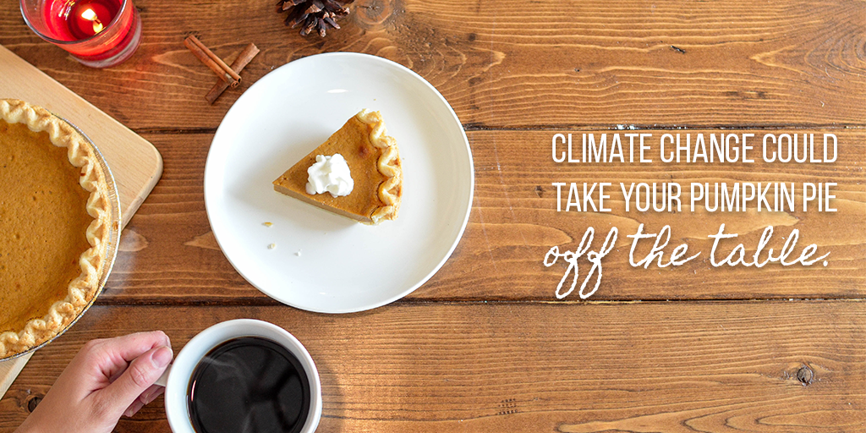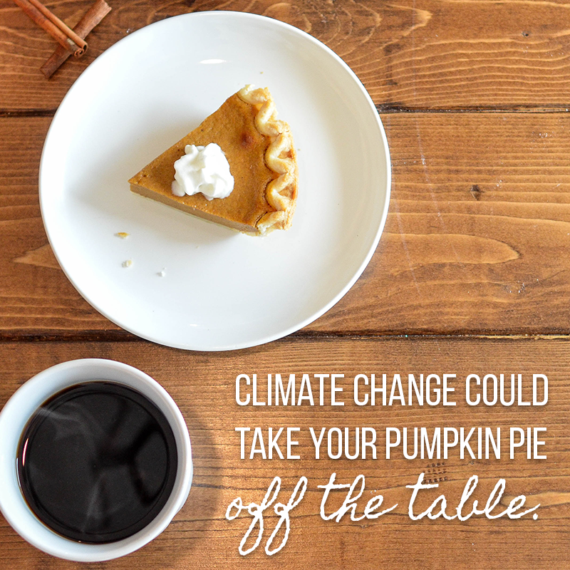

**Wine and Climate Change**

**TWITTER:**

* #Thanksgiving with no wine? Wineries are adapting as climate change continues to threaten the land they’ve been harvesting for generations. To protect this drink and local economies, we must #ActOnClimate. [https://www.nytimes.com/2019/10/24/dining/familia-torres-wine-climate-change.html?](https://www.nytimes.com/2019/10/24/dining/familia-torres-wine-climate-change.html?rref=collection%2Fsectioncollection%2Fclimate&action=click&contentCollection=climate&region=stream&module=stream_unit&version=latest&contentPlacement=3&pgtype=sectionfront)
* When it comes to wine, climate change is affecting everything from where to plant the grapes to what kinds of grapes will actually grow. This #Thanksgiving, learn why vineyards are pushing to #ActOnClimate. [https://www.nytimes.com/2019/10/24/dining/familia-torres-wine-climate-change.html?](https://www.nytimes.com/2019/10/24/dining/familia-torres-wine-climate-change.html?rref=collection%2Fsectioncollection%2Fclimate&action=click&contentCollection=climate&region=stream&module=stream_unit&version=latest&contentPlacement=3&pgtype=sectionfront)
* What are we thankful for this #Thanksgiving? A vineyard in Spain is experimenting with sustainable ways to make delicious wine while pushing to #ActOnClimate. [https://www.nytimes.com/2019/10/24/dining/familia-torres-wine-climate-change.html?](https://www.nytimes.com/2019/10/24/dining/familia-torres-wine-climate-change.html?rref=collection%2Fsectioncollection%2Fclimate&action=click&contentCollection=climate&region=stream&module=stream_unit&version=latest&contentPlacement=3&pgtype=sectionfront)

**Facebook:**

* Thanksgiving with no wine? Wineries are adapting as climate change continues to threaten the land they’ve been harvesting for generations. To protect this drink and local economies, we must #ActOnClimate. [https://www.nytimes.com/2019/10/24/dining/familia-torres-wine-climate-change.html?](https://www.nytimes.com/2019/10/24/dining/familia-torres-wine-climate-change.html?rref=collection%2Fsectioncollection%2Fclimate&action=click&contentCollection=climate&region=stream&module=stream_unit&version=latest&contentPlacement=3&pgtype=sectionfront)
* What are we thankful for this Thanksgiving? A vineyard in Spain is experimenting with ways to make delicious wine while fighting to #ActOnClimate. [https://www.nytimes.com/2019/10/24/dining/familia-torres-wine-climate-change.html?](https://www.nytimes.com/2019/10/24/dining/familia-torres-wine-climate-change.html?rref=collection%2Fsectioncollection%2Fclimate&action=click&contentCollection=climate&region=stream&module=stream_unit&version=latest&contentPlacement=3&pgtype=sectionfront)

**Football**

**TWITTER:**

* What do we love more than football around #Thanksgiving? Football and climate action! Learn more about how students and alumni fought to #ActOnClimate during halftime of the Yale vs. Harvard game:

<https://www.nytimes.com/2019/11/23/us/harvard-yale-game-protest.html>

* 🏈🏈🏈 Things we’re thankful for: the group of students and alumni who stormed the field for climate action during halftime of the Yale vs. Harvard football game. #ActOnClimate

<https://www.nytimes.com/2019/11/23/us/harvard-yale-game-protest.html>

* Roughly 500 students and alumni from Harvard and Yale highlighted the need to #ActOnClimate by storming the field at halftime of their annual football game.

<https://www.nytimes.com/2019/11/23/us/harvard-yale-game-protest.html>

* Harvard and Yale may have a football rivalry, but there’s one thing students can agree on: the need to #ActOnClimate. <https://www.nytimes.com/2019/11/23/us/harvard-yale-game-protest.html>
* Climate change threatens every U.S. city with an NFL team. To save #Thanksgiving football, we must #ActOnClimate.

<https://medialibrary.climatecentral.org/resources/warming-football-season>

* Football season is getting warmer, and threatening every city with an NFL team. For the sake of #Thanksgiving Day football, we need to #ActOnClimate.

<https://medialibrary.climatecentral.org/resources/warming-football-season>

**FACEBOOK:**

* What do we love more than football around Thanksgiving? Football and climate action! Learn more about how students and alumni fought to #ActOnClimate during halftime of the Yale vs. Harvard game:

<https://www.nytimes.com/2019/11/23/us/harvard-yale-game-protest.html>

* 🏈🏈🏈 Things were thankful for: a group of students fought to #ActOnClimate during halftime of the Yale vs. Harvard football game. <https://www.nytimes.com/2019/11/23/us/harvard-yale-game-protest.html>
* Climate change threatens every U.S. city with an NFL team. To save Thanksgiving football, we must #ActOnClimate.

<https://medialibrary.climatecentral.org/resources/warming-football-season>

**Know your facts**

**TWITTER:**

* It wouldn’t be #Thanksgiving without family conversations on hot topics, like climate change. Use this article to learn important facts and opportunities to #ActOnClimate:

<https://www.nytimes.com/2019/11/20/climate/nyt-climate-newsletter-thanksgiving.html>

* Looking for some #Thanksgiving dinner conversation ideas? Use this time to inform your family and friends of the impacts of climate change, and how they can help fight to #ActOnClimate.

<https://www.nytimes.com/2019/11/20/climate/nyt-climate-newsletter-thanksgiving.html>

* Will climate change come up at your #Thanksgiving table? @nytimes has you covered with resources for navigating the climate conversation with your relatives this year. #ActOnClimate <https://www.nytimes.com/2019/11/20/climate/nyt-climate-newsletter-thanksgiving.html>

**FACEBOOK:**

* It wouldn’t be Thanksgiving without family conversations on hot topics, like climate change. Use this article to learn some important facts, and ways you and your family can #ActOnClimate:

<https://www.nytimes.com/2019/11/20/climate/nyt-climate-newsletter-thanksgiving.html>

* Looking for some Thanksgiving dinner conversation ideas? Use this time to inform your family and friends of the impacts of climate change, and how they can help fight to #ActOnClimate.

<https://www.nytimes.com/2019/11/20/climate/nyt-climate-newsletter-thanksgiving.html>

**Six Thanksgiving Foods Affected by Climate Change**

**TWITTER:**

* Your favorite #Thanksgiving foods are being threatened by climate change. To save the best meal of the year, we need to #ActOnClimate.

<https://www.climaterealityproject.org/blog/six-thanksgiving-foods-affected-climate-change>

* Rising temperatures, extreme storms, and drought put our favorite #Thanksgiving dishes at risk. Learn more about how you can #ActOnClimate and save Thanksgiving dinner:

<https://www.climaterealityproject.org/blog/six-thanksgiving-foods-affected-climate-change>

* Many classic #Thanksgiving foods are threatened by climate change. #ActOnClimate

<https://www.climaterealityproject.org/blog/six-thanksgiving-foods-affected-climate-change>

**FACEBOOK:**

* Your favorite Thanksgiving foods are threatened by climate change. To save the best meal of the year, we need to #ActOnClimate.

<https://www.climaterealityproject.org/blog/six-thanksgiving-foods-affected-climate-change>

* Rising temperatures, extreme storms, and drought are putting our favorite Thanksgiving dishes at risk. Learn more about how you can #ActOnClimate and save Thanksgiving dinner:

<https://www.climaterealityproject.org/blog/six-thanksgiving-foods-affected-climate-change>

**Sample Images**



**PennEnvironment Op-Ed**

**TWITTER:**

* READ: This #Thanksgiving, @flora_lucia of @PennEnvironment is thankful for all of the Pennsylvanians who are ready to #ActOnClimate. <https://www.poconorecord.com/opinion/20191125/my-turn-this-thanksgiving-im-thankful-for-climate-action>
* “We can see the climate crisis right here in the Poconos... this #Thanksgiving, I am feeling more hopeful than ever that a cleaner, healthier future is within reach.” - @flora_lucia of @PennEnvironment #ActOnClimate <https://www.poconorecord.com/opinion/20191125/my-turn-this-thanksgiving-im-thankful-for-climate-action>
* In the Poconos, the climate crisis looks like dangerous flash flooding. This #Thanksgiving, @flora_lucia of @PennEnvironment is thankful that climate action is on the horizon. #ActOnClimate <https://www.poconorecord.com/opinion/20191125/my-turn-this-thanksgiving-im-thankful-for-climate-action>
* This #Thanksgiving, @flora_lucia of @PennEnvironment is thankful for @RepCartwright and @RepSusanWild for their support of the 100% Clean Economy Act of 2019. #ActOnClimate <https://www.poconorecord.com/opinion/20191125/my-turn-this-thanksgiving-im-thankful-for-climate-action>

**FACEBOOK:**

* READ: This Thanksgiving, Flora Cardoni of [TAG] PennEnvironment is thankful for all of the Pennsylvanians who are ready to #ActOnClimate. <https://www.poconorecord.com/opinion/20191125/my-turn-this-thanksgiving-im-thankful-for-climate-action>
* “We can see the climate crisis right here in the Poconos… this Thanksgiving, I am feeling more hopeful than ever that a cleaner, healthier future is within reach.” - Flora Cardoni of [TAG] PennEnvironment on her hope that Pennsylvania will #ActOnClimate. <https://www.poconorecord.com/opinion/20191125/my-turn-this-thanksgiving-im-thankful-for-climate-action>