Representative,

Nearly one year ago, on March 8th, 2019, you joined with your colleagues to pass the most comprehensive package of democracy reforms since Watergate. The For the People Act (H.R. 1) delivered on your promise to take on political corruption and clean up Washington.

In the past year, you and your colleagues have taken additional steps to strengthen our democracy by passing the SAFE Act (H.R. 2722) to shore up our voting systems, the SHIELD Act (H.R. 4617) to protect our elections from foreign interference, and the Voting Rights Advancement Act (H.R. 4) to fight back against Republican voter suppression efforts and ensure that every American can vote in our elections.

Unfortunately, Senate Majority Leader Mitch McConnell has blocked all of these bills, siding with the wealthy special interests who want to maintain the status quo in Washington.

**In advance of the first anniversary of House passage of H.R. 1, we have prepared the enclosed toolkit to help you talk about the bill, Majority Leader McConnell’s refusal to allow a vote on it, and to highlight all the work you’ve done in the past year to fight the power of special interests in Washington and create a democracy that works for all of us.**

The enclosed toolkit includes talking points, event ideas, social media guidance and fact sheets. We hope this information will serve as a helpful resource as you continue to lead reform efforts in Washington and keep fighting to put the public interest ahead of special interests.

As always, we are available to work with your office to help amplify your work and events on this issue. Please don’t hesitate to reach out to Action Fund Vice President Scott Fay (scott@endcitizensunited.org) or Deputy Director Erin Fyffe (erin@endcitizensunited.org) if we can be of assistance.

Sincerely,

Tiffany Muller

President, End Citizens United Action Fund

**Talking Points: Anniversary of H.R. 1**

The House passed the For the People Act (H.R. 1) on March 8th, 2019. Over the last year, Senate Majority Leader Mitch McConnell has blocked action on this critical legislation.

* One year ago, I joined with my colleagues to pass the most comprehensive package of anti-corruption reforms since Watergate, the For the People Act (H.R. 1). H.R. 1 will end the dominance of big money in politics, protect the right to vote, and restore ethics and accountability in Washington.
* Since then, House Democrats have also passed bills to lower the cost of prescription drugs, protect our air and water, reduce gun violence, create a fair economy, increase paychecks, and so much more.
* Unfortunately, Mitch McConnell has blocked action on almost everything we’ve passed, including nearly 300 bipartisan bills. His refusal to allow a vote on the For the People Act--which would cut the connection between special interests and Washington--is directly related to his refusal to bring up all of these other bills. The same wealthy special interests opposed to ending corruption in Washington are the same ones trying to block progress on the change Americans want to see.
* This sort of obstruction and gridlock is why my constituents are losing faith in their government. It’s time for Mitch McConnell to stop doing the bidding of wealthy special interests and stand up for Americans tired of the status quo in Washington. He should bring up H.R. 1 for a vote immediately.
* From day one, I’ve been fighting for my constituents and against the power of special interests in Washington. We’ll keep doing our jobs, for the people, because that is what you put me here to do.

*The March 8th anniversary may also serve as a good opportunity for an op-ed in your district about your Member’s support for H.R. 1 and other efforts to fight the power of special interests in Washington. Here are a few examples of similar op-eds.*

* Sen. Tom Udall (D-NM) and Rep. John Sarbanes (D-MD): The US cannot afford another 10 years of Citizens United ([CNN](https://www.cnn.com/2020/01/21/opinions/citizens-united-decision-election-disaster-udall-sarbanes/index.html))
* Rep. Chris Pappas (D-NH): Not up for debate: ending corruption and the power of special interests in Washington ([The Hill](https://thehill.com/blogs/congress-blog/politics/481952-not-up-for-debate-ending-corruption-and-the-power-of-special))
* Rep. Sharice Davids (D-KS): McConnell blocking drug price help that has blessing of Trump, House ([Kansas City Star](https://www.kansascity.com/opinion/readers-opinion/guest-commentary/article238366563.html))
* Rep. Antonio Delgado (D-NY): H.R.1 would bring much-needed campaign finance reform ([Daily Freeman](https://www.dailyfreeman.com/opinion/delgado-letter-h-r-would-bring-much-needed-campaign-finance/article_cc177422-4b0e-11e9-9ce3-670c6d64a45d.html))
* Rep. Abigail Spanberger (D-VA) Voting on side of Central Virginians—not special interests—never a difficult decision ([Culpeper Star-Exponent](https://www.starexponent.com/opinion/commentary-voting-on-side-of-central-virginians-not-special-interests/article_5f92ef61-f8fe-5589-aeef-fc19d8af86d1.html))

**Social Media Guidance**

**Suggested Tweets**

One year ago today, @HouseDemocrats made history by passing #HR1, the #ForThePeople Act – a transformative anti-corruption and clean elections bill. But to maintain the status quo in Washington, @senatemajldr continues to block the bill. It’s time for a Senate vote on #HR1!

It’s been one year since the House passed #HR1 to end the dominance of big money in politics and make it easier to vote. It’s time for @senatemajldr to stop stonewalling and allow a vote on this critical bill.

One year ago, we passed #HR1 to end the dominance of big money in politics, restore ethics and accountability, and protect the right to vote. @HouseDemocrats are committed to ending corruption and it’s time for @senatemajldr to allow a vote on this important bill.

.@HouseDemocrats are committed to lowering drug prices, tackling climate change, and ending gun violence. We passed #HR1 last year to end the dominance of big money in politics so we can make progress on all of these issues. It’s way past time for a vote in the Senate.

One year ago, we delivered on our promise to fight corruption in Washington by passing #HR1. This bill will end the dominance of big money in politics, protect the right to vote, and restore ethics and accountability in Washington. It’s way past time for @senatemajldr to hold a vote in the Senate.

**(Download:** [**Twitter**](https://drive.google.com/open?id=11lVBXV1X3Grz2DdHnYcvlCWui7Up-8Wn)**,** [**Facebook**](https://drive.google.com/open?id=16sYqwIKqy0WqQBIsQyFZoS0A5eXc1qUE)**)**

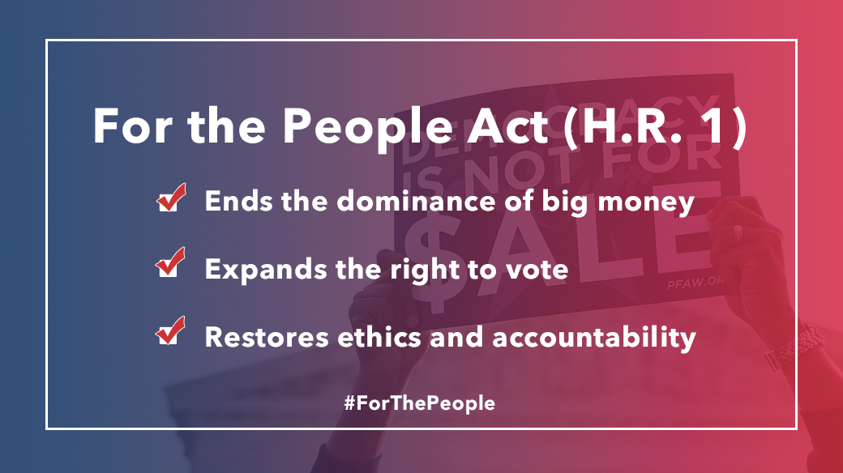

**(Download:** [**Twitter**](https://drive.google.com/file/d/1W-L-v-2VkAbfQyToWlPNCnWPttYTerHk/view)**,** [**Facebook**](https://drive.google.com/open?id=1idhs9tuDmjoiIcsantqrNsJeD9uGiD1m)**)**

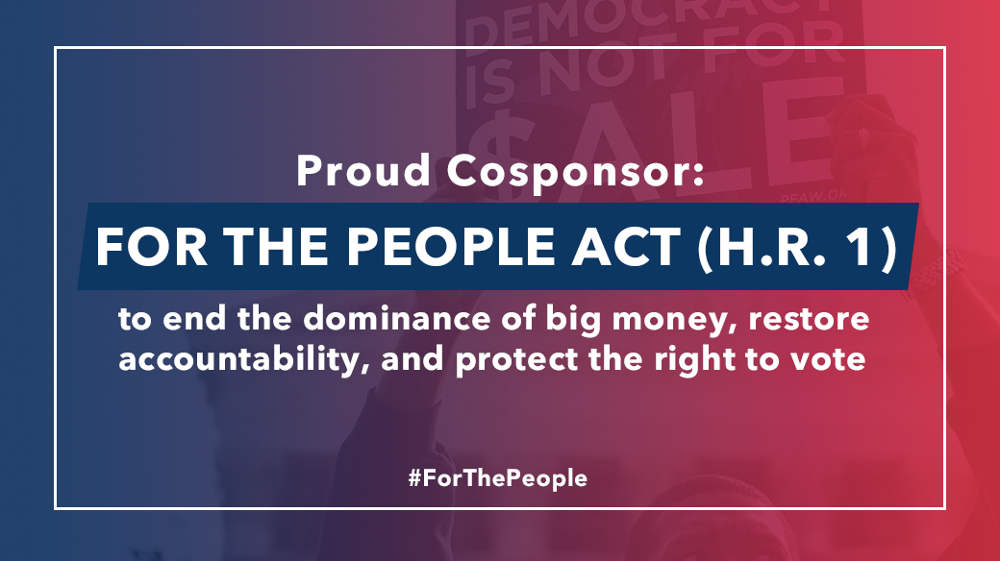

**(Download:** [**Twitter**](https://drive.google.com/open?id=1MyRCSXn2YY5qxhAmTzPNeCaBubnG9kao)**,** [**Facebook**](https://drive.google.com/open?id=19UnyLUjjDXfcBP0n26uGXPLc312OXDf6)**)**

**Hosting an Event**

We recommend you consider hosting an event in your district around the anniversary of H.R. 1’s passage--March 8th--to highlight the work you have done to reform our democracy by ending the dominance of big money in politics and protecting voting rights. You can also tie the Senate’s refusal to allow a vote on H.R. 1 to the Senate’s failure to take up any of the nearly 400 bills passed by the House.

* *Possible Participants*: Local/national reform leaders; local reform-minded public officials; local elected officials who have introduced statewide reform legislation; small business leaders hurt by large corporations; and local leaders who work on climate change issues, gun safety issues or Rx drug/health care/consumer protection issues.

* *Possible Venues*: Outside a courthouse; local city hall buildings; the office of a local chapter of a reform organization.

**Refresher: H.R. 1 Policy Outline**

The For the People Act is the most sweeping package of democracy reforms since Watergate. Below is an outline of the key provisions.

**Making it Easier, Not Harder to Vote**

* **Improve access.** H.R. 1 expands access to the ballot box by taking aim at institutional barriers to voting. It will create automatic voter registration across the country; ensure that individuals who have completed felony sentences have their full rights restored; expand early voting and simplify absentee voting; and modernize the U.S. voting system.
* **Promote integrity.** H.R. 1 commits Congress to build the record necessary to restore the Voting Rights Act; prohibits voter roll purges; and ends partisan gerrymandering to prevent politicians from picking their voters.
* **Ensure security.** H.R. 1 ensures that American elections are decided by American voters without interference by enhancing federal support for voting system security; increasing oversight over election vendors; and requiring the development of a national strategy to protect U.S. democratic institutions.

**End the Dominance of Big Money in Politics**

* **Guarantee disclosure.** H.R. 1 shines a light on dark money in politics by upgrading online political ad disclosure and requiring all organizations involved in political activities to disclose their large donors.
* **Empower citizens.** H.R. 1 gives political power to everyday Americans, creating a multiple-matching system for small donations, thereby allowing the American people to exercise their due influence in our politics. Modeled on successful systems around the country and paid for by wealthy tax dodgers and corporate lawbreakers, this will break special interests’ stranglehold on Congress and lay the groundwork for an agenda that serves the American people. It reaffirms that Congress should have the authority to regulate money in politics, pushing back on the wrongheaded *Citizens United* decision.
* **Strengthen oversight.** H.R. 1 ensures that there are cops on the beat who will enforce the laws. It tightens rules on super PAC, restructures the Federal Election Commission to break the agency’s gridlock, and repeals budget riders that prevent government agencies from requiring common sense disclosure of political spending.

**Ensure Public Officials Work for the Public Interest**

* **Fortify ethics law.** H.R. 1 breaks the influence economy in Washington by expanding conflict of interest law and divestment requirements; slowing the revolving door; and requiring presidents to disclose their tax returns.
* **Impose greater ethics enforcement.** H.R. 1 overhauls the Office of Government Ethics; closes loopholes for lobbyists and foreign agents; and ensures watchdogs have sufficient resources to enforce the law.

**Total Outside Spending By State**

The following table includes total outside spending for federal House and Senate races from 2010-2018 in every state.

*Note: District numbers and Republican/Democratic spending break down by district are available upon request.*

|  |  |
| --- | --- |
| State | Total Outside Spending Since *Citizens United* |
| AK | $48,232,221 |
| AL | $29,676,527 |
| AR | $67,461,548 |
| AZ | $171,259,206 |
| CA | $272,397,500 |
| CO | $178,528,782 |
| CT | $22,460,347 |
| DE | $4,234,714 |
| FL | $320,698,107 |
| GA | $89,703,580 |
| HI | $11,720,589 |
| IA | $121,094,273 |
| ID | $4,476,199 |
| IL | $163,017,380 |
| IN | $171,472,987 |
| KS | $45,088,462 |
| KY | $62,523,165 |
| LA | $40,473,981 |
| MA | $43,273,133 |
| MD | $17,747,783 |
| ME | $38,896,639 |
| MI | $105,457,114 |
| MN | $109,975,608 |
| MO | $155,219,087 |
| MS | $27,756,809 |
| State | **Total Outside Spending Since *Citizens United*** |
| MT | $80,631,356 |
| NC | $188,305,770 |
| ND | $40,049,119 |
| NE | $27,072,929 |
| NH | $174,118,989 |
| NJ | $73,084,861 |
| NM | $24,764,958 |
| NV | $277,857,404 |
| NY | $155,067,979 |
| OH | $161,134,262 |
| OK | $4,547,070 |
| OR | $12,372,960 |
| PA | $266,200,322 |
| RI | $1,475,573 |
| SC | $11,508,407 |
| SD | $8,965,992 |
| TN | $64,792,948 |
| TX | $108,542,262 |
| UT | $13,893,840 |
| VA | $124,140,882 |
| VT | $2,194,649 |
| WA | $53,704,198 |
| WI | $128,490,626 |
| WV | $63,245,514 |
| WY | $735,388 |

[Center for Responsive Politics, Outside Spending, By Race, 2010-2018, Accessed [12/12/19](https://www.opensecrets.org/outsidespending/summ.php?cycle=2018&disp=R&pty=A&type=A)]

**Downloadable Fact Sheets**

Below you’ll find downloadable, issue-specific fact sheets that you can distribute to your constituents. Click the image for downloadable PDF versions.

[***Download***](https://drive.google.com/open?id=1hf8pinhKColmqc4MYogNb5Q-Y4CNCtS4)***: Top 10 Ways Citizens United Has Hurt Our Democracy***

[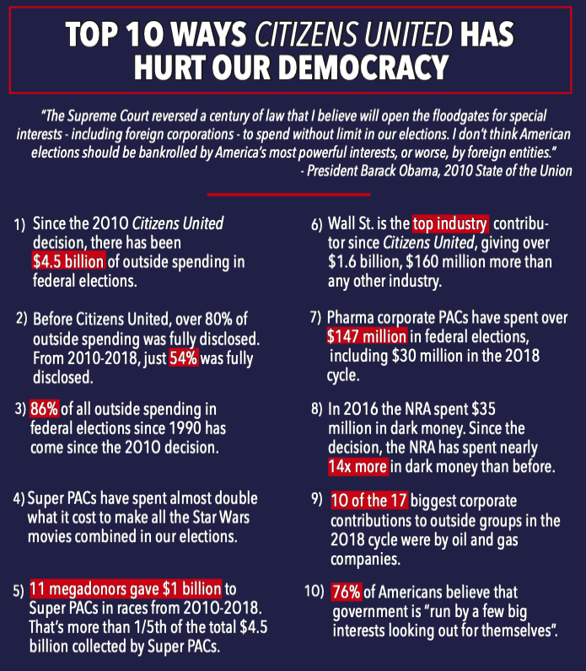](https://drive.google.com/open?id=1hf8pinhKColmqc4MYogNb5Q-Y4CNCtS4)

[***Download***](https://drive.google.com/open?id=1xIGBqAhYPZRcFFHSYGt2POrR2Jflh7Z7)***: Reforming Our Democracy to Save Our Planet:***

[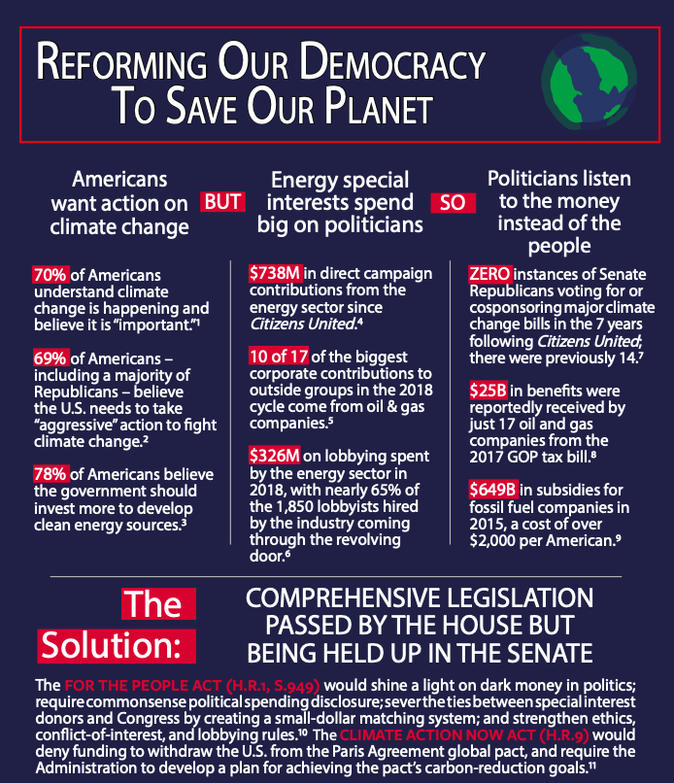](https://drive.google.com/open?id=1xIGBqAhYPZRcFFHSYGt2POrR2Jflh7Z7)

[***Download***](https://drive.google.com/open?id=108qtSvJFiAow5Qn_5foSl0mDMQm8dPlE)***: Reforming Our Democracy to Reduce Prescription Drug Costs***

[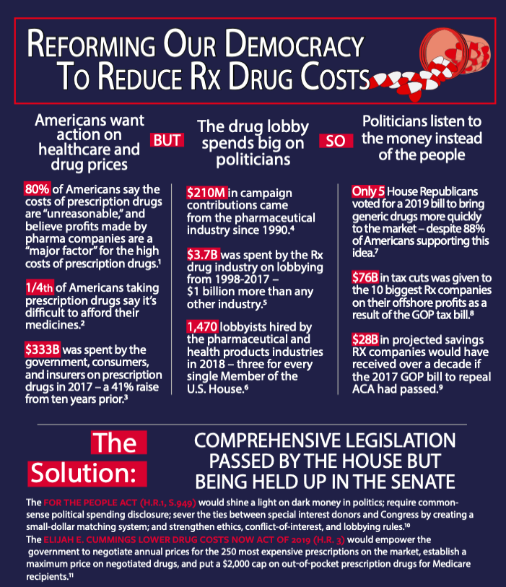](https://drive.google.com/open?id=108qtSvJFiAow5Qn_5foSl0mDMQm8dPlE)

[***Download***](https://drive.google.com/open?id=1KBa4jwzyOMKmMKJZHIJRkthM2DiYOOjA)***: Reforming Our Democracy to Reduce Gun Violence***

[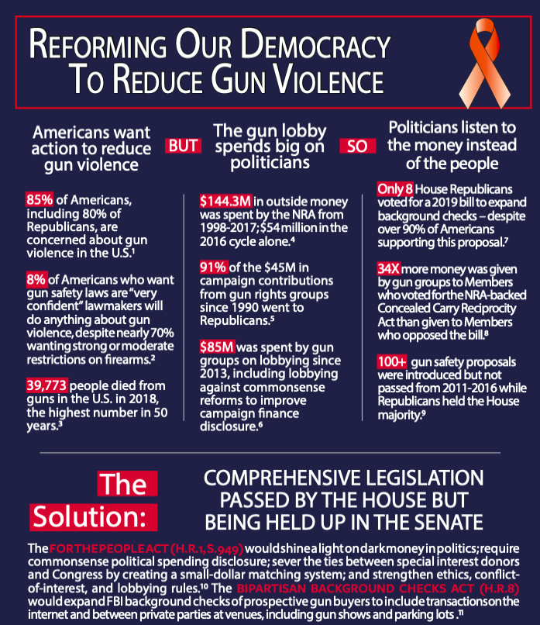](https://drive.google.com/open?id=1KBa4jwzyOMKmMKJZHIJRkthM2DiYOOjA)

[***Download***](https://drive.google.com/open?id=1HwgQXsKhEKPwhRrRqNk4i-uf4pxT8f_Y)***: Reforming Our Democracy to Protect Americans’ Privacy***

[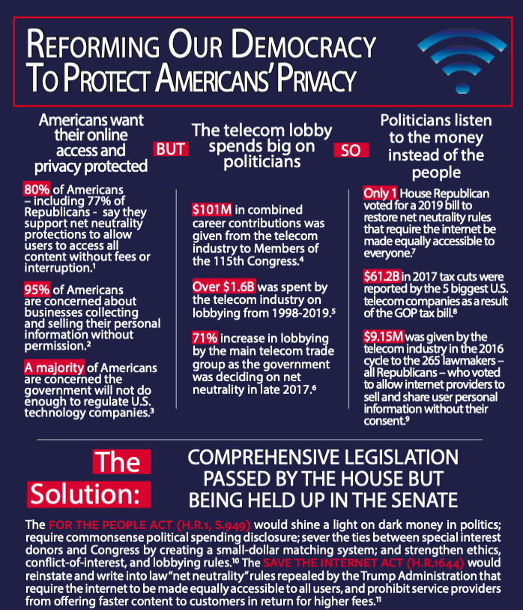](https://drive.google.com/open?id=1HwgQXsKhEKPwhRrRqNk4i-uf4pxT8f_Y)