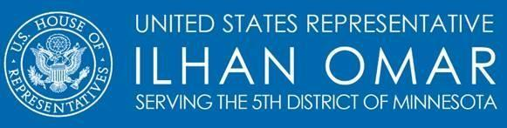

**Stop Trump’s Oil Payoff Act**

**STOP Act**

*House Sponsor: Rep. Ilhan Omar*

*Senate Sponsors: Sen. Merkley, Sen. Markey, and Sen. Sanders*

The Stop Trump’s Oil Payoff Act is a response to Trump’s proposed oil industry bail out as a result of COVID-19. This bill would prohibit the Trump Administration from slashing royalty rates for fossil fuel corporations and giving away billions of dollars to well established and highly profitable polluters.

As our country continues to respond to COVID-19 pandemic and the impact that this disease is having on our workforce, health care system, and families across the country, the reported proposal to bail out the oil industry as part of this administration's response to the financial impact of the coronavirus crisis is wholly misguided and wasteful use of the limited federal resources.

According to Oil Change International, the United States *already* subsides fossil fuel exploration and production at a rate of $20.5 billion annually. The reported proposal of using additional federal funds, low-interest loans, royalty relief, tax breaks, or strategic petroleum reserve purchases, would not only be extremely careless but will continue to exacerbate our climate crisis.

During the 2017-2018 midterm election cycle, corporations, individuals, and trade groups in the fossil fuel industry spent nearly $500,000 per day in contributions to national-level candidates, parties, and outside groups, bringing the total spending by the industry to more than $359 million in two years and this number doesn’t reflect their state-level efforts.

It is clear that this industry does not need additional assistance. Instead our focus should be on supporting American workers and families. Please join me in supporting this important legislation that will prohibit the proposed bail out the oil industry during this crisis and focus our efforts on American families. *For more information on the bill’s energy policy, please contact Maria Martirosyan (*[*Maria.Martirosyan@mail.house.gov*](mailto:Maria.Martirosyan@mail.house.gov).