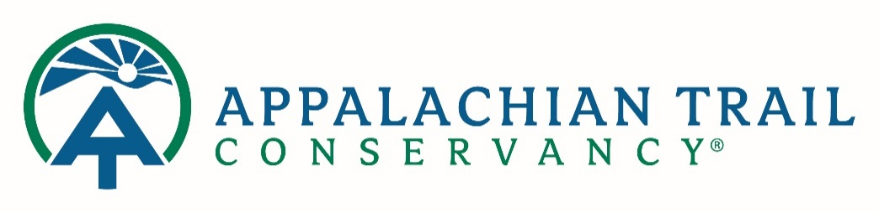

**POSITION DESCRIPTION**

|  |  |  |  |
| --- | --- | --- | --- |
| **Position Title** | Director, Visitor Use Management | **Incumbent** |  |
| **Location** | TBD | **Status** | Exempt |
| **Supervisor** | Vice President, Conservation & Trail Management | **Department** | Conservation |

### Organization Mission:

The Appalachian Trail Conservancy’s mission is to protect, manage, and advocate for the Appalachian National Scenic Trail.

**Purpose**

Five interrelated challenges impact the natural resources and unique recreation opportunities provided by the Appalachian National Scenic Trail (ANST or A.T.):

* A rapidly increasing number of visitors,
* The concentration of visitors in time and space,
* Insufficient adherence to Leave No Trace practices,
* The siting and construction of campsites, trails, and structures at nonresistant locations, and
* A disconnect between visitor expectations and management objectives.

While the environmental deterioration, aesthetic damage, crowding, and conflict that may result from the above conditions are not new problems, the increasing popularity of the ANST has reinforced the need for data-driven visitor use management and program development in select areas.

All proposed management decisions will be attentive to the needs of future visitors and use patterns. These visitors will likely draw from largely metropolitan areas and represent a more diverse audience than currently visiting the Trail today. The Director, Visitor Use Management will work collaboratively with stakeholders, partners, and staff to ensure that our management approach and communication are forward-thinking regarding future hikers with varying experience levels.

### Position Description

The Director, Visitor Use Management serves as a leader of an interdisciplinary monitoring and management team working with federal, state, and local partners to facilitate management planning and data-driven decision making to achieve balanced visitor use in priority areas. Visitor management strategies will redistribute or reduce use, disperse, or modify visitor behavior through education or regulations to minimize resource impact and meet desired condition metrics. Site management strategies will also need to be considered.

Protecting the A.T. experience is an adaptive and iterative management process dependent upon current and reliable data. The Director, Visitor Use Management will assist A.T. partners with the data collection and analyses needed to design appropriate management strategies for mitigating undesirable social and environmental impacts associated with overnight and day-use on the Trail. The Director, Visitor Use Management will also support determination of the desired conditions for each Trail section and implementation of strategies and tactics for desired condition achievement. This individual will lead and coordinate the evaluation of such management actions.

Specific duties include, but are not limited to:

* Works collaboratively with A.T. volunteers, ATC staff and Board of Directors, and A.T. partners.
* Works collaboratively with land managers, academic partners and the ATC Stewardship Council to establish standardized protocols for A.T. visitor use management and visitor use data collection and analysis.
* Manages the collection and integration of recreational use, natural and cultural resource, and related visitor use impact data; and synthesizes this data into professional reports for planning and management efforts and decision-making.
* Provides technical assistance and experienced judgment in analyzing and understanding ecological systems' human dimensions, including their natural resource, visitor experience, visitor capacity, and other visitor use related elements within a recreational ecology framework.
* Serves as the trail planning professional and scientific expert on a wide range of visitor use management issues such as developing user capacities, thresholds for impacts, and identifying appropriate management actions.
* Analyzes existing Visitor Use Management programs Trail-wide, makes suggestions for improvement as needed, and determines the reproducibility in other areas with similar visitor use management requirements
* Measures and evaluates progress toward mitigating impact and achieving desired conditions.
* Effectively communicates visitor use issues and management strategies to a wide and diverse audience, working closely with conservation and communication staff.
* Leads VUM training of A.T. volunteers, staff and agency partners.

**Desired Qualifications**

* Master’s degree in natural resource management, environmental policy, recreation ecology, statistics, math, or similar field
* Experience working across a variety of federal and state land managing agencies
* Strong quantitative analysis skills with demonstrated experience in research design, data management, data visualization, and leading project implementation
* Field research experience: must work on remote A.T. sections, on and off Trail, in all weather conditions, independently if necessary. Must be proficient with map & compass and GPS.
* A demonstrated ability to engage diverse stakeholder groups and build relationships to advance action toward goals
* Advanced data management skills
* Proficiency and experience with ArcGIS software and GIS principles
* Excellent oral and written communication skills
* Highly organized self-starter who can track, manage and report on multiple programs and frequently changing priorities with patience, perseverance, minimal supervision and successful completion.

**Physical Requirements**

* Ability to lift and move moderate weight (50+ pounds)
* Travel and weekend work may be required
* Ability and willingness to travel extensively and regularly between Georgia and Maine and points in between by vehicles and airplanes in all seasons.
* Ability to hike significant distances on and off the Trail, in rugged terrain
* Requires the ability to work under adverse weather conditions.

**To Apply:**

Please follow the link to ADP below. All files attached should be “[your last name]_[your first name]_[file name]”.

<https://workforcenow.adp.com/mascsr/default/mdf/recruitment/recruitment.html?cid=308869eb-4bf3-4360-a0b8-b26c926a5f77&ccId=19000101_000001&type=JS&lang=en_US>

***ATC Equal Employment Opportunity Statement***

*The Appalachian Trail Conservancy (ATC) encourages collaboration, flexibility, and fairness with all employees and volunteers to enable participation and contributions to their fullest potential.*

*We are committed to being a diverse and inclusive organization, and recognize that diversity contributes to an effective and successful organizational culture and mission.*

*The ATC prohibits discrimination in employment on the basis of race, color, religion, sex (including pregnancy, gender identity and/or expression), national origin, political affiliation, sexual orientation, marital status, disability, genetic information, age, membership in an employee organization, retaliation, parental status, military service, political affiliation, union membership, or any other status protected by the laws and regulations in the locations where we operate.*