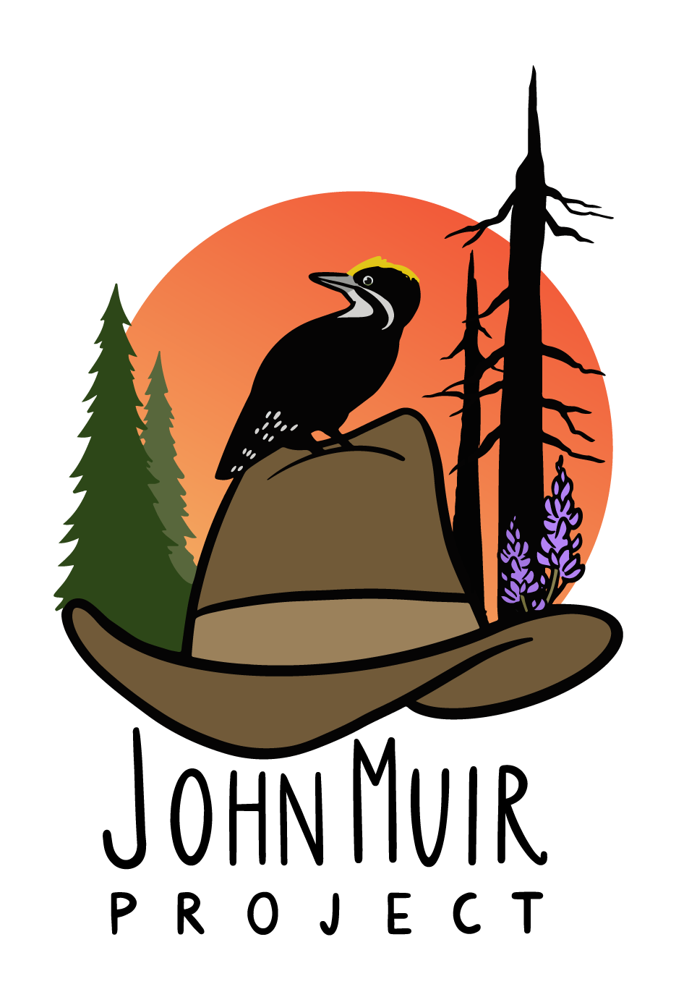

**1015 15th St NW, Suite 600 PO Box 897**

**Washington, DC 20005 Big Bear City, CA 92314**

**Office: 202-657-7270 Telephone: 530-273-9290**

**SOCIAL MEDIA TOOLKIT**  
Reject the Nomination of Thomas Vilsack for Secretary of Agriculture

The John Muir Project wanted to share some guidance with this list about community coordination regarding the Senate Agriculture Committee’s hearing on Thomas Vilsack for Secretary of Agriculture and, based on his record under President Obama, how damaging this could be for forest ecosystems and communities.

During his previous 7 + years as Secretary of Agriculture, the agency that oversees the United States Forest Service, Tom Vilsack supported policies that benefited logging corporations by increasing logging levels on National Forests by 35% all while damaging our forest ecosystems and exacerbating the climate crisis. He also pushed a false narrative that logging our forests could curb wildfire behavior and protect communities, which it didn’t. He is also an outspoken supporter of cutting and burning trees to generate electricity (biomass logging), a practice which destroys forests, burns dirtier than coal, and heavily impacts environmental justice communities from coast to coast. If we want 21st century forest policy that is aligned with the stated priorities of the Biden Administration to address the climate crisis, Tom Vilsack is not our man. We need an Agriculture Secretary who will keep our trees in our forests ecosystems, to store and sequester carbon, provide habitat, and protect communities by buffering the effects of floods, sea surge, rising temperatures and wind driven wildfires. Please join us by posting social media pushback on this nomination!

***Please use this tool kit to mobilize your Senator to oppose confirmation of Thomas Vilsack for Secretary of Agriculture.***

**All interested organizations are encouraged to join in the coordinated efforts to fight back against this concerning proposal.**

*Please let us know if you have any questions.*

*Feel free to share this information with your partners and lists.*

* **SAMPLE SOCIAL**

Tom #Vilsack served corporate logging and farming interests for over 7 years as Secretary of Agriculture under Obama. Now he is the nominee for the same position under Biden. Corporate interests got us into this mess -Tell your senators to oppose Vilsack for USDA.

If he gets confirmed as USDA Secretary #Vilsack will bring his support for dangerous timber-industry favored false solutions to the climate crisis into the Biden-Harris Administration. We do not have time to waste on the rebranding of failed forest policies! #NoOnVilsack

Under President Obama, Tom #Vilsack worked hand in hand with the wood pellet industry to expand operations @ taxpayer expense while falsely promoting woody biomass as a clean replacement for coal. Neither our forests nor our communities can take another 4 years!

Biden needs someone who will fight hard to protect our climate and communities by protecting National forests, not logging them. Based on his history, there is little hope that Vilsack is the right man for the job.

During his time at USDA, Tom Vilsack worked hand in hand with the timber industry to wreak havoc on our national forests. Biden needs someone who will follow the science, not suppress it, and who understands keeping our existing forests standing is the best natural way to fight climate change.

If we want 21st century forest policy that is aligned with the stated priorities of the Biden Administration to address the climate crisis, Tom Vilsack is not our man. We need an Agriculture Secretary who will keep our trees in our forests ecosystems!

* **KEY LINKS**
  + **PFPI PRESS RELEASE**

<http://www.pfpi.net/statement>

* + **PEER PRESS RELEASE: VILSACK SCIENCE SUPPRESSION**<https://www.peer.org/vilsacks-disturbing-suppression-of-usda-science/>
* **HASHTAGS**
  + **#NoOnVilsack**
  + **#Vilsack**
  + **#USDA**
  + **#MrMonsanto**
  + **#AgMonopolies**
  + #StopTheChop
  + #Stand4Forests
  + #ClimateDefense
  + #ForestDefenseIsClimateDefense
  + #KeepCarbonInTheForest
  + #KeepItInTheForest
  + #BiomassBurnsThePlanet
* **TARGETED CONGRESSIONAL SM HANDLES**
  + These are the targeted accounts that we suggest tagging in your social media.

|  |  |  |
| --- | --- | --- |
| **Representative** | **Twitter** | **Facebook** |
| Senate Democrats | @SenateDems | @USSenateDemocrats |
| Senate Agriculture Committee | @SenateAg  @SenateAgDems  @SenateAgGOP | @senateagGOP |

* **GRAPHICS**



**Agriculture Sec. Tom Vilsack and U.S. Rep. Derek Kilmer (Wash.) hold a press conference with Sierra Pacific Industries President George Emmerson (R) and representatives of the Olympic Peninsula Collaborative on Oct. 14, 2015.**

