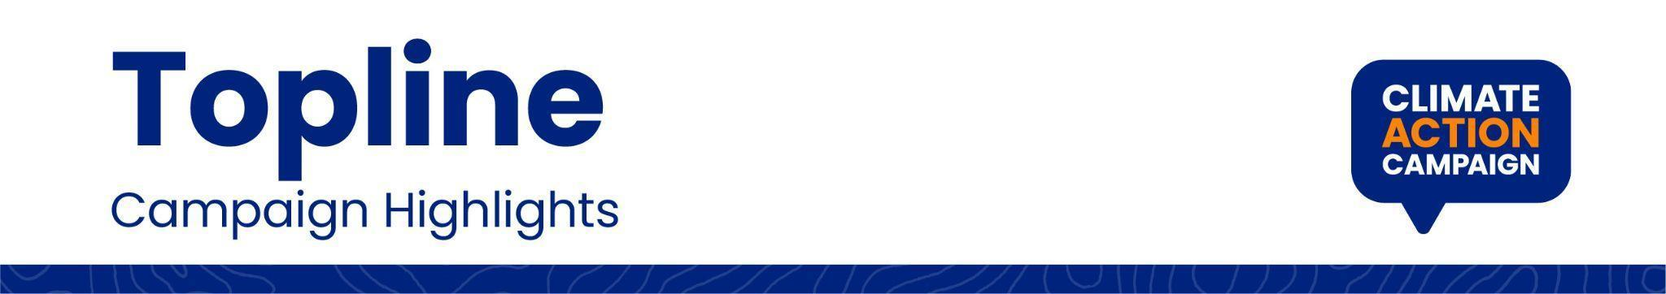

**CAC Briefings with Key Congressional Caucuses on the “Solutions for Pollution” Campaign Reinforce the Urgency of Setting Strong Federal Pollution Standards**

**November 4, 2022**

Over the Congressional recess, CAC organized virtual Hill briefings for members of Congress and their staff to share updates about the Solutions for Pollution campaign and the important role members of Congress can play to protect public health and environmental justice by encouraging the Biden administration to use its power to set the strongest possible standards.

The first of these briefings was on October 4, 2022, organized in partnership with the Congressional Black Caucus and Representative Donald McEachin’s office. Speakers included: Melody Tan from Congressman McEachin’s office, Reverend Emily Carroll from Green the Church, Terry McGuire from Earthjustice, Jessica Mengistab from Alliance of Nurses for Healthy Environments (ANHE), and CAC staff.

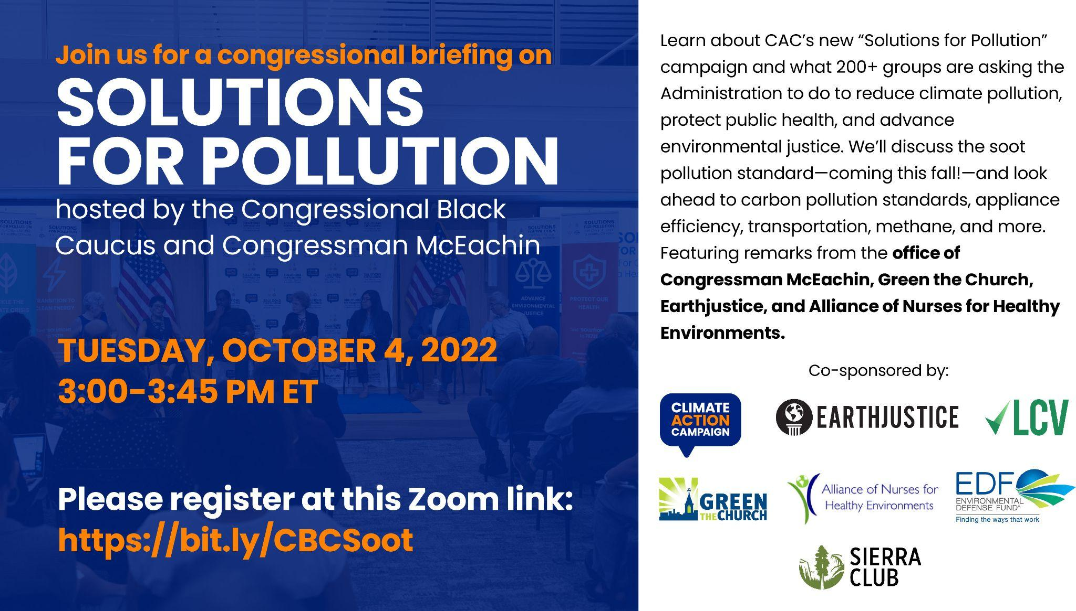

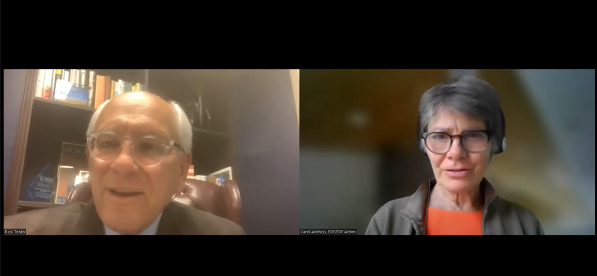

The second Solutions for Pollution briefing was co-hosted by the House Select Committee on the Climate Crisis and the House Sustainable Energy and Environment Coalition. House staffers heard from Congressman Paul Tonko, Jessica Mengistab from ANHE, Patrick Drupp from the Sierra Club, Anastasia Gordon from WE ACT for Environmental Justice, Rose Garr from CAC, and Carol Andress from the Environmental Defense Fund.

All told, 19 CAC partners and 87 congressional staff from 63 offices and four committees attended. The events were sponsored by groups including Earthjustice, LCV, Alliance of Nurses for Healthy Environments, EDF, Green the Church, Sierra Club, and WE ACT for Environmental Justice.

***CAC’s Topline shares brief descriptions of key moments from the campaign and its partners.***