
Fact Sheet on H.R. 6008
Studying America’s most endangered whale to death
so the oil and gas industry can carry on as usual

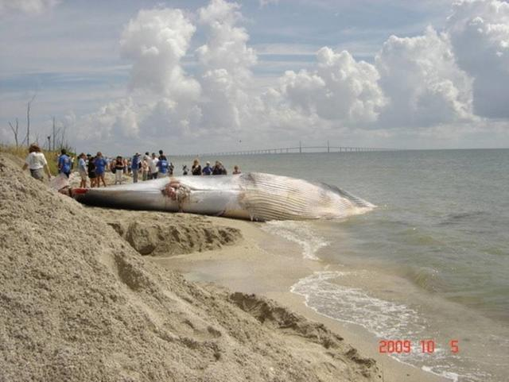
The Requiring Integrity in Conservation Efforts Act (H.R. 6008), introduced by Rep. Graves (R-LA), would prohibit and delay necessary protections for the critically endangered Gulf of Mexico Rice’s whale in favor of the oil and gas industry, which, not coincidentally, is largely responsible for the species’ decline.

The magnificent Rice’s whale, with fewer than 100 individuals left, is one of America’s most endangered marine mammals. It is particularly vulnerable to vessel strike, as it spends the majority of its time near the ocean surface. In a 2020 Biological Opinion, NOAA found that mortalities from vessel strikes are likely to exceed—by more than ten times —what the species can sustain. And the oil and gas industry is a major contributor to the problem, with frequent transits representing at least one-third of the total strike risk.
A fatally struck Rice’s whale in the Port of Tampa, brought to shore by volunteers.

NOAA estimates that the catastrophic Deepwater Horizon spill is directly responsible for the loss of more than 20% of the entire Rice’s whale population. The recent Main Pass pipeline spill, which leaked more than one million gallons of crude oil off the Louisiana coast, including in the whale’s habitat, highlights the risk that the oil and gas industry poses to one of our most endangered marine mammals. Avoiding Rice's whale habitat in leasing and slowing vessels down while transiting their habitat are bare minimum protections that we can offer to save the species from extinction in the near term.

And yet, despite the serious threat the oil and gas industry poses to the whale’s survival, this bill aims to undermine measures to protect the whale. It does so by carving exemptions into the Endangered Species Act and Marine Mammal Protection Act, ignoring the science, and giving industry unprecedented influence over agency decision-making. The fewer than 100 remaining Rice’s whales cannot afford to pay the price of this gift to the oil industry, extending business-as-usual in the Gulf of Mexico. We oppose H.R. 6008.

What would H.R. 6008 and similar legislation do?

- Interfere with our bedrock environmental laws. The bill would preempt protections in the Endangered Species Act, the Marine Mammal Protection Act, and every other federal environmental law.
- Prohibit NOAA and BOEM from taking measures to protect the whale even as it opens huge expanses of the Gulf to new oil and gas leasing. The bill would prohibit the federal government from acting on the best available and latest science and from implementing any additional protections for Rice's whales for years, if not forever.
- Force delay in protecting one of our most endangered species. The bill would delay the development and release of a new biological opinion by forcing NMFS to run a gauntlet of procedural requirements.
- Intervene in ongoing litigation. The bill would undermine a settlement agreement that requires BOEM to reevaluate protections for Rice’s whale, in light of new information about oil spill risk and a new, five-year NMFS study of Rice’s whale habitat.
- Provide the oil and gas industry with unprecedented special influence over NMFS’s decision-making. The bill would require NMFS to have special private meetings with industry about any proposed measures in a new biological opinion that may be required to protect Rice’s whales. This special access will allow industry to attempt to influence what should be strictly a science-based process.

Contact Information

Kristin Butler, Associate Legislative Representative, Earthjustice, kbutler@earthjustice.org
Valerie Cleland, Senior Ocean Advocate, NRDC, vcleland@nrdc.org
[Others TBA]

[Logos TBA]

