**Make Polluters Pay Agenda Press Conference 7/23, 1PM ET  
Messaging Guidance + Social Toolkit**

**Overview:**

* Congressional Democrats and environmental groups are holding a press conference to highlight [overwhelming public support](https://www.dataforprogress.org/blog/2023/12/12/voters-support-making-oil-and-gas-companies-pay-a-share-of-climate-costs-caused-by-pollution) for holding polluters accountable and introducing the "Make Polluters Pay" agenda, which will address critical issues facing Americans today, including measures to combat price gouging by oil companies, eliminate fossil fuel subsidies, and implement strategies to mitigate increasingly frequent extreme weather events linked to climate change.

**Topline Messaging:**

* Two-thirds of American voters support making Big Oil pay for the climate damage they've caused. The people are clear: it's time for polluters, not taxpayers, to foot the bill for extreme weather disasters.
* Climate change-fueled extreme weather is devastating communities across America:
  + Hurricane Beryl was the earliest category 5 hurricane ever.
  + Unusually early record-setting heat waves have swept the country
  + California has already seen a [600% increase in wildfires](https://www.cnn.com/2024/07/04/weather/west-heatwave-wildfires-california-butte/index.html) this year.
* While Congressional Democrats passed the biggest bill ever to combat climate change, and are investing in resilient infrastructure to protect our cities and towns, Republicans in Congress continue to deny the reality of climate change and instead focus on handouts to Big Oil, leaving people everywhere vulnerable to the devastating impacts of climate change and missing out on the economic opportunities of the clean energy future.
* The conservative Project 2025 agenda would go even further: with plans for massive expansions of fossil fuel drilling, blocking the EPA from enforcing limits on pollution, gutting the EPA staff and blocking its work on climate change and eliminating critical federal clean energy programs.
* The fossil fuel industry has known about climate change for decades, yet they've lied to the public and blocked action simply because it would affect their record profits. It's time they face the consequences of their deception.
* While American families struggle with high energy costs, Big Oil receives [$20 billion annually](https://www.budget.senate.gov/chairman/newsroom/press/sen-whitehouse-on-fossil-fuel-subsidies-we-are-subsidizing-the-danger-) in taxpayer-funded subsidies and price gouges consumers at the pump. By eliminating fossil fuel subsidies and implementing strong anti-price gouging measures, we can level the playing field for clean energy, reduce energy costs for American families, create jobs, and accelerate our transition to a sustainable future.

**MoC Sample Social + Resources:**

**Social to RT/Amplify:** @LCVoters | @SierraClub | @FossilFreeMedia | @Climate Power | @StopBigOil

**Hashtags:** #MakePollutersPay

**Graphics:** [link](https://drive.google.com/file/d/1ifdc8mllVBOvDnyCgQMmd1E59Q8r536W/view?usp=sharing)

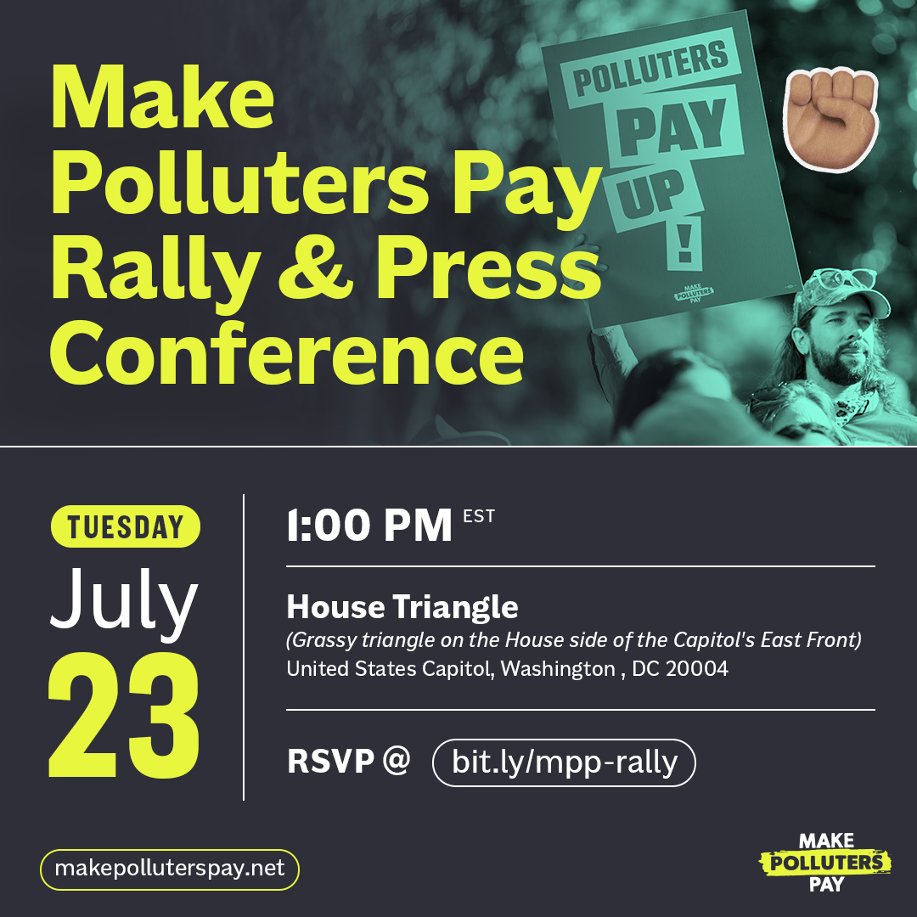

* The majority of the American public agrees: it’s time to hold Big Polluters accountable.

Rather than let Big Oil continue to price gouge families, make record profit, and deny their role in the climate crisis, I’m working with my Democratic colleagues to #MakePollutersPay.

* While communities bear the brunt of record-breaking heat waves and high energy costs, Big Oil continues to make historic profits and deny their role in the climate crisis.

That’s why I’m joining my colleagues to announce our plan to #MakePollutersPay and hold Big Oil accountable.

* Big Oil has long been aware of their role in the climate crisis.

And yet, they refuse to take action and continue price-gouging consumers at the pump to rake in record profits.

My colleagues and I are clear: it’s time to hold Big Oil accountable and #MakePollutersPay.

**Partner Sample Social + Resources:**

**Handles to Tag:** @SenMarkey | @SenBrianSchatz | @SenPeterWelch | @RepHuffman | @USRepKCastor | @Rep_Stansbury | @Ilhan | @RepJerryNadler | @RepMikeLevin

**Social to RT/Amplify:** @LCVoters | @SierraClub | @FossilFreeMedia | @Climate Power | @StopBigOil

**Hashtag:** #MakePollutersPay

**Livestream**: [link](https://www.youtube.com/watch?v=UdS-FipPZVs)

**Graphics:** [link](https://drive.google.com/file/d/1ifdc8mllVBOvDnyCgQMmd1E59Q8r536W/view?usp=sharing)



* The majority of the American public agrees: it’s time to hold Big Polluters accountable.

I’m glad to join champions in Congress who are refusing to let Big Oil continue to price gouge families, make record profit, and deny their role in the climate crisis. #MakePollutersPay [+ Photo from event]

* While our communities bear the brunt of record-breaking heat waves & high energy costs, Big Oil continues to make historic profits & deny their role in the climate crisis.

Watch Congressional Dems’ plan to #MakePollutersPay & hold Big Oil accountable 👇 https://www.youtube.com/watch?v=UdS-FipPZVs

* Big Oil has long known their role in the climate crisis.

And yet, they refuse to take action & price-gouge consumers at the pump for record profits.

That's why @SenateDems & @HouseDemocrats are working to hold Big Oil accountable & #MakePollutersPay 👏 https://www.youtube.com/watch?v=UdS-FipPZVs

* Two-thirds of voters support making Big Oil pay for the climate damage they've caused.

The people are clear: it's time for polluters, not taxpayers, to foot the bill for extreme weather disasters. #MakePollutersPay

* While Republicans cozy up to fossil fuel executives, Democrats in Congress are fighting to lower energy costs for American families through investments in clean, renewable energy. #MakePollutersPay
* Momentum is building to hold Big Oil accountable, with states and cities filing lawsuits, advancing "climate superfund" legislation, and demanding a federal bill to hold polluters accountable at the highest level. #MakePollutersPay
* While working families struggle with high energy costs and extreme heat, Big Oil continues to receive billions in taxpayer-funded subsidies.

It's time to end these handouts and invest in clean energy that will lower costs for consumers. #MakePollutersPay