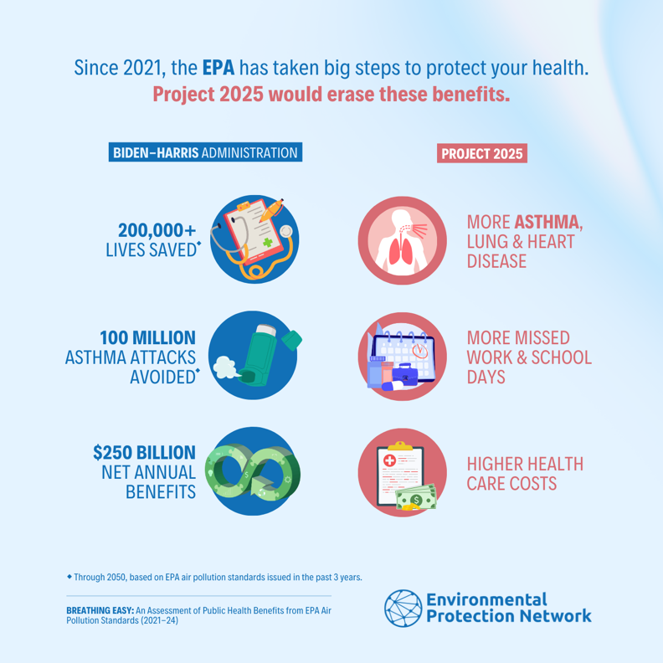
Environmental Protection Network
Figure 1*Image Link
Social Media Toolkit for:

Breathing Easy
An Assessment of Public Health Benefits from
EPA Air Pollution Standards (2021-24)
September 2024

Resource: https://www.environmentalprotectionnetwork.org/BreathingEasyReport

Summary: Environmental Protection Network (EPN), an association of 650 former Environmental Protection Agency (EPA) staff who volunteer their time to support EPA’s mission, analyzed sixteen major EPA air pollution rule updates issued from 2021 to 2024.

Topline Talking Points:
Based on data published by EPA for these rules, EPN concludes that the air pollution reductions from smokestacks, tailpipes, and pipelines will:

- Save over 200,000 lives through 2050. That’s the equivalent of a convoy of thousands of buses stretching along the highway from Philadelphia to New York City. The children, grandparents, moms, and dads on those buses will live longer, healthier lives thanks to these rules.
- Avoid over 100 million asthma attacks in the United States through 2050. That means fewer missed school days, missed work days, and trips to the school nurse or the emergency room.

- Deliver over $250 billion in net benefits annually, with total monetized public health and climate benefits exceeding regulatory costs by a ratio of six-to-one. That is, the public health and climate benefits of the rules will exceed compliance costs by trillions of dollars through 2050.

Social Media Guidance:

- Sample Tweet/Thread: @EnviroProtNet's new report "Breathing Easy" assesses public health benefits from @EPA air pollution standards 2021-24. Project 2025 would revert this work, putting millions of people at risk from asthma attacks and heart/lung disease. Read the report: https://bit.ly/4dY9Z2J
Twitter/Threads/Instagram Image

- Sample Facebook/Instagram Post: The Environmental Protection Network’s latest report analyzes the impact of EPA air pollution regulations and accomplishments over the last three and a half years. Since 2021, EPA has undergone an impressive reset—reestablishing scientific integrity and taking historic actions to address climate pollution; boost environmental justice; and protect America’s water, air, and land.

Project 2025 would revert this work — preventing the EPA from protecting public health, putting millions of people at risk from asthma attacks, cancer, heart disease and lung disease. Read EPN’s full report Breathing Easy: An Assessment of Public Health Benefits from EPA Air Pollution Standards (2021-24) here: https://bit.ly/4dY9Z2J
Facebook Image

Hashtags:
#airquality
#cleanair
#cleanerair
#environmentaljustice
#asthma
#PublicHealth
#ClimateAction

