**Hartnett White and Wheeler Social**

**Graphics** (on Materials Hub [HERE](http://materials.actonclimate.com/search/?q=&search_folder=&tags_include=81&tags_include=113&tags_include=436&extensions_include=&extensions_exclude=&published_start=2017-10-24&published_end=))

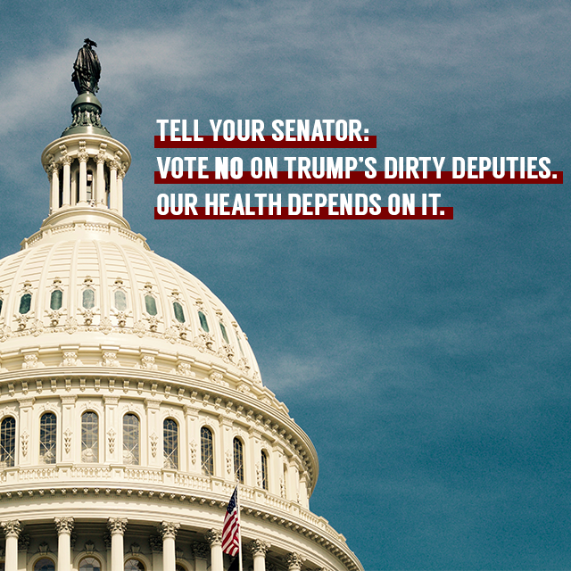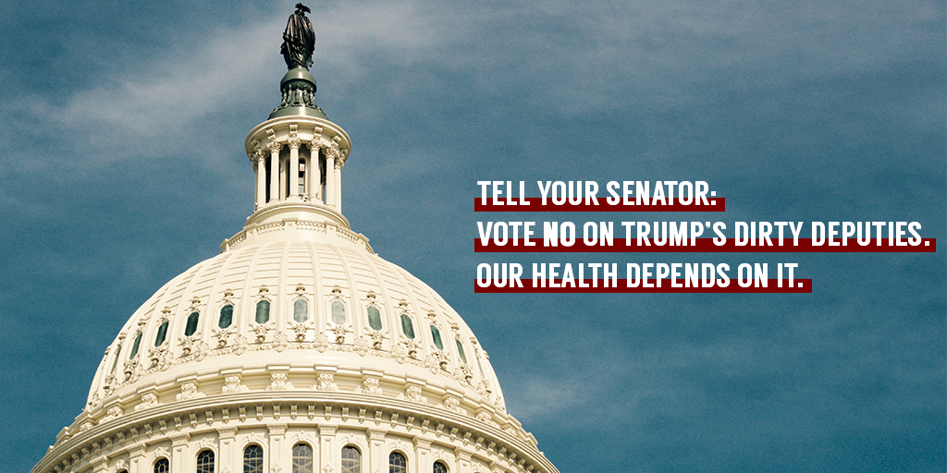

**KATHLEEN HARTNETT WHITE – Council for Environmental Quality (CEQ)**

**Suggested Hashtag:** #DirtyDeputies

**TWITTER:**

* “Trump taps climate skeptic for top White House environmental post” (via @washingtonpost) #DirtyDeputies <http://wapo.st/2hG0cTV>
* The top White House environmental post is no place for someone who refuses to #DefendClimate. <http://wapo.st/2hG0cTV>
* Kathleen Hartnett White rejects science and won’t #DefendClimate. She’s unfit to lead the CEQ. <http://wapo.st/2hG0cTV>
* Kathleen Hartnett White spent years trying to undermine science. Now she could oversee climate policy #DefendClimate <http://wapo.st/2hG0cTV>
* Kathleen Hartnett White’s climate denial puts us all in danger. CEQ needs a leader who will #DefendClimate. <http://wapo.st/2hG0cTV>
* Kathleen Hartnett White is the latest in a long series of Trump’s climate denying #DirtyDeputies. <http://wapo.st/2hG0cTV>
* From coal lobbyists to climate deniers, @realDonaldTrump has put polluters in charge. #DirtyDeputies <http://wapo.st/2hG0cTV>
* It would be "regrettable" to put Kathleen Hartnett White in charge. Of anything. Ever. #DirtyDeputies <https://youtu.be/5NhaBTiurm0?t=239>
* Kathleen Hartnett White ignored radiation standards and put lives at risk in Texas. #DirtyDeputies <https://youtu.be/5NhaBTiurm0?t=239>
* Trump’s latest nominee has already been embroiled in scandal for ignoring cancer-causing radiation. #DirtyDeputies <https://youtu.be/5NhaBTiurm0?t=239>
* Kathleen Hartnett White is the wrong choice for the Council on Environmental Quality. Here's proof. #DirtyDeputies <https://youtu.be/5NhaBTiurm0?t=239>

**FACEBOOK:**

* If you deny climate science, you can’t protect the American people. Kathleen Hartnett White doesn’t believe that we need to #DefendClimate - she’s unfit to lead the Council on Environmental Quality. <http://wapo.st/2hG0cTV>
* From *literally* writing an article titled “Coal is Clean” to repeatedly attacking the EPA repeatedly, Kathleen Hartnett White has made it clear that she has no use for science. It’s absolutely UNACCEPTABLE that [TAG] Donald J. Trump just nominated her for a top White House environmental post. #DirtyDeputies <http://wapo.st/2hG0cTV>
* From coal lobbyists to climate deniers, [TAG] President Donald J. Trump has a long history of putting polluters in charge. Kathleen Hartnett White is the latest of Trump’s #DirtyDeputies – and her dangerous, anti-science views put us at risk. <http://wapo.st/2hG0cTV>

**Unfit for CEQ**

**TWITTER:**

* Kathleen Hartnett White is a natural disaster. Watch some highlights from her hearing and see why the #DirtyDeputies can't be trusted with our health. <https://www.facebook.com/NowThisPolitics/videos/vb.908009612563863/1778169845547831/?type=2&theater>
* As chair of the Texas Commission on Environmental Quality, Kathleen Hartnett White purposefully underreported radiation in water. Trump's #DirtyDeputies would be disastrous for our communities. <https://www.facebook.com/NowThisPolitics/videos/vb.908009612563863/1778169845547831/?type=2&theater>
* Kathleen Hartnett White's congressional hearing put her incompetence on full display. #DirtyDeputies <https://www.facebook.com/NowThisPolitics/videos/vb.908009612563863/1778169845547831/?type=2&theater>
* Confirming Kathleen Hartnett White or any of @realDonaldTrump's #DirtyDeputies would put our families at risk. <https://www.facebook.com/NowThisPolitics/videos/vb.908009612563863/1778169845547831/?type=2&theater>

**FACEBOOK:**

* Kathleen Hartnett White is a natural disaster. Watch some highlights from her congressional hearing and see why the #DirtyDeputies can't be trusted with our health. <https://www.facebook.com/NowThisPolitics/videos/vb.908009612563863/1778169845547831/?type=2&theater>
* Kathleen Hartnett White's congressional hearing put her incompetence on full display. Confirming her or any of Trump’s #DirtyDeputies would put our families and communities at risk. <https://www.facebook.com/NowThisPolitics/videos/vb.908009612563863/1778169845547831/?type=2&theater>

**Hearing**

**TWITTER:**

* WATCH: Kathleen Hartnett White dodges questions about why it's acceptable to deny climate science. That's why we can’t expect her to be transparent about climate policy. #DirtyDeputies <http://bit.ly/2yJoPdS>
* If you’re not convinced that Trump’s #DirtyDeputies will put your health in danger, watch this. <http://bit.ly/2yJoPdS>
* Kathleen Hartnett White isn’t interested in fact or reason – which means she’s not interested in protecting your health. That's because she ALWAYS puts polluters first. We deserve better. #DirtyDeputies. <http://bit.ly/2yJoPdS>
* @realDonaldTrump’s nominee for the White House Council on Environmental Quality faltered when simply answering where she gets her facts. This isn’t normal. @SenatorCardin won’t stand for these #DirtyDeputies. Neither should we. <http://bit.ly/2yJoPdS>
* Kathleen Hartnett White can’t get her facts straight when discussing WHERE she gathers information. She thinks scientists shouldn’t “dictate” climate policy – because she trusts polluters, not facts. #DirtyDeputies <http://bit.ly/2yJoPdS>

**FACEBOOK:**

* WATCH: Kathleen Hartnett White dodges questions about where she gets her information. That's just one reason why we can’t expect her to be transparent about climate policy. #DirtyDeputies <http://bit.ly/2yJoPdS>
* [TAG] Donald J. Trump’s nominee for the White House Council on Environmental Quality faltered when simply discussing where she gathers facts. This isn’t normal. [TAG] Senator Cardin won’t stand for these #DirtyDeputies. Neither should we. <http://bit.ly/2yJoPdS>
* Kathleen Hartnett White can’t get her facts straight when discussing WHERE she gathers information. She thinks scientists shouldn’t “dictate” climate policy – because she trusts polluters, not facts. #DirtyDeputies <http://bit.ly/2yJoPdS>

**Lack of Trust for Science**

**TWITTER:**

* Kathleen Hartnett White said that scientists shouldn’t dictate policy. She trusts polluters, not accepted science. #DirtyDeputies <http://bit.ly/2yJoPdS>
* If confirmed by the Senate, Kathleen Hartnett White would support policies that would hurt Americans for generations. #DirtyDeputies <http://bit.ly/2yJoPdS>
* Kathleen Hartnett White has a longstanding history of putting the interests of corporate polluters first. #DirtyDeputies <http://bit.ly/2yJoPdS>
* Why does @realdonaldTrump want Kathleen Hartnett White on his team of #DirtyDeputies? She’s paid for by polluters and ready to push his toxic agenda. <http://bit.ly/2yJoPdS>

**FACEBOOK:**

* Trump’s #DirtyDeputies will put our health at risk – and yesterday their allegiance to polluters was on full display. Kathleen Hartnett White spent her time dodging questions and denying science. <http://nyti.ms/2jdWKVc>
* If confirmed by the Senate, Kathleen Hartnett White is the kind of polluter puppet who would support climate policies that hurt our families for generations. Her nomination is absolutely unacceptable. #DirtyDeputies <http://nyti.ms/2jdWKVc>
* Kathleen Hartnett White has YEARS of experience – propping up polluters and their toxic agenda. She’ll never put our health first. #DirtyDeputies <http://nyti.ms/2jdWKVc>
* Kathleen Hartnett White said that policy shouldn’t be dictated by science. It’s clear that she trusts polluters and refuses to acknowledge facts,. If confirmed by the Senate, Hartnett White would push for policies that could harm Americans for generations to come. #DirtyDeputies <http://bit.ly/2yJoPdS>

**ANDREW WHEELER – EPA Deputy Director**

**Suggested Hashtag:** #DirtyDeputies

**SUGGESTED LINKS**

“[Trump Nominates a Coal Lobbyist to Be No. 2 at EPA](https://www.nytimes.com/2017/10/05/climate/trump-epa-andrew-wheeler.html),” *New York Times*, 10/5

“[Trump Taps Ex-lobbyist for EPA No. 2 Job](http://bit.ly/2gfC3E2),” *The Hill*, 10/5

“[Trump Picks Coal Lobbyist for EPA deputy Role, Drawing Mixed Reactions](https://www.reuters.com/article/us-usa-trump-epa-wheeler/trump-picks-coal-lobbyist-for-epa-deputy-role-drawing-mixed-reaction-idUSKBN1CB014),” *Reuters*, 10/5

**Wheeler Background/Nomination**

**TWITTER:**

* The only people who approve of Trump’s latest nominee are corporate polluters. Shocker. #DirtyDeputies <http://nyti.ms/2xlIkZ2>
* Andrew Wheeler would work directly with @EPAScottPruitt to undermine our health protections. #DirtyDeputies <http://bit.ly/2gfC3E2>
* Sue the @EPA – Become EPA administrator. Lobby for coal companies – Become deputy administrator. #DirtyDeputies <http://bit.ly/2gfC3E2>
* EPA nominations used to be about skill and experience. Now they’re about how many polluters you know. #DirtyDeputies <http://nyti.ms/2xlIkZ2>
* Tweet to quote: <https://twitter.com/EPA/status/916058369068355585>
  + Once again proving that you’ll always put polluter profits over our health. #DirtyDeputies
  + Sickening. (Literally.) #DirtyDeputies
  + Fox, welcome to the hen house. #DirtyDeputies

**FACEBOOK:**

* Andrew Wheeler would be the latest in [TAG] Donald J. Trump’s string of #DirtyDeputies to threaten our health. <http://nyti.ms/2xlIkZ2>
* If confirmed, Andrew Wheeler would work hand in hand with [TAG] Scott Pruitt to undermine clean air and clean water protections. #DirtyDeputies <http://bit.ly/2gfC3E2>
* EPA nominations used to be about skill and experience. Now they’re about how many corporate polluters you’ve rubbed elbows with. #DirtyDeputies <http://nyti.ms/2xlIkZ2>
* Sue the EPA? Become EPA administrator. Lobby for coal polluters? Become deputy administrator. #DirtyDeputies <http://bit.ly/2gfC3E2>

**Targeted to Trump**

**TWITTER:**

* @RealDonaldTrump’s latest nomination is *literally* sickening. #DirtyDeputies <http://nyti.ms/2xlIkZ2>
* @RealDonaldTrump named a coal lobbyist to the #2 spot at @EPA. Fox, welcome to the hen house. <http://nyti.ms/2xlIkZ2>
* Trump just tapped a coal lobbyist to be 2nd in command at @EPA. He will NEVER put our health first. #DirtyDeputies <http://nyti.ms/2xlIkZ2>
* @realDonaldTrump’s latest assault on your health? Nominating a coal lobbyist to serve at @EPA. #DirtyDeputies <http://nyti.ms/2xlIkZ2>

**FACEBOOK:**

* [TAG] Donald J. Trump just nominated ex-coal lobbyist Andrew Wheeler to be second in command at the EPA. From the #DirtyDeputies he’s nominated, it’s clear where Trump’s priorities lie. Hint: not with our health. <http://nyti.ms/2xlIkZ2>
* [TAG] Donald J. Trump just nominated a lobbyist for corporate coal polluters to the #2 spot at the EPA. Yes, really. Fox – welcome to the hen house. #DirtyDeputies <http://nyti.ms/2xlIkZ2>
* [TAG] Donald J. Trump just tapped a coal lobbyist to be second in command at the EPA. Make no mistake: he will NEVER put our health above polluter profits. #DirtyDeputies <http://nyti.ms/2xlIkZ2>

**Targeted to Pruitt**

**TWITTER:**

* Apparently a requirement for joining @EPAScottPruitt’s #DirtyDeputies is deference to corporate polluters. SAD. <http://bit.ly/2gfC3E2>
* 🚨🚨🚨 @EPAScottPruitt wants the “swift confirmation” of an coal lobbyist as his second in command. #DirtyDeputies <http://bit.ly/2gfC3E2>
* Lobby for coal industry polluters? ✔️  
  Care about our health? ❌  
  Andrew Wheeler fits right into @EPAScottPruitt’s polluter-friendly EPA. #DirtyDeputies <http://nyti.ms/2xlIkZ2>

**FACEBOOK:**

* UNACCEPTABLE: [TAG] Scott Pruitt is hoping to orchestrate the “swift confirmation” of a coal lobbyist as his second in command. This latest nominee is further proof that Pruitt prioritizes big polluters over protecting Americans’ health. #DirtyDeputies <http://bit.ly/2gfC3E2>
* [TAG] Scott Pruitt and his newest nominee have tons in common – they both made careers fighting lifesaving health protections and pandering to corporate polluters. #DirtyDeputies <http://nyti.ms/2xlIkZ2>

**SPANISH TRANSLATIONS**

**KATHLEEN HARTNETT WHITE – Consejo de Calidad Ambiental (CEQ)**

**Hashtag Sugerido :** #DirtyDeputies

**TWITTER:**

* "Trump aprovecha al escéptico del clima para el principal puesto ambiental de la Casa Blanca" (a través de @washingtonpost) #DirtyDeputies<http://wapo.st/2hG0cTV>
* La principal publicación ambiental de la Casa Blanca no es lugar para alguien que se niega a #Defenderelclima.<http://wapo.st/2hG0cTV>
* Kathleen Hartnett White rechaza la ciencia y no #DefendClimate. Ella no es apta para dirigir el CEQ.<http://wapo.st/2hG0cTV>
* Kathleen Hartnett White pasó años tratando de socavar la ciencia. Ahora ella podría supervisar la política climática #DefendClimate<http://wapo.st/2hG0cTV>
* La negación climática de Kathleen Hartnett White nos pone a todos en peligro. CEQ necesita un líder que lo haga #DefendClimate.<http://wapo.st/2hG0cTV>
* Kathleen Hartnett White es la última de una larga serie de Trump que niega el clima #DirtyDeputies.<http://wapo.st/2hG0cTV>
* Desde cabilderos de carbón hasta negadores del clima, @realDonaldTrump ha puesto a los contaminadores a cargo.#DirtyDeputies<http://wapo.st/2hG0cTV>
* Sería "lamentable" poner a Kathleen Hartnett White a cargo. De nada. Nunca. #DirtyDeputies<https://youtu.be/5NhaBTiurm0?t=239>
* Kathleen Hartnett White ignoró los estándares de radiación y puso vidas en riesgo en Texas.#DirtyDeputies<https://youtu.be/5NhaBTiurm0?t=239>
* El último nominado de Trump ya se ha visto envuelto en un escándalo por ignorar la radiación causante de cáncer. #DirtyDeputies<https://youtu.be/5NhaBTiurm0?t=239>
* Kathleen Hartnett White es la elección incorrecta para el Consejo de Calidad Ambiental. Aquí hay una prueba. #DirtyDeputies<https://youtu.be/5NhaBTiurm0?t=239>

**FACEBOOK:**

* Si niegas la ciencia climática, no puedes proteger al pueblo estadounidense. Kathleen Hartnett White no cree que necesitemos #DefendClimate - ella no es apta para dirigir el Consejo de Calidad Ambiental.<http://wapo.st/2hG0cTV>

**ANDREW WHEELER – EPA Deputy Director**

**Suggested Hashtag:** #DirtyDeputies

**SUGGESTED LINKS**

“[Trump Nominates a Coal Lobbyist to Be No. 2 at EPA](https://www.nytimes.com/2017/10/05/climate/trump-epa-andrew-wheeler.html),” *New York Times*, 10/5

“[Trump Taps Ex-lobbyist for EPA No. 2 Job](http://bit.ly/2gfC3E2),” *The Hill*, 10/5

“[Trump Picks Coal Lobbyist for EPA deputy Role, Drawing Mixed Reactions](https://www.reuters.com/article/us-usa-trump-epa-wheeler/trump-picks-coal-lobbyist-for-epa-deputy-role-drawing-mixed-reaction-idUSKBN1CB014),” *Reuters*, 10/5

**Wheeler Background/Nomination**

**TWITTER:**

* Las únicas personas que aprueban los nominados de Trump son los contaminadores corporativos. #DirtyDeputies<http://nyti.ms/2xlIkZ2>
* Andrew Wheeler trabajaría directamente con @EPAScottPruitt para eliminar las protección a la salud pública. #DirtyDeputies<http://bit.ly/2gfC3E2>
* Demanda a la @EPA, se convierte en administrador de la EPA. Cabildea a favor de la minería de carbón, se convierte en subdirector. #DirtyDeputies<http://bit.ly/2gfC3E2>

**FACEBOOK:**

* Si es confirmado, Andrew Wheeler trabajaría mano a mano con [TAG] Scott Pruitt para eliminar protección de aire y agua limpia. #DirtyDeputies<http://bit.ly/2gfC3E2>

**Targeted to Trump**

**TWITTER:**

* Las recientes nominaciones de @RealDonaldTrump son literalmente repugnantes. #DirtyDeputies<http://nyti.ms/2xlIkZ2>
* @RealDonaldTrump acaba de nominar al cabildero de minería de carbón como segundo al mando de la EPA. Es pedirle al zorro que proteja el gallinero. #DirtyDeputies

**FACEBOOK:**

* [TAG] Donald J. Trump acaba de nominar a ex cabildero de la industria de minería de carbón Andrew Wheeler como segundo en mando en la EPA. es evidente que sus prioridad no es nuestra salud.<http://nyti.ms/2xlIkZ2>