**#ClimateActionSavesLives Social Media Guide**

**PURPOSE**

This week, EPA Administrator Scott Pruitt took his climate denial to a new level, claiming that humans “flourish” under warmer conditions. This isn’t just factually inaccurate – it’s a dangerous belief that ignores communities facing devastating impacts of extreme weather and illness intensified by climate change and warming temperatures.

To push back on Pruitt’s dangerous narrative, we’re uplifting the **#ClimateActionSavesLives** hashtag to collect personal stories from people affected by climate change and advocating for climate action. We need strong climate action to protect our health and environment, and it’s vital that decision makers hear your personal story.

**HOW TO PARTICIPATE**

Share your story on social media using the hashtag **#ClimateActionSavesLives.** There are multiple ways you can do this: creating a chain of tweets to tell your story or the story of someone close to you, tweeting a picture of climate impacts in your area, recording yourself talking about how climate action affects you, or holding a Facebook livestream or Twitter Q+A where you tackle the issue in a more interactive format.

**RESOURCES**

However you’re most comfortable telling your story, the Digital team at CAC is here to help! Included in this document is some sample social media posts you can use to get you started as well as a guide to recording a successful Facebook livestream. Feel free to reach out to us with more specific questions at [digital@cacampaign.com](mailto:digital@cacampaign.com). We’re looking forward to working with you – thank you for telling your story!

**Examples:** the sentiment we’re trying to drive around this campaign is like the **#HowACASavedMyLife** campaign around the healthcare fight in Congress from Summer 2017. Examples of powerful stories that emerged from that campaign can be found on Twitter [HERE](https://twitter.com/kennethn/status/879367091953868801) and as a more visual representation [HERE](http://www.motherjones.com/politics/2017/02/obamacare-saved-my-life/).

**SAMPLE SOCIAL CONTENT**

**Hashtags:** #ClimateActionSavesLives (personal stories); #PollutingPruitt (references to Pruitt’s comments on climate change); #EarthToPruitt

**TWITTER:**

* Starting off a tweetstorm:
  + Climate change is an issue for EVERYONE in this country. Here’s my story. #ClimateActionSavesLives
  + We need our representatives to realize that #ClimateActionSavesLives – and act accordingly. Thread >>
  + Climate change is a personal issue for me. Without a doubt, #ClimateActionSavesLives. Here’s how it saved mine >>
* Pruitt-focused:
  + .@EPAScottPruitt said humans “flourish” because of climate change. That’s beyond false – it’s insulting. Thread >> #PollutingPruitt #ClimateActionSavesLives
  + Hey @EPAScottPruitt – my family isn’t “flourishing” under warmer conditions. Please listen to my story. #PollutingPruitt #ClimateActionSavesLives

**FACEBOOK:**

* Preceding your personal story:
  + Climate change is an issue for EVERYONE in this country. Here’s my story. [INSERT STORY/ATTACH VIDEO]  
    #ClimateActionSavesLives
  + Climate change is a personal issue for me. Without a doubt, #ClimateActionSavesLives. Here’s how it saved mine: [INSERT STORY/ATTACH VIDEO]
* Pruitt-focused:
  + [TAG] Scott Pruitt said humans “flourish” because of climate change. That’s beyond false – it’s insulting. Here’s my story: [INSERT STORY/ATTACH VIDEO]  
    #ClimateActionSavesLives #PollutingPruitt
  + [TAG] Scott Pruitt – my family isn’t “flourishing” under warmer conditions. Please listen to my story. [INSERT STORY/ATTACH VIDEO]  
    #PollutingPruitt #ClimateActionSavesLives

**HOW TO LIVESTREAM**

**Facebook Live**

You can reach an audience far beyond those in attendance by utilizing a new feature called “Facebook Live” that allows you to livestream directly from your phone. The best part? The footage is automatically saved to your page after the broadcast concludes, so you’ll have something to keep amplifying afterward.

Here’s how it’s done.

**Going “Live”**

Facebook makes starting a live video incredibly easy. All you have to do is download the Facebook app to your smartphone and look for the Facebook live icon just below the status box (you can see an example of the where to find it, circled in yellow below).

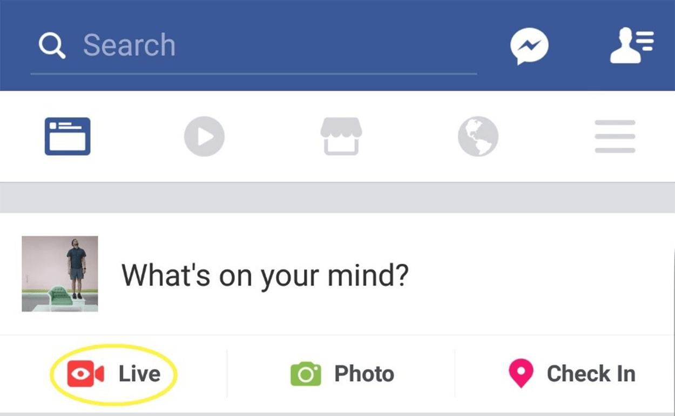

All you have to do is tap the “Live” icon and you’ll be able to start setting up your video – entering a description and selecting what audience can view the broadcast. Your viewing audience will likely be set to “**friends**” by default, but you can change it to “**public**” so your video can be shared widely across Facebook. This will ensure that your story is seen by the widest audience possible. You’ll also be able to view a preview of how the video will look, so you can adjust lighting, backdrop or framing before going live (as seen below).

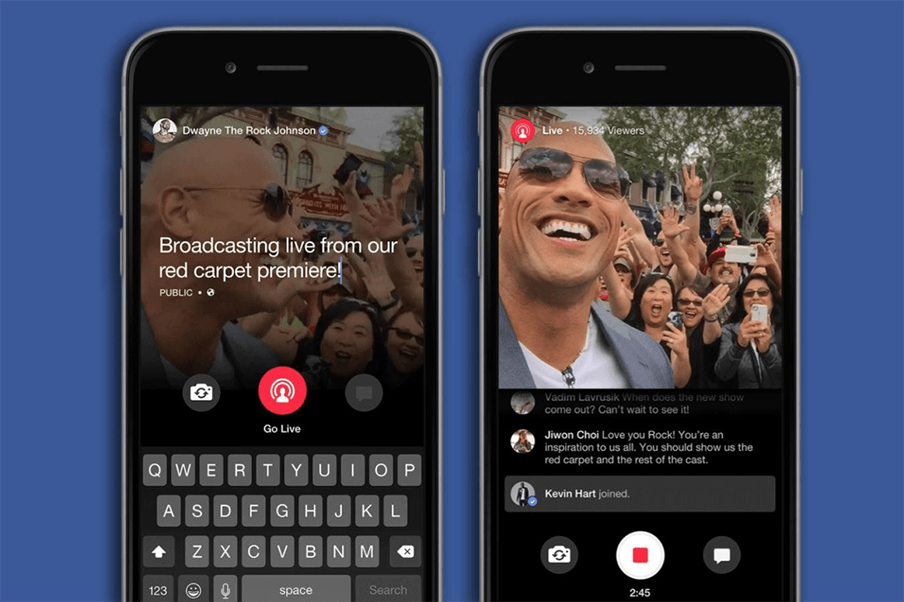

**Setup**

If filming a testimonial direct to camera, make sure your face and any visuals are fully in the frame and well lit. If possible, prop up your phone so you can have your hands free and keep the shot steady. If you’re planning on taking questions or monitoring comments, you should leave that portion of the screen visible.

**Visuals**

Your video will automatically appear and play in your follower’s Facebook feeds, but it will be muted by default. If you want to communicate something to people who may not directly engage with the video, it can help to have some signage or visual that communicates your message even if someone can’t hear. If you’re at an event, try and capture the sense of scale and activity around you.

You can also easily switch over to using the rear camera on your phone by tapping the reverse icon in the lower left-hand side of the screen. This is helpful when wanting to show viewers what you’re looking at, but keep an eye on any incoming questions and comments.

**Questions and Comments**

You will be able to view any comments or questions that come in while you’re streaming. You are under no obligation to engage with them (especially if they are negative) but if appropriate, it can be nice to acknowledge some of the viewers and make the broadcast feel more interactive.

**Archiving**

When you’re ready to conclude your broadcast, you can simply hit the red square button in the middle to end it. Unless you decide otherwise, the broadcast will be archived and offered for viewing on your page shortly after you conclude.

**After your stream: Keep the conversation going**

* Expand the reach of the **#ClimateActionSavesLives** tag by amplifying other voices and engaging with what other people are posting with the hashtag.
* Tweet directly at Administrator Pruitt or your Congressional representative and ask what they’re doing to protect you from the impacts of climate change.

**Other Tips for Recording your Story**

If you won’t be posting a Facebook live, you can still record your story to share on social media (Facebook, Twitter, Instagram, etc.)! Here are some tips for filming your story:

* **Steady hands.** You can film horizontally or vertically but choose one and stick to it throughout the entire video. It can be distracting to the audience to have the screen flip orientation mid-video, and it can make it harder to use the archived video in the future.
* **Practice!** This goes for Facebook live recording as well, but make sure that you’re comfortable with your equipment and have an outline of what you’re going to say before you start so you feel more at ease.
* **Visibility.** If you’re planning to tag your senator (or their office) on Twitter, make sure to put a period before their handle if it’s the first thing in your tweet. This ensures that a wider audience will see your tweet, instead of just your followers who also follow the senator.