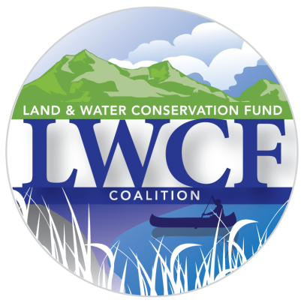**LWCFCoalition.org**

**FOR IMMEDIATE RELEASE:** March 22, 2018

**CONTACT:** Justin Bartolomeo

(202) 789-4365

[jbartolomeo@hdmk.org](mailto:jbartolomeo@hdmk.org)

**Omnibus Increases Funding for LWCF**

***Program’s future still hangs in balance***

WASHINGTON, D.C. – The LWCF Coalition expressed appreciation for the increase in LWCF funding in the Fiscal Year 2018 Omnibus Appropriations Act, representing a win for conservation.  The bipartisan legislation increases spending for the Land and Water Conservation Fund (LWCF) to $425 million in FY18, a $25 million increase from previous-year levels.  The bill contains additional funding for a wildlife conservation account previously derived from LWCF, bringing the effective total to $436 million in land conservation spending.

The funding agreement means that many critical on-the-ground conservation and recreational access projects will receive funding from America’s most important conservation program this year.  More importantly, the agreement represents a bipartisan rejection of the Trump Administration’s proposal to eliminate funding for the LWCF.

Tom Cors, the Director of Government Relations for Land at The Nature Conservancy and a spokesman for the LWCF Coalition commented on the bipartisan funding package:

“The conservation of our National Parks, public lands and outdoor heritage has always been an area of bipartisan agreement, and the omnibus spending bill continues to honor that tradition by investing in the Land and Water Conservation Fund.  The legislation recognizes the vital importance of America’s most important conservation program, which reinvests royalties from offshore energy development into the lasting natural infrastructure of our land, the outdoor recreation economy, access to hunting and angling opportunities, water resources, and the history and culture of our great nation.

“The LWCF Coalition extends its thanks to champions in the House and Senate who led the fight for increased funding for America’s most important conservation program.  We would particularly like to thank the Appropriations Committees for their successful efforts to secure much-needed funding this year.

“It is unfortunate that the reauthorization of LWCF was not included in the bill, despite the efforts of LWCF supporters in the House and Senate. The current authorization for LWCF is set to expire on September 30, putting the program at risk unless Congress acts to save it from extinction. This bipartisan, bicameral priority has overwhelming support in Congress and across the country -- it should be a slam dunk.”

“Our nationwide movement of conservationists, sportsmen, landowners, businesses and outdoor recreation enthusiasts will find every opportunity to work with our champions on the #SaveLWCF campaign until we have secured a long-term future and dedicated funding for America’s most important conservation program. ”

###

**About the Land and Water Conservation Fund**

The Land and Water Conservation Fund is America’s most important conservation program, responsible for protecting parks, wildlife refuges and recreation areas at the federal, state and local level. For over 50 years, it has provided critical funding for land and water conservation projects, recreational infrastructure and activities and the continued historic preservation of our nation’s iconic landmarks from coast to coast.

LWCF does not use any taxpayer dollars – it is funded using a small portion of revenues from offshore oil and gas royalty payments. Outdoor recreation, conservation and historic preservation activities contribute more than a trillion dollars annually to the U.S. economy, supporting 9.4 million jobs.

**About the LWCF Coalition**

The LWCF Coalition is the umbrella group of more than 1,000 small businesses, ranchers, sportsmen, state and local landowners, veterans, outdoor recreationists and conservation organizations working to protect America’s public lands and safeguard our shared outdoor heritage for future generations.

The Coalition is united in its advocacy for the reauthorization and full funding of the Land and Water Conservation Fund, which will ensure the continued conservation of our national parks, forests, wildlife refuges, wilderness and civil war battlefields, as well as state and local parks.

For more information on LWCF and the places in each state that have been protected using LWCF funds, visit [www.lwcfcoalition.org](http://www.lwcfcoalition.org).