**State-Specific CPP Impacts Social Guidance**

CO | ME | MO | MT | NV | OH | PA | VA

**Wide variety of *NEW* graphics** [**available on the Materials Hub**](http://materials.actonclimate.com/search/?q=&search_folder=&tags_include=83&tags_include=436&extensions_include=&extensions_exclude=&published_start=2017-03-14&published_end=) **and** [**the Dropbox**](http://bit.ly/2ockiHT)

**(samples below)**

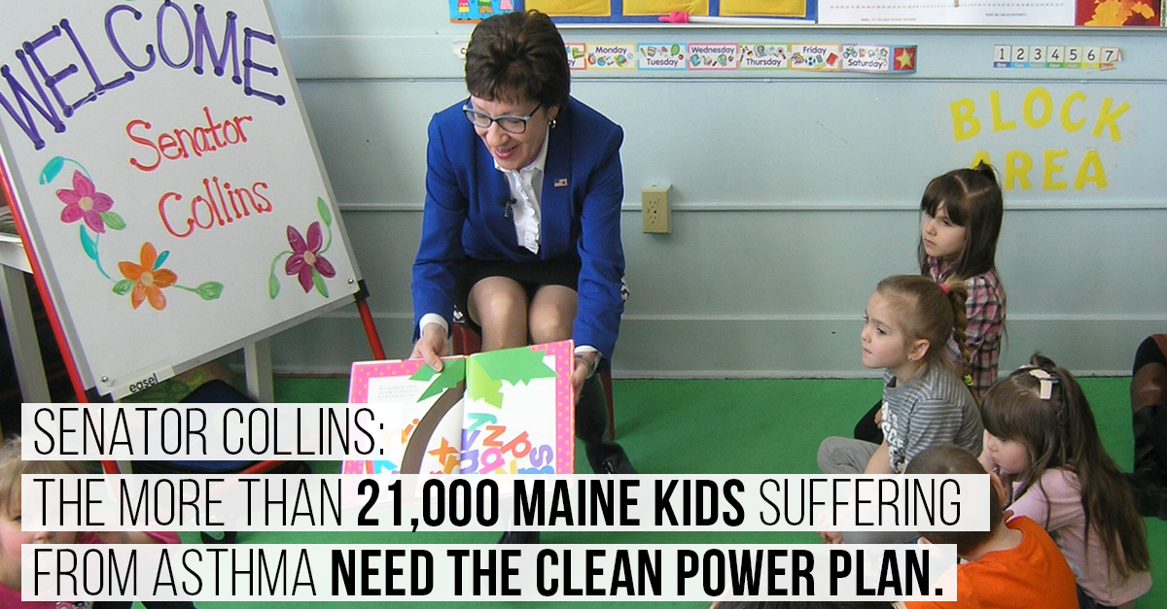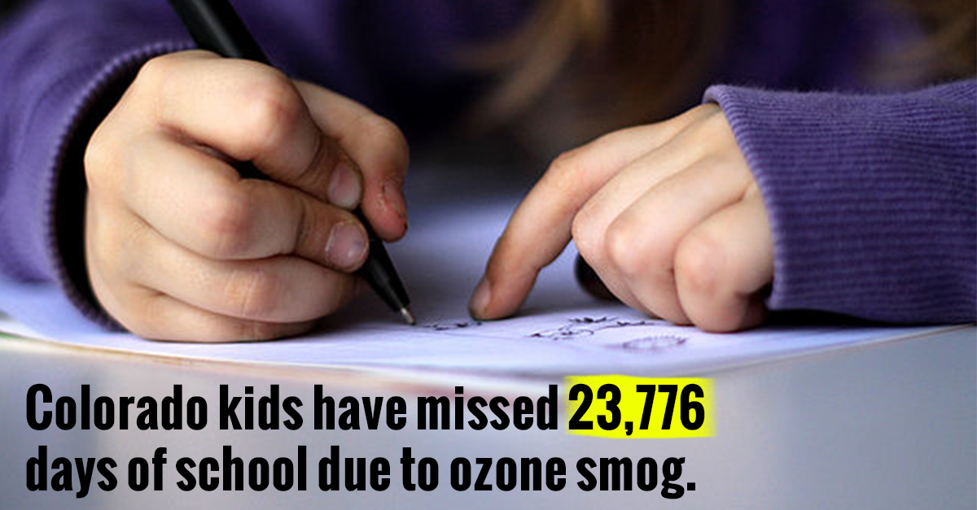

**Colorado**

Senators: Bennet (D) – [@SenBennetCO](https://twitter.com/SenBennetCO) and Gardner (R) – [@SenCoryGardner](https://twitter.com/SenCoryGardner)

**TWITTER:**

* Ozone smog caused more than 32k childhood asthma attacks in CO, [TAG SENATOR]. We need to #ProtectCPP.
* .@POTUS’s attempt to repeal the #CleanPowerPlan puts the 103k Colorado kids with asthma at serious risk.#ProtectCPP
* .@POTUS’s plan to repeal the #CleanPowerPlan IGNORES the thousands of Coloradans with asthma. #ProtectCPP
* .@[TAG Senator], bottom line: the #CleanPowerPlan protects Coloradans. We need you to support these standards. #ProtectCPP
* .@POTUS wants to ignore Coloradans and dismantle the #CleanPowerPlan. We need you to advocate for us, [TAG SENATOR]. #ProtectCPP
* Dismantling the #CleanPowerPlan would leave Coloradans gasping for breath, [TAG SENATOR]. #ProtectCPP
* Ozone smog caused CO kids to miss 23k days of school. We NEED the #CleanPowerPlan, [TAG SENATOR]. #ProtectCPP
* .@SenCoryGardner – it’s CRITICAL that you protect CO kids by speaking up in support of the #CleanPowerPlan. #ProtectCPP
* The #CleanPowerPlan is a historic step toward tackling climate change, [TAG SENATOR]. We can’t afford to go backward. #ProtectCPP
* Coloradans depend on a healthy environment – it’s a way of life. That’s why we need the #CleanPowerPlan, [TAG SENATOR]. #ProtectCPP

**FACEBOOK:**

* Ozone smog has caused more than 32,000 childhood asthma attacks in Colorado, [TAG SENATOR]. We need the #CleanPowerPlan – Trump’s attempts to repeal these lifesaving standards put us at serious risk. #ProtectCPP
* Ozone smog has caused Colorado kids to miss 23,000 days of school. That’s why we need the #CleanPowerPlan, [TAG SENATOR]. #ProtectCPP
* [TAG] Donald Trump’s plan to dismantle the #CleanPowerPlan ignores the thousands of Coloradans suffering from asthma. [TAG SENATOR] – advocate for us by protecting these lifesaving standards. #ProtectCPP
* [TAG] Senator Gardner – it’s CRITICAL that you protect Colorado kids by speaking up in support of the #CleanPowerPlan. #ProtectCPP
* The #CleanPowerPlan is the single biggest step the U.S. has ever taken to combat climate change, [TAG SENATOR]. Coloradans depend on a healthy environment – we can’t afford to go backward. #ProtectCPP

**Maine**

Senators: Collins (R) – [@SenatorCollins](https://twitter.com/SenatorCollins) and King (I) – [@SenAngusKing](https://twitter.com/SenAngusKing)

**TWITTER:**

* .@POTUS’s attempt to repeal the #CleanPowerPlan puts the 21k Maine kids with asthma at serious risk. #ProtectCPP
* .@POTUS’s plan to repeal the #CleanPowerPlan IGNORES the thousands of Mainers with asthma. #ProtectCPP
* .@[TAG Senator], bottom line: the #CleanPowerPlan protects Mainers. We need you to support these standards. #ProtectCPP
* .@POTUS wants to ignore Mainers and dismantle the #CleanPowerPlan. We need you to advocate for us, [TAG SENATOR]. #ProtectCPP
* Dismantling the #CleanPowerPlan would leave Mainers gasping for breath, [TAG SENATOR]. #ProtectCPP
* [TAG SENATOR] – it’s CRITICAL that you protect ME kids by speaking up in support of the #CleanPowerPlan. #ProtectCPP
* The #CleanPowerPlan is a historic step toward tackling climate change, [TAG SENATOR]. We can’t afford to go backward. #ProtectCPP
* Mainers depend on a healthy environment – it’s a way of life. That’s why we need the #CleanPowerPlan, [TAG SENATOR]. #ProtectCPP

**FACEBOOK:**

* Ozone smog has caused almost a thousand childhood asthma attacks in Maine, [TAG SENATOR]. We need the #CleanPowerPlan – Trump’s attempts to repeal these lifesaving standards put us at serious risk. #ProtectCPP
* [TAG] Donald Trump’s plan to dismantle the #CleanPowerPlan ignores the thousands of Mainers suffering from asthma. [TAG SENATOR] – advocate for us by protecting these lifesaving standards. #ProtectCPP
* [TAG] Senator – it’s CRITICAL that you protect Maine kids by speaking up in support of the #CleanPowerPlan. #ProtectCPP
* The #CleanPowerPlan is the single largest step the U.S. has ever taken to combat climate change, [TAG SENATOR]. Mainers depend on a healthy environment – we can’t afford to go backward. #ProtectCPP

**Missouri**

Senators: Blunt (R) – [@RoyBlunt](https://twitter.com/RoyBlunt) and McCaskill (D) – [@Clairecmc](https://twitter.com/clairecmc)

**TWITTER:**

* Ozone smog caused more than 23k childhood asthma attacks in MO, [TAG SENATOR]. We need the #CleanPowerPlan. #ProtectCPP
* .@POTUS’s attempt to repeal the #CleanPowerPlan puts the 99k Missouri kids with asthma at serious risk. #ProtectCPP
* .@POTUS’s plan to repeal the #CleanPowerPlan IGNORES the thousands of Missourians with asthma. #ProtectCPP
* .@[TAG Senator], bottom line: the #CleanPowerPlan protects Missourians. We need you to support these standards. #ProtectCPP
* .@POTUS wants to ignore Missourians and dismantle the #CleanPowerPlan. We need you to advocate for us, [TAG SENATOR]. #ProtectCPP
* Dismantling the #CleanPowerPlan would leave Missourians gasping for breath, [TAG SENATOR]. #ProtectCPP
* Ozone smog caused MO kids to miss 16k days of school. We NEED the #CleanPowerPlan, [TAG SENATOR]. #ProtectCPP
* [TAG SENATOR] – it’s CRITICAL that you protect MO kids by speaking up in support of the #CleanPowerPlan. #ProtectCPP
* The #CleanPowerPlan is a historic step toward tackling climate change, [TAG SENATOR]. We can’t afford to go backward. #ProtectCPP
* Missourians depend on a healthy environment – it’s a way of life. That’s why we need the #CleanPowerPlan, [TAG SENATOR]. #ProtectCPP

**FACEBOOK:**

* Ozone smog has caused more than 23,000 childhood asthma attacks in Missourians, [TAG SENATOR]. We need the #CleanPowerPlan – Trump’s attempts to repeal these lifesaving standards put us at serious risk. #ProtectCPP
* Ozone smog has caused Missouri kids to miss more than 16,000 days of school. That’s why we need the #CleanPowerPlan, [TAG SENATOR]. #ProtectCPP
* [TAG] Donald Trump’s plan to dismantle the #CleanPowerPlan ignores the thousands of Missourians suffering from asthma. [TAG SENATOR] – advocate for us by protecting these lifesaving standards. #ProtectCPP
* [TAG] Senator – it’s CRITICAL that you protect Missouri kids by speaking up in support of the #CleanPowerPlan. #ProtectCPP
* The #CleanPowerPlan is the single biggest step the U.S. has ever taken to combat climate change, [TAG SENATOR]. Missourians depend on a healthy environment – we can’t afford to go backward. #ProtectCPP

**Montana**

Senators: Daines (R) – [@SteveDaines](https://twitter.com/SteveDaines) and Tester (D) – [@SenatorTester](https://twitter.com/SenatorTester)

**TWITTER:**

* .@POTUS’s attempt to repeal the #CleanPowerPlan puts the 6k Montana kids with asthma at serious risk. #ProtectCPP
* .@POTUS’s plan to repeal the #CleanPowerPlan IGNORES the thousands of Montanans with asthma. #ProtectCPP
* .@[TAG Senator], bottom line: the #CleanPowerPlan protects Montanans. We need you to support these standards. #ProtectCPP
* .@POTUS wants to ignore Montanans and dismantle the #CleanPowerPlan. We need you to advocate for us, [TAG SENATOR]. #ProtectCPP
* Dismantling the #CleanPowerPlan would leave Montanans gasping for breath, [TAG SENATOR]. #ProtectCPP
* [TAG SENATOR] – it’s CRITICAL that you protect MT kids by speaking up in support of the #CleanPowerPlan. #ProtectCPP
* The #CleanPowerPlan is a historic step toward tackling climate change, [TAG SENATOR]. We can’t afford to go backward. #ProtectCPP
* Montanans depend on a healthy environment – it’s a way of life. That’s why we need the #CleanPowerPlan, [TAG SENATOR]. #ProtectCPP

**FACEBOOK:**

* [TAG] Donald Trump’s plan to dismantle the #CleanPowerPlan ignores the thousands of Montanans suffering from asthma. [TAG SENATOR] – advocate for us by protecting these lifesaving standards. #ProtectCPP
* [TAG] Senator – it’s CRITICAL that you protect Montana kids by speaking up in support of the #CleanPowerPlan. #ProtectCPP
* The #CleanPowerPlan is the single biggest step the U.S. has ever taken to combat climate change, [TAG SENATOR]. Montanans depend on a healthy environment – we can’t afford to go backward. #ProtectCPP

**Nevada**  
Senators: Cortez Masto (D) – [@SenCortezMasto](https://twitter.com/SenCortezMasto) and Heller (R) – [@SenDeanHeller](https://twitter.com/SenDeanHeller)

**TWITTER:**

* Ozone smog caused more than 1.3k childhood asthma attacks in NV, [TAG SENATOR]. We need the #CleanPowerPlan. #ProtectCPP
* .@POTUS’s attempt to repeal the #CleanPowerPlan puts the 42k Nevada kids with asthma at serious risk. #ProtectCPP
* .@POTUS’s plan to repeal the #CleanPowerPlan IGNORES the thousands of Nevadans with asthma. #ProtectCPP
* .@[TAG Senator], bottom line: the #CleanPowerPlan protects Nevadans. We need you to support these standards. #ProtectCPP
* .@POTUS wants to ignore Nevadans and dismantle the #CleanPowerPlan. We need you to advocate for us, [TAG SENATOR]. #ProtectCPP
* Dismantling the #CleanPowerPlan would leave Nevadans gasping for breath, [TAG SENATOR]. #ProtectCPP
* Ozone smog caused NV kids to miss 989 days of school. We NEED the #CleanPowerPlan, [TAG SENATOR]. #ProtectCPP
* [TAG SENATOR] – it’s CRITICAL that you protect NV kids by speaking up in support of the #CleanPowerPlan. #ProtectCPP
* The #CleanPowerPlan is a historic step toward tackling climate change, [TAG SENATOR]. We can’t afford to go backward. #ProtectCPP
* Nevadans depend on a healthy environment – it’s a way of life. That’s why we need the #CleanPowerPlan, [TAG SENATOR]. #ProtectCPP

**FACEBOOK:**

* Ozone smog has caused more than 1,352 childhood asthma attacks in Nevadans, [TAG SENATOR]. We need the #CleanPowerPlan – Trump’s attempts to repeal these lifesaving standards put us at serious risk. #ProtectCPP
* Ozone smog has caused Nevada kids to miss more than 900 days of school. That’s why we need the #CleanPowerPlan, [TAG SENATOR]. #ProtectCPP
* [TAG] Donald Trump’s plan to dismantle the #CleanPowerPlan ignores the thousands of Nevadans suffering from asthma. [TAG SENATOR] – advocate for us by protecting these lifesaving standards. #ProtectCPP
* [TAG] Senator – it’s CRITICAL that you protect Nevada kids by speaking up in support of the #CleanPowerPlan. #ProtectCPP
* The #CleanPowerPlan is the single biggest step the U.S. has ever taken to combat climate change, [TAG SENATOR]. Nevadans depend on a healthy environment – we can’t afford to go backward. #ProtectCPP

**Ohio**

Senators: Brown (D) – [@SenSherrodBrown](https://twitter.com/SenSherrodBrown) and Portman (R) – [@SenRobPortman](https://twitter.com/senrobportman)

**TWITTER:**

* Ozone smog caused more than 29k childhood asthma attacks in OH, [TAG SENATOR]. We need the #CleanPowerPlan. #ProtectCPP
* .@POTUS’s attempt to repeal the #CleanPowerPlan puts the 213k Ohio kids with asthma at serious risk. #ProtectCPP
* .@POTUS’s plan to repeal the #CleanPowerPlan IGNORES the thousands of Ohioans with asthma. #ProtectCPP
* .@[TAG Senator], bottom line: the #CleanPowerPlan protects Ohioans. We need you to support these standards. #ProtectCPP
* .@POTUS wants to ignore Ohioans and dismantle the #CleanPowerPlan. We need you to advocate for us, [TAG SENATOR]. #ProtectCPP
* Dismantling the #CleanPowerPlan would leave Ohioans gasping for breath, [TAG SENATOR]. #ProtectCPP
* Ozone smog caused OH kids to miss 21k days of school. We NEED the #CleanPowerPlan, [TAG SENATOR]. #ProtectCPP
* [TAG SENATOR] – it’s CRITICAL that you protect OH kids by speaking up in support of the #CleanPowerPlan. #ProtectCPP
* The #CleanPowerPlan is a historic step toward tackling climate change, [TAG SENATOR]. We can’t afford to go backward. #ProtectCPP
* Ohioans depend on a healthy environment – it’s a way of life. That’s why we need the #CleanPowerPlan, [TAG SENATOR]. #ProtectCPP

**FACEBOOK:**

* Ozone smog has caused more than 29,000 childhood asthma attacks in Ohioans, [TAG SENATOR]. We need the #CleanPowerPlan – Trump’s attempts to repeal these lifesaving standards put us at serious risk. #ProtectCPP
* Ozone smog has caused Ohio kids to miss more than 21,000 days of school. That’s why we need the #CleanPowerPlan, [TAG SENATOR]. #ProtectCPP
* [TAG] Donald Trump’s plan to dismantle the #CleanPowerPlan ignores the thousands of Ohioans suffering from asthma. [TAG SENATOR] – advocate for us by protecting these lifesaving standards. #ProtectCPP
* [TAG] Senator – it’s CRITICAL that you protect Ohio kids by speaking up in support of the #CleanPowerPlan. #ProtectCPP
* The #CleanPowerPlan is the single biggest step the U.S. has ever taken to combat climate change, [TAG SENATOR]. Ohioans depend on a healthy environment – we can’t afford to go backward. #ProtectCPP

**Pennsylvania**

Senators: Casey (D) – [@SenBobCasey](https://twitter.com/SenBobCasey) and Toomey (R) – [@SenToomey](https://twitter.com/SenToomey)

**TWITTER:**

* Ozone smog caused more than 30k childhood asthma attacks in PA, [TAG SENATOR]. We need the #CleanPowerPlan. #ProtectCPP
* .@POTUS’s attempt to repeal the #CleanPowerPlan puts the 259k PA kids with asthma at serious risk. #ProtectCPP
* .@POTUS’s plan to repeal the #CleanPowerPlan IGNORES the thousands of Pennsylvanians with asthma. #ProtectCPP
* .@[TAG Senator], bottom line: the #CleanPowerPlan protects Pennsylvanians. We need you to support these standards. #ProtectCPP
* .@POTUS wants to ignore Pennsylvanians and dismantle the #CleanPowerPlan. We need you to advocate for us, [TAG SENATOR]. #ProtectCPP
* Dismantling the #CleanPowerPlan would leave Pennsylvanians gasping for breath, [TAG SENATOR]. #ProtectCPP
* Ozone smog caused PA kids to miss 22k days of school. We NEED the #CleanPowerPlan, [TAG SENATOR]. #ProtectCPP
* [TAG SENATOR] – it’s CRITICAL that you protect PA kids by speaking up in support of the #CleanPowerPlan. #ProtectCPP
* The #CleanPowerPlan is a historic step toward tackling climate change, [TAG SENATOR]. We can’t afford to go backward. #ProtectCPP
* Pennsylvanians depend on a healthy environment – it’s a way of life. That’s why we need the #CleanPowerPlan, [TAG SENATOR]. #ProtectCPP

**FACEBOOK:**

* Ozone smog has caused more than 30,000 childhood asthma attacks in Pennsylvanians, [TAG SENATOR]. We need the #CleanPowerPlan – Trump’s attempts to repeal these lifesaving standards put us at serious risk. #ProtectCPP
* Ozone smog has caused Pennsylvania kids to miss more than 22,000 days of school. That’s why we need the #CleanPowerPlan, [TAG SENATOR]. #ProtectCPP
* [TAG] Donald Trump’s plan to dismantle the #CleanPowerPlan ignores the thousands of Pennsylvanians suffering from asthma. [TAG SENATOR] – advocate for us by protecting these lifesaving standards. #ProtectCPP
* [TAG] Senator – it’s CRITICAL that you protect Pennsylvania kids by speaking up in support of the #CleanPowerPlan. #ProtectCPP
* The #CleanPowerPlan is the single biggest step the U.S. has ever taken to combat climate change, [TAG SENATOR]. Pennsylvanians depend on a healthy environment – we can’t afford to go backward. #ProtectCPP

**Virginia**

Senators: Kaine (D) – [@timkaine](https://twitter.com/timkaine) and Warner (D) – [@MarkWarner](https://twitter.com/MarkWarner)

**TWITTER:**

* Ozone smog caused more than 24k childhood asthma attacks in VA, [TAG SENATOR]. We need the #CleanPowerPlan. #ProtectCPP
* .@POTUS’s attempt to repeal the #CleanPowerPlan puts the 107k Virginia kids with asthma at serious risk. #ProtectCPP
* .@POTUS’s plan to repeal the #CleanPowerPlan IGNORES the thousands of Virginians with asthma. #ProtectCPP
* .@[TAG Senator], bottom line: the #CleanPowerPlan protects Virginians. We need you to support these standards. #ProtectCPP
* .@POTUS wants to ignore Virginians and dismantle the #CleanPowerPlan. We need you to advocate for us, [TAG SENATOR]. #ProtectCPP
* Dismantling the #CleanPowerPlan would leave Virginians gasping for breath, [TAG SENATOR]. #ProtectCPP
* Ozone smog caused VA kids to miss 17k days of school. We NEED the #CleanPowerPlan, [TAG SENATOR]. #ProtectCPP
* [TAG SENATOR] – it’s CRITICAL that you protect VA kids by speaking up in support of the #CleanPowerPlan. #ProtectCPP
* The #CleanPowerPlan is a historic step toward tackling climate change, [TAG SENATOR]. We can’t afford to go backward. #ProtectCPP
* Virginians depend on a healthy environment – it’s a way of life. That’s why we need the #CleanPowerPlan, [TAG SENATOR]. #ProtectCPP

**FACEBOOK:**

* Ozone smog has caused more than 24,000 childhood asthma attacks in Virginians, [TAG SENATOR]. We need the #CleanPowerPlan – Trump’s attempts to repeal these lifesaving standards put us at serious risk. #ProtectCPP
* Ozone smog has caused Virginia kids to miss more than 17,000 days of school. That’s why we need the #CleanPowerPlan, [TAG SENATOR]. #ProtectCPP
* [TAG] Donald Trump’s plan to dismantle the #CleanPowerPlan ignores the thousands of Virginians suffering from asthma. [TAG SENATOR] – advocate for us by protecting these lifesaving standards. #ProtectCPP
* [TAG] Senator – it’s CRITICAL that you protect Virginia kids by speaking up in support of the #CleanPowerPlan. #ProtectCPP
* The #CleanPowerPlan is the single biggest step the U.S. has ever taken to combat climate change, [TAG SENATOR]. Virginians depend on a healthy environment – we can’t afford to go backward. #ProtectCPP