**Clean Power Plan Rollback Materials**

National Social | Impacts on African American Communities | Impacts on Latinx Communities Spanish Translations| Targeted to Pruitt

**Additional resources:**

**Email and Sample Comment Language:** [HERE](http://materials.actonclimate.com/asset/3369/)

**State-specific CPP Job Impacts:** [HERE](https://docs.google.com/document/d/1ShVXMncVgHD7RiDJRLSglJAb4s4xiWZFkWxni-esqBY/edit?usp=sharing)

**High-res Graphics:** [HERE](http://materials.actonclimate.com/search/?q=&search_folder=&tags_include=4&tags_include=83&extensions_include=&extensions_exclude=&published_start=&published_end=)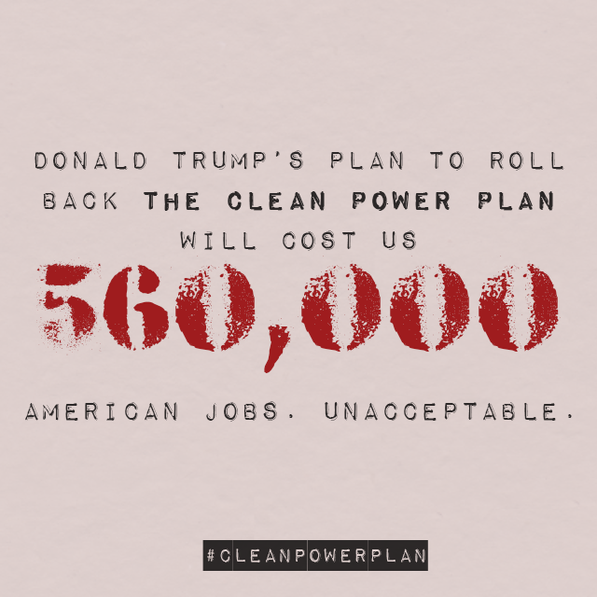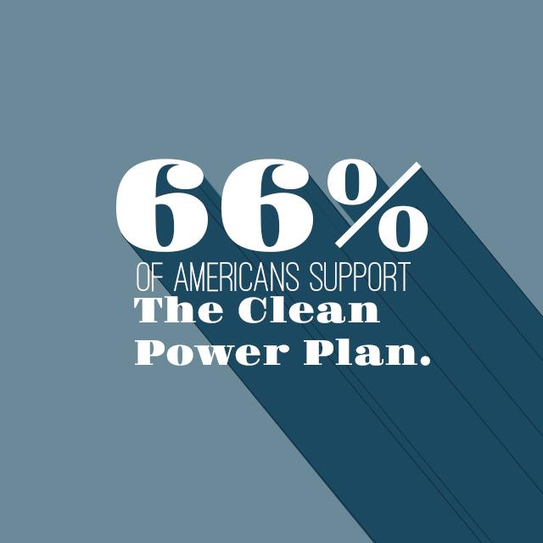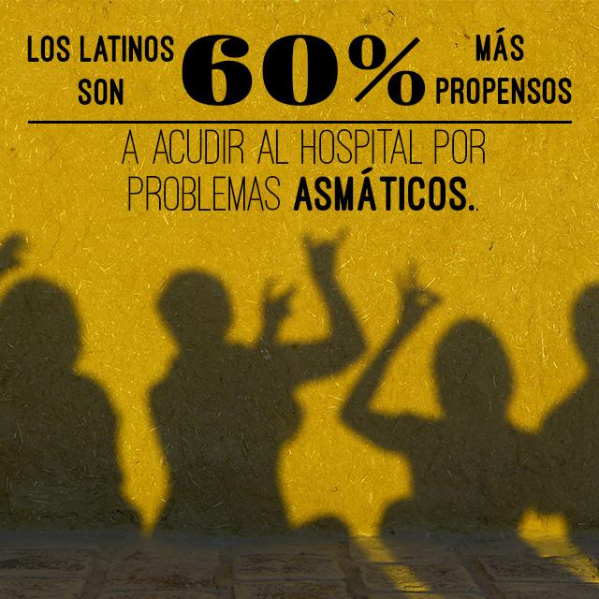

**National Social**

**TWITTER**:

* .@RealDonaldTrump is being reckless. Gutting the #CleanPowerPlan would cost us up to 560k jobs by 2030.#ProtectCPP <https://www.e2.org/wp-content/uploads/2017/06/FINAL-CPP-jobs-report-6.21.17.pdf>
* NEW REPORT: The #CleanPowerPlan would support $52 BILLION in GDP growth by 2030, but @POTUS wants to gut it.#ProtectCPP <https://www.e2.org/wp-content/uploads/2017/06/FINAL-CPP-jobs-report-6.21.17.pdf>
* UNACCEPTABLE: @EPAScottPruitt's willingness to gut the #CleanPowerPlan will could cost us 560,000 American jobs.#ProtectCPP <https://www.e2.org/wp-content/uploads/2017/06/FINAL-CPP-jobs-report-6.21.17.pdf>
* Overturning the #CleanPowerPlan could cause up to 3,600 premature deaths by 2030. So much for making America great again. #ProtectCPP
* .@POTUS’s decision to overturn the #CleanPowerPlan could increase the risk of asthma attacks for our children. #ProtectCPP
* .@POTUS just overturned the #CleanPowerPlan – which could result in 300k missed school and work days by 2030. #ProtectCPP
* .@POTUS just overturned the #CleanPowerPlan – putting our health and climate at serious risk. #ProtectCPP

**FACEBOOK:**

* [TAG] Donald J. Trump’s plan to gut the #CleanPowerPlan could cost us 560,000 American jobs by 2030. He’s ignoring American workers in favor of corporate polluters – and [TAG] Scott Pruitt is complicit.#ProtectCPP <https://www.e2.org/wp-content/uploads/2017/06/FINAL-CPP-jobs-report-6.21.17.pdf>
* NEW REPORT: The #CleanPowerPlan would support $52 BILLION in GDP growth by 2030. By attempting to repeal these lifesaving standards, [TAG] Donald J. Trump is ignoring the chance to create American jobs.#ProtectCPP <https://www.e2.org/wp-content/uploads/2017/06/FINAL-CPP-jobs-report-6.21.17.pdf>
* [TAG] Donald J. Trump would throw away 560,000 jobs supported by the #CleanPowerPlan. That’s more than 4 times the amount reported in the May job growth numbers Trump touted. #ProtectCPP <http://www.politico.com/story/2017/06/02/may-economy-report-jobs-239060>
* [TAG] Donald Trump just overturned the #CleanPowerPlan – which could result in up to 3,600 premature deaths, 90,000 asthma attacks in children, and 300,000 missed work and school days by 2030. #ProtectCPP

**Impacts on** **African American Communities**

**TWITTER:**

* 83% of African Americans support the #CleanPowerPlan – @POTUS’s executive order is out of line. #ProtectCPP <http://www.baltimoresun.com/news/opinion/oped/bs-ed-rggi-wdc-20161006-story.html>
* 1 in 6 black children suffers from asthma, and dismantling the #CleanPowerPlan will make things even worse. #ProtectCPP <http://www.aafa.org/page/burden-of-asthma-on-minorities.aspx>
* 68% of African Americans lived near polluting coal power plants. We NEED the #CleanPowerPlan, @POTUS. #ProtectCPP <http://www.dallasweekly.com/news/national/article_ad6ce6ec-d72c-11e4-8ecd-1337fc769c4c.html>
* .@POTUS’s executive order IGNORES the 68% of African Americans who lived near dangerous coal power plants. #ProtectCPP <http://www.dallasweekly.com/news/national/article_ad6ce6ec-d72c-11e4-8ecd-1337fc769c4c.html>

**FACEBOOK:**

* [TAG] Donald Trump’s attempts to dismantle the #CleanPowerPlan don’t take into account the 83% of African Americans who support these lifesaving pollution standards. We deserve better. #ProtectCPP <http://www.baltimoresun.com/news/opinion/oped/bs-ed-rggi-wdc-20161006-story.html>
* 1 in 6 black children suffers from asthma – [TAG] Donald Trump’s attempts to dismantle the #CleanPowerPlan ignores their need to breathe clean air in favor of lining polluters’ pockets. SAD! #ProtectCPP <http://www.aafa.org/page/burden-of-asthma-on-minorities.aspx>
* Black children are more than 7 times likely to die from asthma attacks than white children, and Trump’s executive order to dismantle the #CleanPowerPlan won’t let them breathe any easier. #ProtectCPP <https://minorityhealth.hhs.gov/omh/browse.aspx?lvl=4&lvlid=15>

**Impacts on Latinx Communities**

**TWITTER:**

* Any attempts to dismantle the #CleanPowerPlan ignores the 70% of Latinos who want aggressive climate action. #ProtectCPP <http://www.huffingtonpost.com/latino-decisions/latino-voters-strongly-op_b_14562028.html>
* UNACCEPTABLE: @POTUS wants to dismantle the #CleanPowerPlan, but he’s ignoring Latinos ready to #ActOnClimate. #ProtectCPP <http://www.huffingtonpost.com/latino-decisions/latino-voters-strongly-op_b_14562028.html>
* .@POTUS’s executive order IGNORES the nearly 2 in 5 Latinos who live within 30 miles of a power plant. #ProtectCPP <http://www.foxnews.com/health/2014/04/24/latinos-three-times-more-likely-to-die-from-asthma-than-other-groups-in-us.html>
* Latinos are 60% more likely to visit the hospital for asthma than white people. We need the #CleanPowerPlan. #ProtectCPP <https://minorityhealth.hhs.gov/omh/browse.aspx?lvl=4&lvlid=60>
* We NEED the #CleanPowerPlan – many Latino farmworkers are at increased risk from extreme heat. #ProtectCPP <https://www.nrdc.org/media/2016/161013>

**FACEBOOK:**

* UNACCEPTABLE: Any attempt to dismantle the #CleanPowerPlan goes against the 70% of Latinos who want aggressive climate action. We cannot be ignored. #ProtectCPP <http://www.huffingtonpost.com/latino-decisions/latino-voters-strongly-op_b_14562028.html>
* Latinos are 60% more likely to visit the hospital for asthma than white people. We need the #CleanPowerPlan, [TAG] Donald Trump – our health is non-negotiable. #ProtectCPP <https://minorityhealth.hhs.gov/omh/browse.aspx?lvl=4&lvlid=60>
* [TAG] Donald Trump – we NEED the #CleanPowerPlan. Many Latino farmworkers are at increased risk from extreme heat made worse by climate change. #ProtectCPP <https://www.nrdc.org/media/2016/161013>

**Spanish Translations**

**TWITTER:**

* Cualquier intento de eliminar el #CleanPowerPlan pasa por el alto que 70% de los latinos están a favor de #AcciónClimática#ProtectCPP <http://www.huffingtonpost.com/latino-decisions/latino-voters-strongly-op_b_14562028.html>
* INACEPTABLE: @POTUS quiere acabar con el #CleanPowerPlan, pero está ignorando que los latinos están listos para tomar #AcciónClimática #ProtectCPP
* La orden ejecutiva de @POTUS IGNORA que 2 de cada 5 latinos viven a 30 millas de una planta eléctrica de carbón.#ProtectCPP <http://www.foxnews.com/health/2014/04/24/latinos-three-times-more-likely-to-die-from-asthma-than-other-groups-in-us.html>
* Los latinos son 60% + propensos a visitar el hospital x asma que las personas blancas. Necesitamos el #CleanPowerPlan#ProtectCPP <https://minorityhealth.hhs.gov/omh/browse.aspx?lvl=4&lvlid=60>
* NECESITAMOS el #CleanPowerPlan porque muchos agricultores latinos están en peligro#ProtectCPP <https://www.nrdc.org/media/2016/161013>
* Revocar el #CleanPowerPlan causaría + de 3,600 muertes prematuras anuales para el 2030. ¿Y así lograremos que el país sea grande nuevamente? #ProtectCPP
* .@POTUS acaba de revocar el #CleanPowerPlan, poniendo en serio peligro la salud pública y el medio ambiente. #ProtectCPP

**FACEBOOK:**

* INACEPTABLE: Cualquier intento de revocar el #CleanPowerPlan es una movida en contra del 70% de los latinos que quieren fuertes acciones climáticas. Nosotros no podemos ser ignorados.#ProtectCPP <http://www.huffingtonpost.com/latino-decisions/latino-voters-strongly-op_b_14562028.html>
* Latinos son 60% más propensos a visitar el hospital por asma que una persona blanca. [TAG] Donald Trump, necesitamos el #CleanPowerPlan. ¡Nuestra salud no es negociable!#ProtectCPP <https://minorityhealth.hhs.gov/omh/browse.aspx?lvl=4&lvlid=60>
* [TAG] Donald Trump — NECESITAMOS el #CleanPowerPlan. Muchos agricultores latinos están en peligro debido a condiciones climatológicas extremas provocadas por el cambio climático. #ProtectCPP
* [TAG] Donald Trump acaba de revocar el #CleanPowerPlan, lo que resultaría en 3,600 muertes prematuras, 90,000 ataques de asma infantil y 300,000 días escolares perdidos para el año 2030. #ProtectCPP

**Targeted to Pruitt**

Suggested Graphics **(**[**Available on Materials Hub**](http://materials.actonclimate.com/search/?q=&search_folder=&tags_include=4&tags_include=5&tags_include=340&tags_include=522&extensions_include=&extensions_exclude=&published_start=2017-06-20&published_end=)**)**

**TWITTER**:

* .@EPAScottPruitt can fight against the #CleanPowerPlan, but he “won’t be able to undo the duty to act.” #ProtectCPP <http://bit.ly/2sTYbs2>
* Any move to dismantle the #CleanPowerPlan is a direct assault on our health and environment. #PollutingPruitt#ProtectCPP <http://bit.ly/2sTYbs2>
* .@EPAScottPruitt has made a career of attacking the #CleanPowerPlan – he’ll cost us our health. #PollutingPruitt #ProtectCPP <http://bit.ly/2sTYbs2>

**FACEBOOK**:

* [TAG] Scott Pruitt has made a career of fighting the #CleanPowerPlan, but the EPA has “the duty to act” on climate change. #PollutingPruitt #ProtectCPP <http://bit.ly/2sTYbs2>
* [TAG] Scott Pruitt built his career on attacking environmental safeguards instead of protecting his constituents. Any move to dismantle the #CleanPowerPlan is a direct assault on our health and environment. #PollutingPruitt #ProtectCPP <http://bit.ly/2sTYbs2>