## BOOT PRUITT CAMPAIGN LAUNCH

Today, the Boot Pruitt Campaign launched. With a diverse coalition of 11 progressive and environmental groups, this multidimensional national advocacy campaign will demonstrate why **EPA** **Administrator Scott Pruitt’s toxic tenure at the EPA must end**. His dirty dealings and reckless rollbacks have exploited and endangered Americans. He's under multiple investigations for serious ethics violations and shown a penchant for luxury travel on the taxpayers’ dime. He is unfit for public office.

**The campaign website, BootPruitt.com, and Twitter account, @BootPruitt, are now live.** The launch has garnered earned media in the *Washington Post*, *Politico*, *The Hill*, *Mother Jones*, *E&E News* and the Spanish language outlet *EFE*. Even conservative media like *Newsmax* are covering the launch. The day was capped by a *Washington Post* op-ed from John Podesta; other opinion pieces from campaign leaders will continue to run in national outlets in the coming weeks.

Finally, conservative voices like Steve Malloy engaged early, but were overwhelmed by the support. Notably, **15 Members of Congress tweeted about Scott Pruitt’s dirty dealings and Boot Pruitt**. This included House E&C Ranking Member [Frank Pallone](https://twitter.com/FrankPallone/status/979088641103421445), [Raul Grijalva](https://twitter.com/RepRaulGrijalva/status/979021617878585349), [Bobby Rush](https://twitter.com/RepBobbyRush/status/979040571703681026), [Ted Lieu](https://twitter.com/RepTedLieu/status/979047346481844224), [Barbara Lee](https://twitter.com/RepBarbaraLee/status/979024819638370306) and [Paul Tonko](https://twitter.com/RepPaulTonko/status/979069062184566784), with several retweets from House E&C Dems.

The drive to #BootPruitt has begun.

## THE WEBSITE

The #BootPruitt website launched today and has had **5,456 users as of 3 PM**. That includes new, returning, and unique visitors to the website.

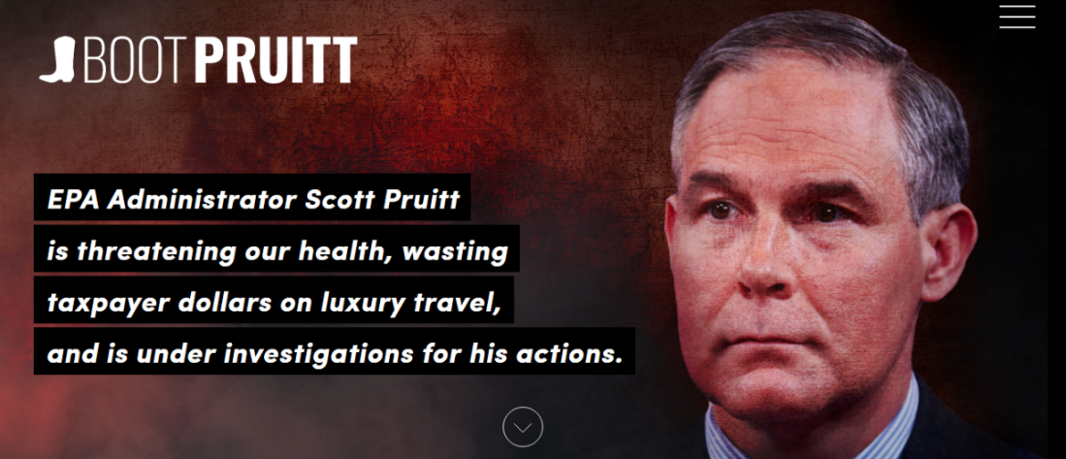



## TV ADVERTISEMENTS (SIERRA CLUB)

Sierra Club began airing a [TV ad](https://www.youtube.com/watch?v=D9dYLiCujaY&feature=youtu.be) on Fox and Friends and Morning Joe calling for Trump to fire Environmental Protection Agency administrator Scott Pruitt. The ads will air on Wednesday, Thursday and Friday this week. Press release [here](https://www.sierraclub.org/press-releases/2018/03/sierra-club-launches-tv-ad-calling-for-trump-boot-pruitt#.WruL9BGPiRA.twitter).

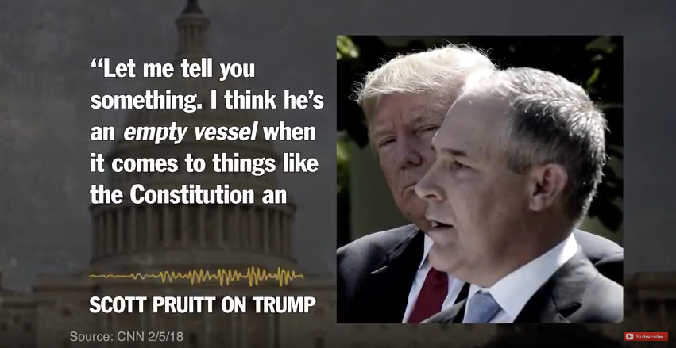

## HOMEPAGE TAKEOVERS AND TWITTER ADS (DEFEND OUR FUTURE)

Defend Our Future sponsored a six-figure digital ad buy around the launch of BootPruitt.com with homepage takeovers in *The Hill*, *Roll Call*, and *Politico*, as well as Twitter ads targeting DC insiders and policymakers that has so far **40k impressions** and **1,610 engagements**, including **938 clicks** and **318 retweets**.



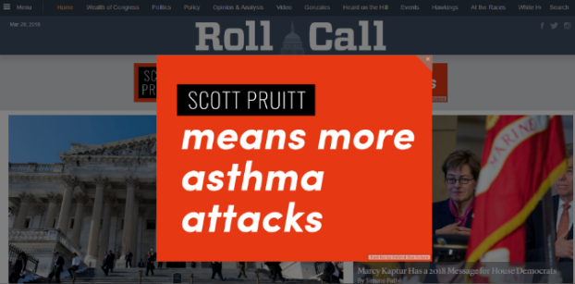



## EARNED MEDIA GENERATED

[**Washington Post**](https://www.washingtonpost.com/opinions/scott-pruitt-needs-to-go/2018/03/28/8984cd26-32a0-11e8-8bdd-cdb33a5eef83_story.html?utm_term=.98e1ab87a804)**: Podesta: Scott Pruitt needs to go**

The mission of the Environmental Protection Agency has always been to protect human health and the environment. But since taking the helm just over a year ago, EPA Administrator Scott Pruitt has made no secret that his personal mission is to do the opposite.

[**Washington Post**](https://www.washingtonpost.com/news/powerpost/paloma/the-energy-202/2018/03/28/the-energy-202-epa-chief-fires-back-on-flight-costs-as-bootpruitt-campaign-revs-up/5abaa98b30fb042a378a2eb5/?utm_term=.84591c39928c)**: The Energy 202: EPA chief fires back on flight costs as #BootPruitt campaign revs up**

Environmental Protection Agency chief Scott Pruitt flew through a storm of criticism over his use of first-class flights in the last month. Now Pruitt has emerged to throw some lightning bolts of his own. In radio interviews over the past week, Pruitt has pushed back against criticism from environmentalists and Democrats that he is spending too much on travel.

[**The Hill**](http://thehill.com/policy/energy-environment/380551-greens-launch-campaign-to-get-pruitt-fired)**: Greens launch campaign to get Pruitt fired**

A coalition of environmental groups is teaming up for a multi-pronged campaign to try to get Environmental Protection Agency (EPA) head Scott Pruitt fired or to resign. The groups, including the Sierra Club, Green For All and Center For American Progress Action, are dubbing its campaign “Boot Pruitt.”

[**Politico**](https://www.politico.com/morningenergy/)**: Morning Energy: GREENS TRY TO GET TRUMP'S ATTENTION**

Environmental and progressive advocates today launch a campaign to unseat Pruitt, with ads aimed right at President Donald Trump. The Sierra Club is running “Boot Pruitt” spots through Friday on "Fox & Friends" and "Morning Joe," shows watched by the president.

[**EFE Newswire**](http://www.eleconomistaamerica.com/medio-ambiente-eAm/noticias/9037203/03/18/Diez-grupos-ecologistas-piden-la-renuncia-del-jefe-de-Medioambiente-de-EEUU.html)**: Diez grupos ecologistas piden la renuncia del jefe de Medioambiente de EE.UU.**

Diez grupos ecologistas de Estados Unidos iniciaron hoy una campaña para forzar la renuncia del administrador de la Agencia de Protección Medioambiental (EPA), Scott Pruitt, un escéptico del cambio climático que está siendo investigado por malgastar fondos públicos.

[**St. Louis Dispatch**](http://www.stltoday.com/business/local/epa-chief-fires-back-on-flight-costs-as-bootpruitt-campaign/article_c68d2270-b6dc-5b9f-a897-572f38bb8fd9.html) **(reprinted from the Washington Post): EPA chief fires back on flight costs as #BootPruitt campaign revs up**

Environmental Protection Agency chief Scott Pruitt flew through a storm of criticism over his use of first-class flights in the last month. Now Pruitt has emerged to throw some lightning bolts of his own.

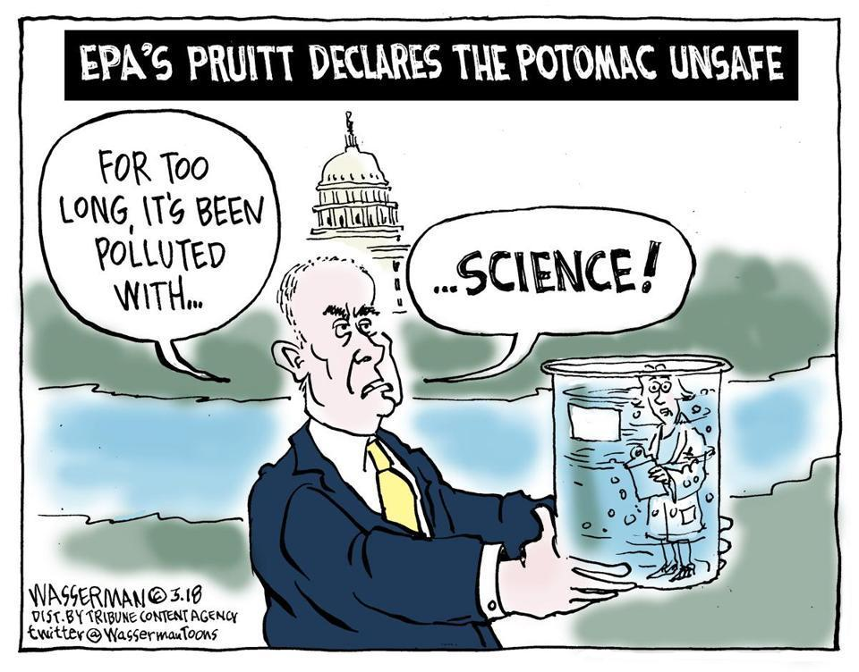[**Boston Globe**](https://www.bostonglobe.com/opinion/2018/03/28/scott-pruitt-takes-pollution-washington/7OJeCWwG3swM9Z4SJoGu5K/story.html)**: Scott Pruitt takes on pollution in Washington (cartoon)**

**E&E****: Pruitt foes buy ad time during Trump's favorite TV shows**

Environmental groups are taking their campaign to force U.S. EPA Administrator Scott Pruitt from office to a new domain: President Trump's television screen. Ten green organizations have banded together to a launch a new effort aimed at removing Pruitt. The "Boot Pruitt" campaign begins today with the Sierra Club running television ads on what are considered Trump's favorite morning shows, Fox News' "Fox & Friends" and MSNBC's "Morning Joe."

[**el Economista America**](http://www.eleconomistaamerica.com/medio-ambiente-eAm/noticias/9037203/03/18/Diez-grupos-ecologistas-piden-la-renuncia-del-jefe-de-Medioambiente-de-EEUU.html)**: Diez grupos ecologistas piden la renuncia del jefe de Medioambiente de EE.UU.**

Diez grupos ecologistas de Estados Unidos iniciaron hoy una campaña para forzar la renuncia del administrador de la Agencia de Protección Medioambiental (EPA), Scott Pruitt, un escéptico del cambio climático que está siendo investigado por malgastar fondos públicos.

[**Prensa Latina**](http://prensa-latina.cu/index.php?o=rn&id=163717&SEO=grupos-ecologistas-de-ee.uu.-buscan-echar-al-jefe-de-la-epa)**: Grupos ecologistas de EE.UU. buscan echar al jefe de la EPA**

Una coalición de grupos ecologistas de Estados Unidos comenzará hoy el lanzamiento de comerciales y anuncios como parte de una campaña que busca sacar del puesto al jefe de la Agencia de Protección Ambiental (EPA), Scott Pruitt.La iniciativa, bautizada como Boot Pruitt (Echar a Pruitt) incluye a organizaciones como Sierra Club, Green For All y Center for American Progress Action, precisó el portal digital The Hill.

[**Mother Jones**](https://www.motherjones.com/environment/2018/03/scott-pruitts-dirty-dealings-stir-a-campaign-to-oust-him-from-the-epa/)**: Scott Pruitt’s “Dirty Dealings” Stir a Campaign to Oust Him From the EPA**

A coalition of 10 progressive and environmental groups are launching a campaign Wednesday saying President Donald Trump’s EPA Administrator Scott Pruitt needs to go. The campaign, which is spearheaded by the Sierra Club, the Natural Resources Defense Council, Green Latinos, Defend Our Future, Hip Hop Caucus, and others, includes many of the groups that have been out front protesting Pruitt and the Trump administration.

[**Newsmax**](https://www.newsmax.com/politics/epa-scott-pruitt-travel-criticism-campaign/2018/03/28/id/851254/)**: EPA's Pruitt 'Dumbfounded' by Travel Criticism Amid Campaign**

Environment Protection Agency (EPA) head Scott Pruitt is firing back against criticism of his travel habits, saying he's "dumbfounded" by the attacks and calling the reports "gratuitous" amid a growing campaign to get him ousted, The Washington Post reports

[**The Western Journal**](https://www.westernjournal.com/climate-activists-try-strange-tactic-to-push-trump-to-boot-epas-scott-pruitt/)**: Climate Activists Try Strange Tactic To Push Trump To ‘Boot’ EPA’s Scott Pruitt**

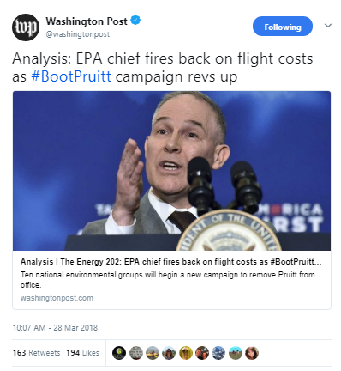Environmentalists have launched their latest attempt to get Environmental Protection Agency Administrator Scott Pruitt fired, buying air time on cable news shows President Donald Trump is known to watch.The Sierra Club aired a TV ad on MSNBC’s “Morning Joe” and Fox News’ “Fox & Friends.”

## SOCIAL MEDIA

#BootPruitt held the **#1 trending spot for Washington, DC** on Twitter for several hours, and it’s still on the trending topics list as of 5 PM. We have also counted **over 7,500 #BootPruitt Twitter mentions** as of 5 PM. @BootPruitt gained **over 100 new followers**, and over **1,000 people signed onto the petition**, largely from partners promoting it in tweets. Additionally, we saw a host of notable tweets. Representatives [Grijalva](https://twitter.com/RepRaulGrijalva/status/979021617878585349), [Lee](https://twitter.com/RepBarbaraLee/status/979024819638370306), [Lieu](https://twitter.com/RepTedLieu/status/979047346481844224), [Brown](https://twitter.com/RepAnthonyBrown/status/979058932676251648), [Quigley](https://twitter.com/RepMikeQuigley/status/979059501100949504), and [Sarbanes](https://twitter.com/RepSarbanes/status/979042905842159616) all asked for Pruitt's resignation and the [*Washington Post*](https://twitter.com/washingtonpost/status/978997101236498432) used the hashtag from their main account.

## ALLIES ON THE HILL

Nine members of Congress and House of Representatives [Sustainable Energy & Environment Coalition (SEEC)](https://twitter.com/SEEC/status/979035085956624384) tweeted today that it’s time to #BootPruitt:

[**Rep. Frank Pallone (NJ-6)**](https://twitter.com/FrankPallone/status/979088641103421445): FACT: @EPAScottPruitt is currently under THREE separate investigations. He needs to be held accountable for his failures at @EPA.

[**Rep. Alma Adams**](https://twitter.com/RepAdams/status/979081375641931777) **(NC-12)**: .@EPAScottPruitt has proposed drastic budget cuts @EPA programs that protect Americans’ health – all while wasting $$$ on luxury & paranoid privacy measures. It’s time for answers. #BootPruitt

[**Rep. Earl Blumenauer (OR-3)**](https://twitter.com/repblumenauer/status/979084863742660611): EPA Administrator Scott Pruitt has to go. He has failed to protect your health, failed to safeguard the environment, and failed to follow the law. He is unfit to lead the EPA. #BootPruitt

[**Rep. Barabra Lee (CA-13)**](https://twitter.com/RepBarbaraLee/status/979024819638370306): As EPA Administrator, Scott Pruitt has undermined climate and public health protections, jeopardized the health of communities of color, and wasted taxpayer $$ on luxury travel. It’s time to #BootPruitt #LetusBreathe

[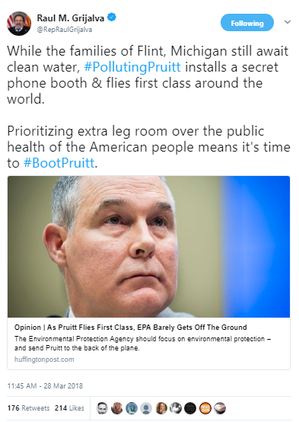](https://twitter.com/RepRaulGrijalva/status/979021617878585349)

[**Rep. David Price (NC-4)**](https://twitter.com/RepDavidEPrice/status/979078327184084994): From misusing taxpayer dollars, to violating lobbying laws, to denying the impact of climate change, Scott Pruitt has put his own toxic agenda above his agency's mission to protect public health and the environment. It's time to #BootPruitt

[**Rep. Raul Grijalva (AZ-3)**](https://twitter.com/RepBarbaraLee/status/979024819638370306): While the families of Flint, Michigan still await clean water, #PollutingPruitt installs a secret phone booth & flies first class around the world. Prioritizing extra leg room over the public health of the American people means it's time to #BootPruitt.

[**Rep. John Sarbanes (CA-3)**](https://twitter.com/RepBarbaraLee/status/979024819638370306): @EPAScottPruitt’s tenure: ✅ Fundraisers with Big Oil and Gas. ✅ Secret meetings with political donors. ✅ Hiding the science. ✅ Blocking efforts to protect public health. ✅ First-class flights on the taxpayer’s dime. ✅ Under federal investigation. It’s time to #BootPruitt

[**Rep. Ted Lieu (CA-33)**](https://twitter.com/RepBarbaraLee/status/979024819638370306): Since taking office, @EPAScottPruitt has put the health of California at risk every day with his toxic agenda. Enough is enough – it’s time for him to go. #BootPruitt

[**Rep. Mike Quigley (IL-5)**](https://twitter.com/RepBarbaraLee/status/979024819638370306): We have a moral obligation to ensure future generations have access to #cleanair #cleanwater and a safe, stable #climate. It’s time to #BootPruitt so that @EPA can get back to protecting all Americans, not shielding the Administration’s polluting friends.

[**Rep. Anthony Brown (MD-4)**](https://twitter.com/RepBarbaraLee/status/979024819638370306): .@EPAScottPruitt wants to roll back vehicle greenhouse gas standards, paying no mind to how dirty air impacts the 25 million Americans who have asthma - 6 million of whom are children - or how this rollback will cost Americans more at the pump. It's time to #BootPruitt