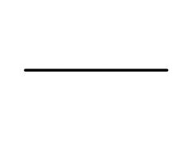**CONGRESSIONAL BRIEFING**

**EPA Phase I: Proposed Rule to Weaken Coal Ash Disposal Regulations**

Wednesday, April 25th

Room 485 Russell Senate Office Building

11:00 AM

Join a congressional briefing to hear stories of impacted citizens living with coal ash pollution and a deep dive by experts on how the new proposed rule will govern the disposal of coal ash across the country. Please RSVP by April 23rd through [this form](https://docs.google.com/forms/d/e/1FAIpQLSdvDp4rlp47c_20qwo18T3bBHXPtN-rdIlRq5PIDfhzh5kb0g/viewform?usp=sf_link).

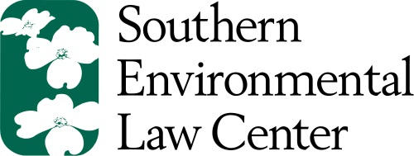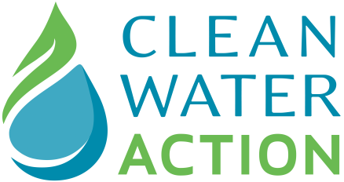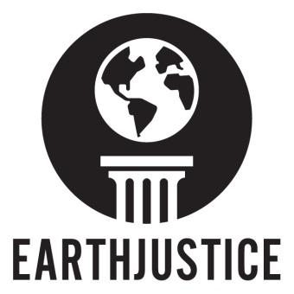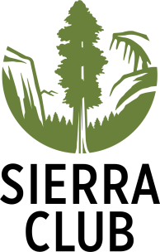Sponsoring Organizations: