

**Fact Sheet**

Use of National Defense bill to undermine protections for whales

## *Summary of Navy proposal*

The U.S. Navy has proposed eliminating a core provision of the Marine Mammal Protection Act (MMPA), the statute that has conserved the country’s whales, dolphins and other species for forty-five years. If amended, the law would no longer require the Defense Department to periodically undergo environmental review and permitting for the harm its training activities cause marine mammals. Instead, the permits it obtains could last indefinitely, undermining a process that is intended to ensure continued oversight over uniquely vulnerable species.

Under the MMPA, the Defense Department already has a renewable, two-year exemption that it can invoke at any time for national security. The Navy proposal, which would be added to the National Defense Authorization Act, does not affect military readiness, but is an attempt to reduce the Navy’s environmental compliance effort.

## *What would the Navy’s proposal do?*

* **The proposal would curtail review for species that require consistent oversight.**

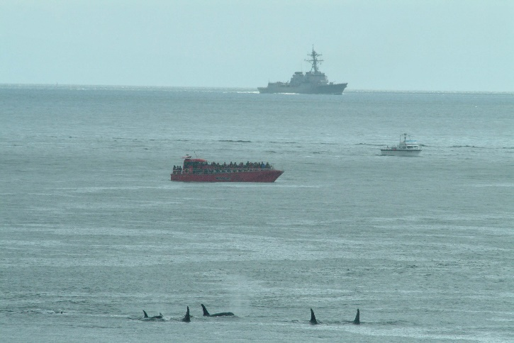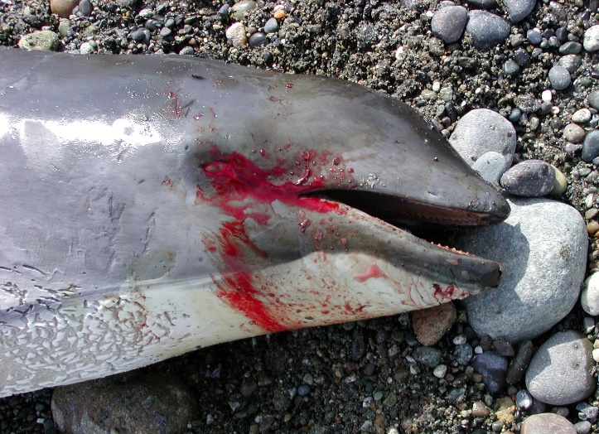

A Navy sonar exercise off Washington State (a) causes endangered southern resident orcas to cluster in the shallows, and (b) is associated with a spate of harbor porpoise strandings.

(a)

(b)

As Congress recognized in enacting the MMPA, marine mammals are extraordinarily difficult to monitor in the wild, to the point where they may suffer grievous harm before we are able to detect it. Indeed, a 2007 NOAA study concluded that we are unlikely to detect even a catastrophic collapse for most of the marine mammal populations off our coasts. For this reason, the law requires that the Defense Department, and others whose activities harm marine mammals, obtain authorization from the wildlife agencies at intervals no greater than every five years. The Navy’s proposal would undermine this critical safeguard, which is aimed at preventing these vulnerable, iconic species from becoming threatened or endangered.

Notably, the Navy claims that its proposal would put the MMPA in line with the Endangered Species Act, which does not set time limits on permits. Yet the Endangered Species Act, consistent with its focus on individual species, provides other safeguards for the species it covers—including a thorough review of each species’ progress towards recovery every five years. The Navy’s proposal would eliminate the analogous five-year review that Congress established in the activity-focused MMPA.

* **The proposal would undermine marine mammal conservation in every region of the United States.** Off the east coast, from New England to the Gulf of Mexico, the Navy is currently authorized to use some 50,000 hours of high-intensity active sonar—which is harmful to marine mammals—and detonate some 50,000 explosives underwater each year. Similar levels of training and testing activity take place off So. California and Hawaii; and additional training occurs off the Pacific Northwest, from California to Washington, and in the Gulf of Alaska.

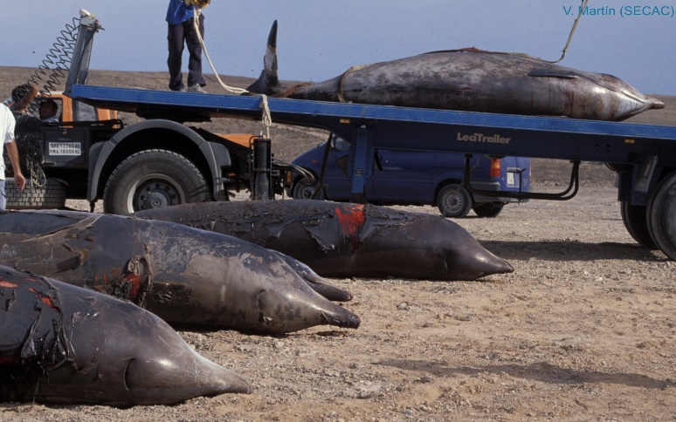

Beaked whales killed in a mass stranding caused by a Navy sonar exercise.

During its most recent 5-year cycle, the Navy estimated that it would kill more than 250 whales and other marine mammals; cause permanent injury, including lung and hearing damage, in another 3,000; and disrupt foraging and other vital behavior, to the point of having significant biological effects in whales and other species, more than 30 million times. Eliminating periodic review and permitting risks the health of marine mammal populations in every region of the country, and the Navy’s proposal does so at a moment when several marine mammal populations*—including the southern resident orcas off Washington State and the North Atlantic right whales off New England*—are in serious decline.

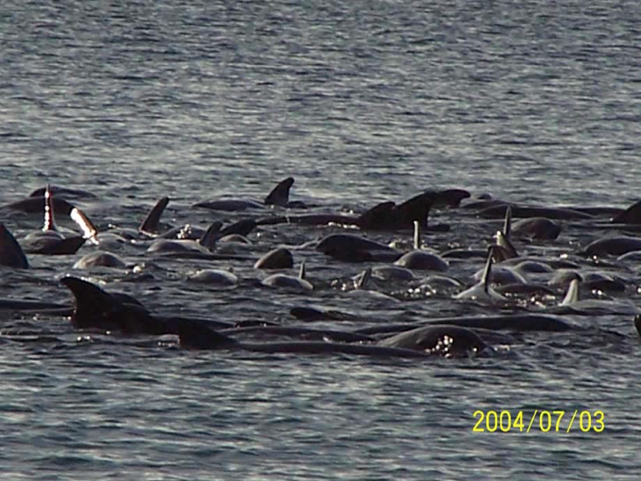

Some of the 150-200 melon-headed whales trapped in Hanalei Bay, Hawaii, during the Navy’s Rim of the Pacific (RIMPAC) exercise.

* **The proposal would remove the main driver for critical conservation monitoring and research.** Since 2006, the Navy has funded an “Integrated Comprehensive Monitoring Program” for marine mammals on its training ranges, off every region of the country, in order to meet its permitting responsibilities under the Marine Mammal Protection Act. This work is essential to ensure the health of marine mammal populations that are harmed by the Navy’s constant activity, and to develop new means of mitigating the effects of the Navy’s actions. In ending the permitting process, the Navy would eliminate the primary driver of its monitoring program and with it the ability to detect and minimize marine mammal impacts.
* **The proposal would not address any problem related to military readiness, however, because the MMPA does not affect military readiness.** NOAA has never denied the Defense Department an MMPA permit to harm marine mammals while conducting military readiness activities; even so, the statute affords the Department a renewable two-year exemption, to be invoked as needed for national security. Moreover, the MMPA limits mitigation of Defense Department activities to what is practicable, taking into account personnel safety, practicability of implementation, and effect on military readiness. There is no question that the Navy’s proposal would curtail an important safeguard for marine mammals; it would not solve any problem related to national defense.

## *Contact Information*

Lara Levison, Senior Director, Federal Policy, Oceana: [llevison@oceana.org](mailto:llevison@oceana.org)

Nora Apter, Legislative Advocate, Natural Resources Defense Council: [napter@nrdc.org](mailto:napter@nrdc.org)

Michael Harris, Government Relations Associate, Defenders of Wildlife: [mharris@defenders.org](mailto:mharris@defenders.org)

CT Harry, Marine Campaigner, International Fund for Animal Welfare: [charry@ifaw.org](mailto:charry@ifaw.org)

Keisha Sedlacek, Senior Regulatory Specialist, HSUS and HSLF: [ksedlacek@hlsf.org](mailto:ksedlacek@hlsf.org)