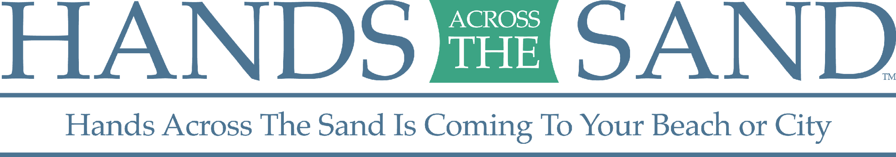

**FOR IMMEDIATE RELEASE**

May 15, 2018

**\*\*\*\*\*\*\* MEDIA ADVISORY \*\*\*\*\*\*\***

**“HANDS ACROSS THE SAND/LAND” PROTESTS SLATED FOR 113 LOCATIONS WORLDWIDE ON MAY 19TH**

***Communities standing up against offshore drilling in 17 states and seven countries***

**WHO:** International, national and local conservation groups are organizing local protests against offshore drilling in the waters off the East Coast, West Coast, Gulf of Mexico and Alaska. The groups include: Oceana, Surfrider Foundation, Southern Alliance for Clean Energy, Sierra Club, Earth Ethics, Center for Biological Diversity, Natural Resources Defense Council, Another Gulf is Possible, Redfin and Gulf Restoration Network. For more information, go to [www.handsacrossthesands.org](http://www.handsacrossthesands.org).

**WHAT:** Crowds will join hands forming lines across beaches, parks and state capitol steps in synchronized "Hands Across the Sand/Land" protests. This includes**113 synchronized events across 17 states and seven countries** to raise awareness about the dangers of dirty fuels and the need to accelerate the transition to available, affordable clean energy solutions. The show of opposition is particularly important this year, given the Trump Administration’s draft plan to expand offshore drilling to nearly all of the American coastline and its assault on public lands.

**WHEN: Saturday, May 19th at noon local time** (media check in at 11:30 am local time).

**WHERE:** Across 17 states and seven countries, groups will hold 113 synchronized events. For a full list of events visit: <http://www.handsacrossthesand.com/>

**WHY:** Drilling offshore is investing in a dirty energy past, instead of a green energy future. It also conflicts with international agreements to fight climate change. The impacts of dirty and dangerous offshore drilling threaten people across the world. Hands Across the Sand participants will urge more local elected officials to formally oppose the Trump administration’s draft plan to expand offshore drilling and to take a stronger stand against the expansion of offshore drilling along the coast.

**\*\*\*VISUALS** WILL INCLUDE A LARGE GROUP OF CITIZENS JOINING HANDS AT EVENT LOCATIONS, SIGNS, ETC

**\*\* INTERVIEW AND PHOTO/ VIDEO OPPORTUNITIES AVAILABLE\*\***

**MEDIA CONTACT:** Alex Frank, (703) 276-3264, [afrank@hastingsgroup.com](mailto:afrank@hastingsgroup.com)

###

Floridian Dave Rauschkolb founded Hands Across the Sand/Land in October 2009. Hands Across the Sand/Land is sponsored by national environmental organizations including Oceana, Surfrider Foundation, Southern Alliance for Clean Energy, Sierra Club, Earth Ethics, Center for Biological Diversity, Another Gulf is Possible, Redfin and Gulf Restoration Network.