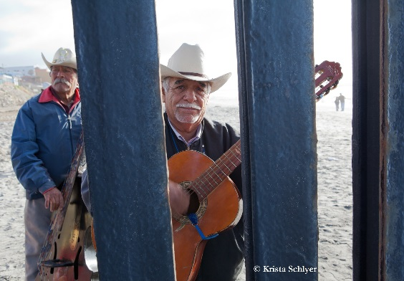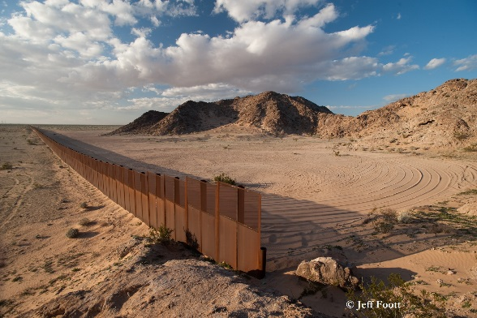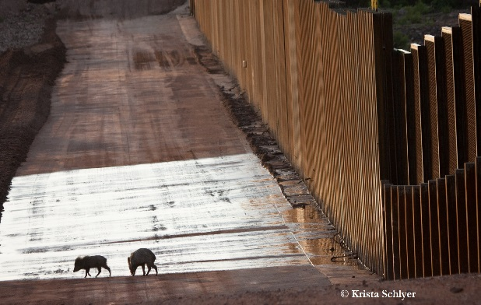

***Continental Divide: Wildlife, People, and the Border Wall***

**Reception & Photography Exhibit on Tuesday, June 12, 2018**

**With Conservation Photographer Krista Schlyer**

**Honorary Co-Host:**

**U.S. Senator Martin Heinrich of New Mexico**

American Rivers • Animal Welfare Institute • Center for Biological Diversity • Defenders of Wildlife • Earthjustice • League of Conservation Voters • National Parks Conservation Association • Natural Resources Defense Council • Rachel’s Network

Sierra Club • The Wilderness Society

U.S. Representative Raul Grijalva (AZ-3) • U.S. Representative Filemon Vela (TX-34) U.S. Representative Beto O’Rourke (TX-16)

**Reception:**

**Tuesday, June 12, 2018, 5:00 PM – 7:00 PM**

385 Russell Senate Office Building

Program includes speakers from the Southwest border region.

*(Drinks and food will be provided.)*

**Exhibit:**

Following the formal program, International League of Conservation Photographer, Krista Schlyer and other members of the coalition will guide attendees through the photo exhibit, which is open from

June 11, 2018 – June 15, 2018

Russell Senate Office Building Rotunda

**RSVPs to the reception appreciated but not required (**[RSVP Here](https://goo.gl/forms/ZTitnH0KSBiTkzwV2)**)**