**#CatholicsAreStillIn + LaudatoSi 3rd Anniversary**

**Catholic Climate Declaration**

**TWITTER:**

* To uplift @Pontifex’s call to climate action in #LaudatoSi, we’re renewing our commitment to #ActOnClimate and protect our common home. #CatholicsAreStillIn <http://www.catholicclimatecovenant.org/press-release/nearly-600-u-s-catholic-institutions-declare-we-are-still-in-on-the-paris-climate-agreement>
* Today, Catholic organizations stand together to ask @EPAScottPruitt and @realDonaldTrump to rejoin the global community by returning to the #ParisAgreement. #CatholicsAreStillIn <http://www.catholicclimatecovenant.org/press-release/nearly-600-u-s-catholic-institutions-declare-we-are-still-in-on-the-paris-climate-agreement>
* As Catholics, we recognize we are part of one human family, and have a moral obligation to protect the most vulnerable among us – and that means being ready and willing to #ActOnClimate. #CatholicsAreStillIn <http://www.catholicclimatecovenant.org/press-release/nearly-600-u-s-catholic-institutions-declare-we-are-still-in-on-the-paris-climate-agreement>
* As Catholics, we have a moral obligation to dialogue with everyone on the care for our common home and future. Let’s reach across divides to #ActOnClimate to generate climate solutions. #CatholicsAreStillIn <http://www.catholicclimatecovenant.org/press-release/nearly-600-u-s-catholic-institutions-declare-we-are-still-in-on-the-paris-climate-agreement>
* We’re renewing our commitment to #ActOnClimate and standing in solidarity with the larger #StillIn movement. #CatholicsAreStillIn <http://www.catholicclimatecovenant.org/press-release/nearly-600-u-s-catholic-institutions-declare-we-are-still-in-on-the-paris-climate-agreement>
* Nearly 600 US Catholic institutions support @Pontifex’s call to care for our common home and to #ActOnClimate in #LaudatoSi. #CatholicsAreStillIn <http://www.catholicclimatecovenant.org/press-release/nearly-600-u-s-catholic-institutions-declare-we-are-still-in-on-the-paris-climate-agreement>
* Three years ago this week, [TAG] Pope Francis in his encyclical, Laudato Si, echoed the calls of his predecessors Pope Emeritus Benedict and Saint Pope John Paul II, to care for our common home and #ActOnClimate <http://www.catholicclimatecovenant.org/press-release/nearly-600-u-s-catholic-institutions-declare-we-are-still-in-on-the-paris-climate-agreement>

**FACEBOOK:**

* Today, Catholic organizations stand together to ask [TAG] Donald J. Trump and [TAG] Administrator Scott Pruitt to rejoin the global community by returning to the #ParisAgreement. #CatholicsAreStillIn <http://www.catholicclimatecovenant.org/press-release/nearly-600-u-s-catholic-institutions-declare-we-are-still-in-on-the-paris-climate-agreement>
* As Catholics, we have a moral obligation to protect the most vulnerable among us – and that means being ready and willing to #ActOnClimate. #CatholicsAreStillIn <http://www.catholicclimatecovenant.org/press-release/nearly-600-u-s-catholic-institutions-declare-we-are-still-in-on-the-paris-climate-agreement>

**Graphics**

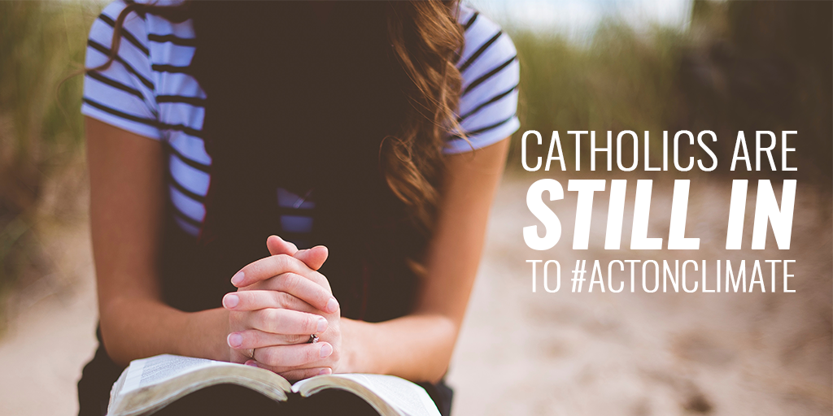

**General *Laudato Si* Anniversary Social**

*We encourage groups to post with blog posts or press releases that their organizations may have released in conjunction with the third anniversary of* Laudato Si.

**TWITTER:**

* Climate change affects the most vulnerable among us – including frontline communities and the elderly. We have a moral obligation to #ActOnClimate. #LaudatoSi
* Three years ago, @Pontifex appealed for a conversation that includes everyone on how to care for our common home and create concrete solutions. Let’s build bridges across partisan divides so we together can #ActOnClimate. #LaudatoSi [LINK]
* Three years ago, @Pontifex voiced concern for the most vulnerable among us, urging Catholics to #ActOnClimate and protect our common home. #LaudatoSi [LINK]
* Three years ago, @Pontifex reminded the world of our moral obligation to #ActOnClimate with #LaudatoSi. We stand with all people of good will who are committed to protecting our common home. [LINK]
* In #LaudatoSi, @Pontifex echoed the calls of Pope Benedict and St. Pope John Paul II of our moral obligation to #ActOnClimate change and protect our one human family, especially our vulnerable sisters and brothers. [LINK]
* Three years ago, @Pontifex laid the groundwork for action on climate change in faith communities with #LaudatoSi. [LINK]
* Three years ago, @Pontifex called on the world to #ActOnClimate in #LaudatoSi. How are you protecting our common home? [LINK]
* As the leader of millions of Catholics worldwide, @Pontifex’s call for action on climate change in #LaudatoSi was a big deal. #ActOnClimate [LINK]

**FACEBOOK:**

* Three years ago this week, [TAG] Pope Francis, in his encyclical, Laudato Si, reminded the world of our moral obligation to care for our common home and dialogue across our differences to create solutions. We stand with all people of good will who are committed to acting on climate change, for our one human family and our shared future. #ActOnClimate [LINK]
* Three years ago, [TAG] Pope Francis outlined how climate change is affecting people all over the world in his encyclical, #LaudatoSi. Since then, millions of people of faith around the world have taken action to fight climate change in their communities and around the world. #ActOnClimate [LINK]
* Vulnerable peoples, including children, the elderly, and people living in poverty, are disproportionately affected by climate change. Three years ago, [TAG] Pope Francis called upon all people of good will to act on climate and protect these communities with his historic encyclical #LaudatoSi. [LINK]
* Three years ago this week, [TAG] Pope Francis in his encyclical, Laudato Si, echoed the calls of his predecessors Pope Emeritus Benedict and Saint Pope John Paul II, to care for our common home and #ActOnClimate [LINK]