**Imperiled Species Fact Sheet: American Burying Beetle**

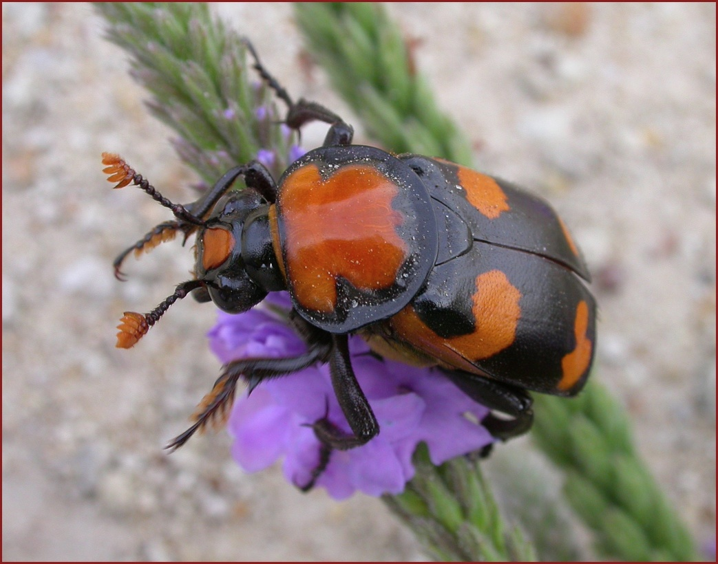**Species Background:**

The American burying beetle (ABB, *Nicrophorus americanus*) is a critically endangered insect that is an indicator species for healthy, functioning grassland ecosystems. The ABB formerly occurred across 34 states, across a vast range from Maine, south to Florida, west to Texas, and north to South Dakota. Total historical numbers are not known, but the species may well have occurred in the tens of millions. The species has been extirpated from 90 percent of its historic range due to disturbances in the food chain, habitat destruction, and habitat fragmentation. Today, it is estimated less than 1,000 ABB exist in a handful of states. Burying beetles are important scavengers that help start the natural recycling process for dead animals, serving as crucial components of healthy natural systems. The beetle can detect a freshly deceased animal from up to two miles away. During the mating ritual, the male and female beetle both bury an animal carcass, and lay their eggs. The young beetles hatch inside the carcass, which serves as a food source.

**Trend Summary and Threats:**

The ABB was listed as endangered under the Endangered Species Act in 1989. At the time there were only two known existing populations — one in Rhode Island and one in eastern Oklahoma.[1] Habitat destruction and loss of native prairie ecosystems are the primary cause of the species’ historic decline. More recently, oil and gas development in the Midwest has further fragmented its remaining habitat. Populations of the burying beetle now occur in as few as four states-- Rhode Island, Oklahoma, Arkansas and Nebraska. On July 14, 2015, Rhode Island designated the ABB as the official state insect after a group of third-graders learned about the plight of the beetle and Rhode Island’s efforts to repopulate the species.

In 1991, the U.S. Fish & Wildlife Service (FWS) developed a recovery plan for the ABB which states that the species could be downlisted from endangered to threatened once twelve populations have been reestablished within each of the four major portions of its range — Northeast, Southeast, Midwest, and Great lakes states.[2] Each population must have a minimum sustaining population of 500 for at least five consecutive years. The beetle is so endangered that scientists have not yet evaluated how many populations would be needed to consider the species as “recovered.”

In 2017, Congress requested that FWS complete a review of the ABB. In response, the Trump Administration is expected to propose that the beetle be downlisted to threatened status, and will propose a Section 4(d) rule with the downlisting, despite the fact that FWS itself recognizes that the species is nearing extinction in an agency fact sheet last updated on March 12, 2018.[3] While protections of the ESA have certainly stabilized the burying beetle and averted the species’ extinction, it is too early to consider downlisting the species to “threatened” status, let alone declare it to be recovered for delisting. Attempts to remove Endangered Species Act protections for the burying beetle are directly contrary to best scientific evidence available, and would be contrary to the legal requirements of the Act as well.

**Congressional Actions:**

Since 2013, there have been nearly a dozen legislative attacks on the ABB including [H.R. 3](https://www.congress.gov/bill/114th-congress/house-bill/3?q=%7b%22search%22%3A%5b%22\%22endangered\%22%22%5d%7d), which would have allowed the Keystone pipeline to be constructed regardless of the impacts the project would have on the species’ survival. Another prevalent attack would permanently remove Endangered Species Act protections for the ABB nationwide and preclude judicial review of that delisting. Such a rider has appeared in the House National Defense Authorization Act (NDAA) a number of times, including in the current version of the bill, H.R. 5515.

1. 54 Fed. Reg. 29652.
2. U.S. Fish & Wildlife Service, American Burying Beetle Recovery Plan at 32 (Sept. 27, 1991).
3. U.S. Fish & Wildlife Service, American Burying Beetle Fact Sheet, last updated March 12, 2018, available at: <https://www.fws.gov/midwest/endangered/insects/ambb/abb_fact.html>