Imperiled Species Fact Sheet: Lesser Prairie-Chicken

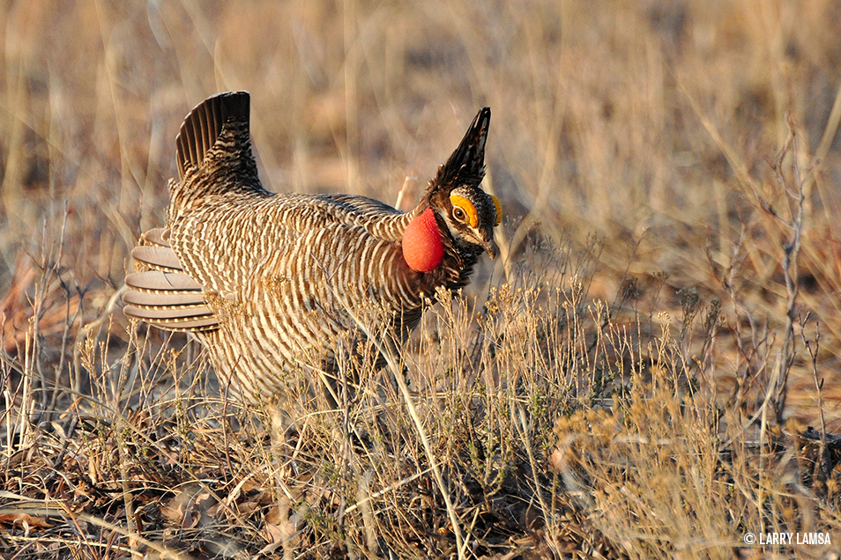
Species Background:
The lesser prairie-chicken (tympanuchus pallidicinctusis) is a highly imperiled southwestern bird currently facing several threats to its population and habitat. This large, ground-nesting bird has warranted ESA protections since 1998, when the U.S. Fish and Wildlife Service (FWS) first identified the species as a candidate for federal listing due to habitat loss, modification, degradation and fragmentation within its range. It has lost an estimated 80% of its traditional habitat due to human activities such as oil and gas drilling, ranching and construction of power lines and wind turbines. According to a November 2017 conservation assessment, lesser prairie-chicken populations are now at an or near all-time lows with an estimated 97% decline in populations and a 92% decline in rangewide occupancy.

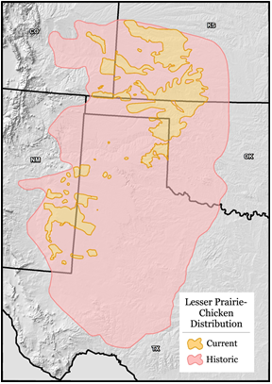
In 2013, the prairie-chicken’s population across five states (Colorado, Kansas, New Mexico, Oklahoma and Texas) declined to fewer than 18,000 birds – nearly 50 percent lower than 2012 population estimates. In 2014, FWS finally listed the bird as threatened under the Endangered Species Act (ESA). This threatened listing was accompanied by a special 4(d) rule that exempts certain land use activities, including oil and gas development and agricultural activities. Regulation of these activities were covered under a voluntary five-state conservation plan developed right before the species was listed. After FWS listed the species as threatened with this permissive 4(d) rule, conservation groups went to court to challenge the listing, arguing that the bird should have been listed as endangered. Meanwhile, contrary to hysterical predictions of the economic ruin of the oil and gas industry from the prairie-chicken’s listing, the industry indicated in August 2014 that it had already easily adjusted to FWS’s listing decision. However, several groups opposed to granting the imperiled bird any federal protections went to court to challenge the threatened listing and in 2015, a judge in Texas vacated FWS’s decision. The judge’s ruling stated that the agency had failed to adequately consider whether existing voluntary conservation programs like the Range-Wide Conservation Plan would help stem the bird’s decline. In September 2016, three conservation groups petitioned the agency to relist the lesser prairie-chicken. In November 2016, FWS took the first step toward again protecting the lesser prairie-chicken by issuing a 90-day finding noting that listing may be warranted. The bird’s status is currently under review.

Congressional Actions:
Some members of recent Congresses have attempted to remove ESA protections for the lesser prairie-chicken and hand over management to the states on numerous occasions. In the last Congress, H.R. 659, the so-called “Lesser Prairie Chicken Voluntary Recovery Act of 2015,” would have delisted the bird and prevented it from being treated as a listed species under the ESA before 2020. After that date, the species could still not be listed unless the Secretary of the Interior published a determination that the conservation goals of the Range-Wide Conservation Plan have not been achieved. House versions of the National Defense Authorization Act (NDAA) and House and Senate versions of the Interior appropriations bill have been perennial points of attack. Currently, the FY 2019 House NDAA (H.R. 5515) includes a rider (Sec. 314) that would block a listing for the lesser prairie-chicken for ten years and block judicial review of that section.

The North American Grouse Partnership, Lesser Prairie-Chicken Conservation Assessment, Nov. 2017, available at: http://www.grousepartners.org/lpc-assessment/
“The Lesser Prairie-Chicken Range-Wide Conservation Plan,” October, 2013, http://www.wafwa.org/Documents%20and% 20Settings/37/Site%20Documents/Initiatives/Lesser%20Prairie%20Chicken/2013LPCRWPfinalfor4drule12092013.pdf
McEwan, M., “Oil Producers Adjust to Lesser Prairie-Chicken Listing,” Midland Reporter Telegram, Aug. 25, 2014.

