**Imperiled Species Fact Sheet: Greater Sage-Grouse**

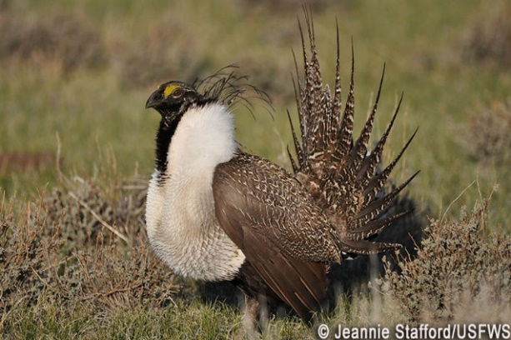**Species Background:**

The greater sage-grouse (*Centrocercus urophasianus*) is an imperiled western bird and charismatic ambassador for the Sagebrush Sea, an ecosystem that is vital to fish and wildlife, recreation, western communities and sustainable economic development. Conserving this iconic bird will help protect a quintessential western landscape and hundreds of other species that also depend on it. As many as 16 million greater sage-grouse once ranged across 297 million acres of sagebrush grasslands in the West. Today, sage-grouse range is little more than half of what it once was and populations have declined more than 90 percent from historical levels, according to some estimates. Remaining sage-grouse populations are threatened by habitat loss, degradation and fragmentation. Nearly half of sage-grouse habitat has been lost to agriculture and development, and less than 3 percent of the bird’s current range is federally protected. The remainder is compromised by poorly managed oil and gas drilling, livestock grazing, mining, unnatural fire, invasive weeds, off-road vehicles, roads, fences, pipelines and utility corridors.

In 2010, the U.S. Fish and Wildlife Service (FWS) found that the greater sage-grouse warranted protection under the Endangered Species Act (ESA), but other, higher priorities precluded the agency from proposing a listing rule at that time.[1] The 2010 finding identified the primary threat to the species as the loss and fragmentation of sagebrush grasslands, coupled with a lack of regulatory mechanisms to protect habitat across the bird’s range. Recognizing the urgent need for conservation action, the Obama administration took the extraordinary step of amending nearly one hundred land use plans across the West with new conservation prescriptions for sage-grouse. The new plans, known collectively as the “National Greater Sage-Grouse Planning Strategy,” were developed with public input and in coordination with western states and ensured continued land use and development of public lands and resources, while also improving management of more than 60 million acres in the Sagebrush Sea. Citing these final plans and other factors, the U.S. Fish and Wildlife Service determined in October 2015 that the sage-grouse did not warrant protection under the ESA at that time.[2]

Unfortunately, the Trump administration has reversed course on the effort to conserve sage-grouse, citing concerns that the National Strategy is “out of balance” for failing to provide more opportunities for industrial development on public lands. The Department of the Interior is now in the midst of revising the dozens of public lands management plans that comprise the National Strategy, jeopardizing the 4-year, $45 million planning effort that enjoyed broad support from diverse stakeholders and competing interests. The draft proposal would allow for more oil and gas drilling, mining and other land uses by eliminating existing protections for sage-grouse, including downsizing designated habitat areas and reducing protective buffers around breeding and nesting habitat.

**Congressional Actions:**

In the 114th Congress, there were a dozen legislative attempts to delay a potential listing for the greater sage-grouse or interfere with the federal planning process to conserve the bird. So far in the 115th Congress, there have been eleven separate measures introduced aimed at blocking conservation efforts for sage-grouse. For the fourth time, the omnibus bill to fund the government in FY 2018 (H.R. 1625, Consolidated Appropriations Act) included a rider preventing a listing for greater-sage-grouse for at least a year. Language included in the FY 2018 House National Defense Authorization Act (H.R. 5155) would block an ESA listing for the sage-grouse for at least ten years. Potential listing under the ESA may become increasingly important as the administration continues to reduce and outright eliminate protections for sage-grouse. Legislation blocking an ESA listing—the impetus for current conservation strategies for the bird—will continue contributing to the long-term declines of the species.

1. 75 Fed. Reg. 13910 (March 23, 2010).
2. 80 Fed. Reg. 59857 (October 2, 2015).