**Best Practices for Digital Storytelling**

**Get your audience involved**

* Pick a hashtag and stick to it! It will help people follow along before, during, and after your meeting via social media. For this action, we’re using **#CensoringScience** and **#ScienceNotSilence.**
* If you’re at the hearing, take and post pictures and key quotes to your social media accounts. This can help people who couldn’t attend feel connected and perhaps encourage them to act in the future. If you’re not at the hearing, post your story as virtual testimony, and encourage your network to like and share widely. This may even inspire them to share their own stories!

**Facebook Live**

You can reach an audience far beyond those in attendance by utilizing a new feature called “Facebook Live” that allows you to livestream directly from your phone. The best part? The footage is automatically saved to your page after the broadcast concludes, so you’ll have something to keep amplifying afterward.

Here’s how it’s done.

**Going “Live”**

Facebook makes starting a live video incredibly easy. All you have to do is download the Facebook app to your smartphone, and look for the Facebook live icon just below the status box (you can see an example of the where to find it, circled in yellow below).

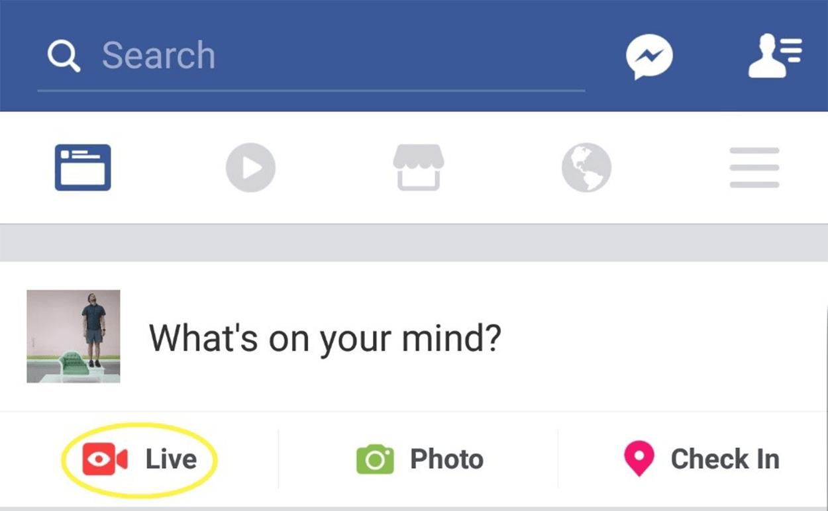

All you have to do is tap the “Live” icon and you’ll be able to start setting up your video – entering a description and selecting what audience can view the broadcast. Your viewing audience will likely be set to “friends” by default, but you can change it to “public” so your video can be shared widely across Facebook. You’ll also be able to view a preview of how the video will look, so you can adjust lighting, backdrop or framing before going live (as seen below).

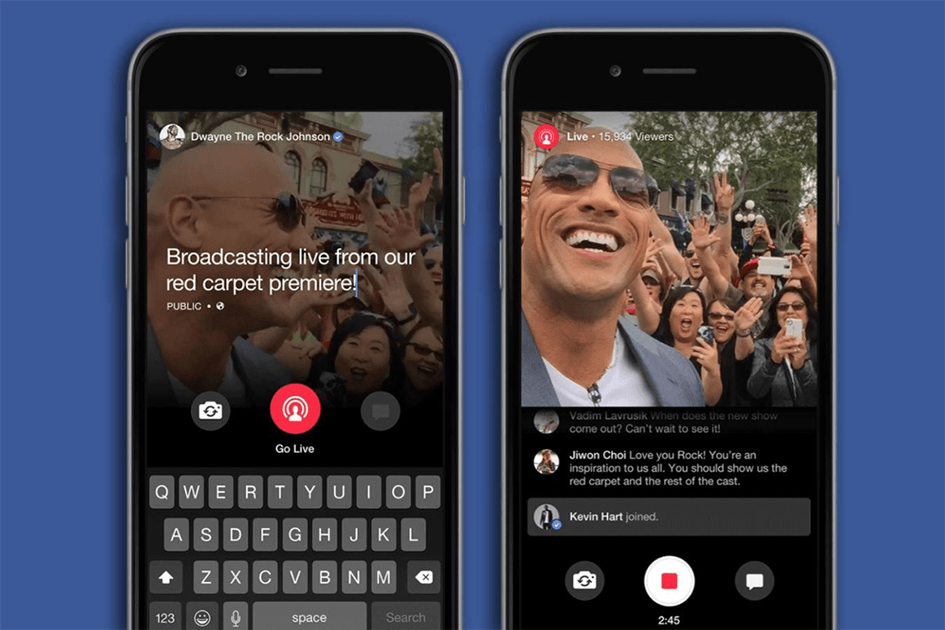

**Setup**

If filming a testimonial direct to camera, make sure your face and any visuals are fully in the frame and well lit. If possible, prop up your phone so you can have your hands free and keep the shot steady. If you’re planning on taking questions or monitoring comments, you should leave that portion of the screen visible.

**Visuals**

Your video will automatically appear and play in your follower’s Facebook feeds, but it will be muted by default. If you want to communicate something to people who may not directly engage with the video, it can help to have some signage or visual that communicates your message even if someone can’t hear. If you’re at an event, try and capture the sense of scale and activity around you.

You can also easily switch over to using the rear camera on your phone by tapping the reverse icon in the lower left hand side of the screen. This is helpful when wanting to show viewers what you’re looking at, but still keep an eye on any incoming questions and comments.

**Questions and Comments**

You will be able to view any comments or questions that come in while you’re streaming. You are under no obligation to engage with them (especially if they are negative) but if appropriate, it can be nice to acknowledge some of the viewers and make the broadcast feel more interactive.

**Archiving**

When you’re ready to conclude your broadcast, you can simply hit the red square button in the middle to end it. Unless you decide otherwise, the broadcast will be archived and offered for viewing on your page shortly after you conclude.

**After your stream: Keep the conversation going**

* Like and share other posts with the **#CensoringScience** and **#ScienceNotSilence** tags.
* Tweet at influencers (like your Senator or Representative or Andrew Wheeler) and let them know why the **#CensoringScience** proposal must be stopped:
  + For example: [.@[TAG](mailto:.@[TAG) INFLUENCER] – the #CensoringScience proposal is dangerous. We want #ScienceNotSilence. Here’s why: [INSERT STORY IN CHAINED TWEETS]

**Other Video Recording**

If you won’t be posting a Facebook live, you can still record your story to share on social media! Here are some tips for filming your story:

* Film horizontally. The quality is higher.
* **Practice!** This goes for Facebook live recording as well, but make sure that you’re comfortable with your equipment and have an outline of what you’re going to say before you start so you feel more at ease.