**Sample Social Media (2018 Survey)**

**Note for partners: Please adjust for your organization or audience**

**Twitter (the below tweets work individually, or can be used from the beginning forward as a thread):**

* This year @UCSUSA surveyed 63K+ federal scientists and the results are in: Political interference, reduced staff capacity and absence of leadership has made it harder for scientists to effectively carry out important work. Read the report here: act.ucsusa.org/2018survey
* This is @UCSUSA’sseventh survey of federal scientists since 2005, and our first opportunity to get a pulse on the state of #science under the Trump administration.
* Across federal agencies: 79% of scientists reported workforce reductions through departures, retirements, and hiring freezes – 87% of which said it’s made their agencies less effective. #ScienceUnderTrump

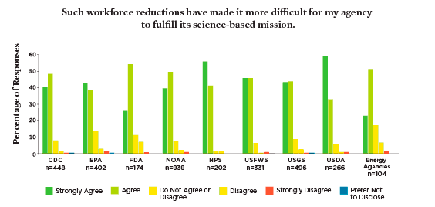

* On workforce reductions at @EPA: “We have fewer people at EPA than under Reagan. There is little retention of institutional knowledge as people retire quicker than ever and hiring is not happening much to replace retirees.” #ScienceUnderTrump
* Reports of political interference and #censorship were highest at @EPA, @NatlParkService, @USGS, and @USFWS. “Anything to do with "climate change" in the by-line has been zeroed out or very drastically reduced.” – Anonymous @USGS scientist #ScienceUnderTrump

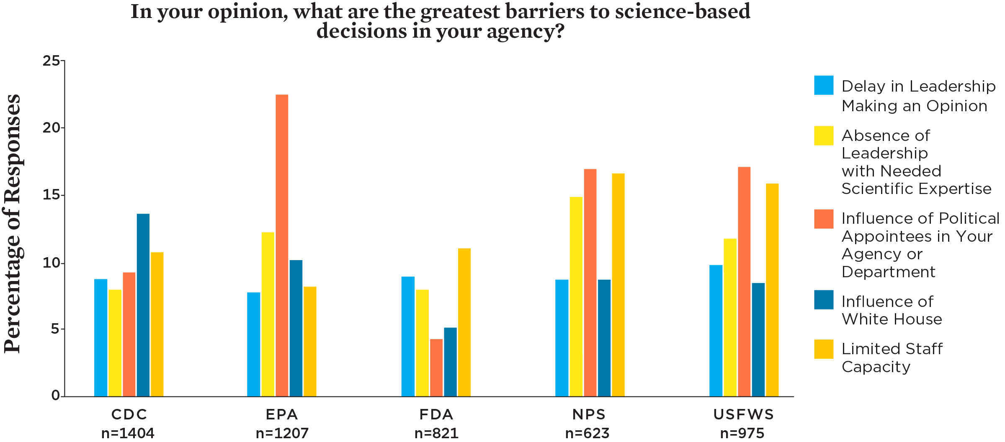

* Leadership matters: at @US_FDA, @CDCgov and @NOAA, scientists say political leadership respects the work they do, reported high morale and agency effectiveness. With good leadership that understands and commits to the mission, scientists are better able to get their work done.
* We need reliable, publicly available #science from federal agencies. Whether it’s farmers, businesses, neighborhoods exposed to pollution, or communities in the path of natural disasters, we depend on federal science and can’t afford to have it compromised.
* Federal scientists are public servants, many of whom have years of experience under administrations of different parties. They care about their jobs, want to be able to do their best work, and often feel like political appointees simply aren’t listening.
* The work of federal scientists matters, and we are defending it. If you’re a government scientist who’s experienced political interference in your work, please utilize our Science Protection Project for legal advice. #StandUpForScience #ScienceNotSilence act.ucsusa.org/ScienceProtection

**Facebook:**

**\*Note: These posts can double as tweets. Just add #ScienceUnderTrump or #ScienceNotSilence**

Federal scientists report feeling the chilling effects of inappropriate political and industry influence, drastic workforce reductions, and an absence of leadership within their agencies. Check out more details here: www.ucsusa.org/2018survey

“We are still free to work on climate change issues, but, for example, the last report we did is published but is not being distributed.” Federal scientists’ work matters. When scientists’ important work is marginalized, underfunded, or censored, we all lose. Read more here: [www.ucsusa.org/2018survey](http://www.ucsusa.org/2018survey)

Federal scientists spoke; we listened. Learn more about our findings in our latest report: [www.ucsusa.org/2018survey](http://www.ucsusa.org/2018survey)

Good leadership at government agencies = agencies that are better able to meet their important missions. We surveyed over 63,000 federal scientists and found that scientists felt more supported and reported higher morale and effectiveness at agency’s helmed by leadership who respect the mission. www.ucsusa.org/2018survey

**Sample language for partners:**

Environmental justice has been sidelined in the Trump era, and the inability of scientists to do their work falls hardest on disadvantaged communities that are already disproportionately burdened. Learn more about what federal scientist have to say: www.ucsusa.org/2018survey

“Most FDA scientists are committed to doing their job. Hiring freezes, budget freezes, training cuts, and a hostile administration make that harder.” Scientific integrity policies and whistleblower safeguards are vital to preventing scientific misconduct, but federal scientists still worry about the influence of political appointees above them. www.ucsusa.org/2018survey

**Hashtags:**

#ScienceUnderTrump

**Memes:**



