**CAC Resource: Clean Power Plan Advance Notice of Proposed Rulemaking (ANPRM) Toolkit**

Table of Contents

Background 1

Talking Points 2

Sample Media Advisory 3

Sample Press Release 4

Sample Letter to the Editor 5

Sample Social Media 6

Sample Comment Card 7

# Background

President Trump and Acting Environmental Protection Agency (EPA) Administrator Andrew Wheeler are trying to bury the Clean Power Plan, the first and only federal limit on carbon pollution from power plants – a major source of the pollution that exacerbates climate change – which protects public health, promotes climate change solutions, and encourages investment in clean energy. With their new “Dirty Power Scam,” Trump and Wheeler are exposing millions of Americans to more pollution and putting corporate polluters before our health and safety.

This toolkit provides resources to help push back on the Trump administration’s attempts to dismantle the lifesaving Clean Power Plan.

# 

# Talking Points

**CAC Message Guidance: Clean Power Plan Replacement**

**Topline Message: With their new “Dirty Power Scam,” Donald Trump and Acting EPA Administrator Andrew Wheeler are endangering lives and undermining the transition to cleaner, safer energy sources. By proposing to bury the Clean Power Plan, which set the first federal limits on carbon pollution from power plants – a major source of the pollution that exacerbates climate change – Trump and Wheeler are putting corporate polluters before our health and safety.**

**The Clean Power Plan should be made stronger, not gutted with a “Dirty Power Scam” that will cost lives, exacerbate climate change, and slow the transition to cleaner, safer energy sources.**

* The Clean Power Plan set the first federal limits on carbon pollution from power plants – a major source of the pollution that drives climate change.
* If we’ve learned anything from last year’s hurricane season, the wildfires currently scorching the west, extreme flooding events and record heat this summer, it’s that we need common sense climate action and health protections like the Clean Power Plan.
* The Trump administration’s own analysis found that the Clean Power Plan could prevent as many as 4,500 premature deaths each year by 2030 — more than even Obama’s EPA estimated — and previous estimates found it could provide up to $54 billion in health and climate benefits.
* The Clean Power Plan also encouraged investment in cleaner, safer energy sources like wind and solar. Clean energy creates jobs and drives economic growth, and is supported by a majority of Americans.
* But instead of listening to American families, Trump and Wheeler are pushing their Dirty Power Scam; a corporate polluter giveaway that will cost thousands of lives, exacerbate climate change, and threaten our health.

**Acting EPA Administrator Andrew Wheeler is an industry insider who has lobbied for some of the world’s biggest polluters. Wheeler’s actions are no different than what his scandal-ridden predecessor Scott Pruitt would have done.**

* Just like Scott Pruitt, Andrew Wheeler has deep conflicts of interest with the very companies the EPA was created to oversee. As recently as 2017, Wheeler lobbied on behalf of coal giant Murray Energy, which sued to block the Clean Power Plan.
* The American people need to be assured that decisions made by Wheeler are based on sound science – not the result of closed-door lobbying by polluters and other special interests.
* With this Dirty Power Scam, Wheeler is letting polluters off the hook at the expense of our health, and continuing the toxic policies of his scandal-plagued predecessor Scott Pruitt.

**The Clean Power Plan is the result of extensive public engagement, and has strong public support.**

* Under the previous administration, EPA experts conducted extensive technical analysis and engaged in unprecedented public outreach to determine the best way to reduce carbon pollution from power plants. The result of that unprecedented outreach is the Clean Power Plan.
* In total, the Obama administration held [11 public listening sessions](https://archive.epa.gov/epa/cleanpowerplan/outreach-reducing-carbon-pollution-existing-power-plants.html) and received 8 million public comments in support of the Clean Power Plan before finalizing it.
* Despite this overwhelming evidence and broad public support for the Clean Power Plan, Wheeler is focused on accommodating a few big polluters, which will cost lives and jobs and undermine our country’s clean energy economy.

# Sample Media Advisory

**FOR PLANNING PURPOSES ONLY**

[MONTH DAY, 2018]

**CONTACT**

[NAME, PHONE NUMBER]

[EMAIL]

**\*Media Advisory\***

**[NAME] Decries “Dirty Power Scam,” the Trump Administration’s Move to Bury the Lifesaving Clean Power Plan**

**(CITY, STATE)** – **[SPONSOR],** environmental leaders, and other public health advocates will hold a hearing on **[DAY]** to stand up for **[STATE]** children and families and express support for strengthening the Clean Power Plan, an important public health protection and climate change solution that sets the first ever federal limits on carbon pollution from power plants and encourages investment in clean energy. Speakers will highlight how the Trump administration’s “Dirty Power Scam” will harm **[STATE]** families and communities. Speakers will also urge President Donald Trump and Acting Environmental Protection Agency (EPA) Administrator Andrew Wheeler to listen to ensure any replacement to the Clean Power Plan is made stronger than the original proposal.

**WHO:**

[NAME, ORGANIZATION]

[NAME, ORGANIZATION]

[NAME, ORGANIZATION]

[NAME, ORGANIZATION]

**WHERE:** [LOCATION]

**WHEN:** [DATE AND TIME]

**TIME:**

To schedule interviews prior to or after the event, or for more information about the hearing, please contact **[NAME]** at **[EMAIL].**

# ###Sample Press Release

**FOR IMMEDIATE RELEASE**

[MONTH DAY, 2018]

**CONTACT**

[NAME, PHONE NUMBER]

[EMAIL]

**[ORGANIZATION] Denounces Trump Administration Proposal to Dismantle the Lifesaving Clean Power Plan**

*Leaders call on the Trump administration to make the Clean Power Plan stronger, not bury it.*

**(CITY, STATE)** – Today**,** as President Trump and Acting Environmental Protection Agency (EPA) Administrator Andrew Wheeler announced their new “Dirty Power Scam,” [ORGANIZATION] released the following statement:

“President Trump and Acting EPA Administrator Andrew Wheeler are at it again with another scam. Eliminating the Clean Power Plan would dismantle America’s only federal limits on carbon pollution from power plants – a major source of the pollution that exacerbates climate change – and put corporate polluters before our health and safety..

“Trump and Wheeler’s new scheme would recklessly expose millions of Americans to more pollution and would place the health and safety of our communities – especially communities of color and vulnerable communities who are disproportionately impacted by pollution – at risk. By the Trump administration’s own estimates, the Clean Power Plan could prevent as many as 4,500 premature deaths each year by 2030, and previous estimates found it could provide up to $54 billion in health and climate benefits.

“Furthermore, the Clean Power Plan is the result of extensive public engagement and enjoys strong public support. With this “Dirty Power Scam,” Wheeler is letting these polluters off the hook at the expense of our health and continuing the toxic policies of his predecessor, disgraced former EPA chief Scott Pruitt. We will oppose this scam to bury the Clean Power Plan with all we have.”

###

# Sample Letter to the Editor

**[STATE DEMONYMS]** count on the Environmental Protection Agency (EPA) to protect us from dangerous pollution that makes our kids sick and our air more dangerous to breathe.

Unfortunately, Acting EPA Administrator Andrew Wheeler is intent on advancing disgraced former EPA chief Scott Pruitt’s toxic agenda, despite his promise to run the agency differently than his predecessor. Wheeler – a former coal lobbyist -- has revealed himself to be far more concerned with advancing the interests of corporate polluters than he is with keeping American families safe.

The Trump administration’s scheme to bury the lifesaving Clean Power Plan is case in point. Their “Dirty Power Scam” would recklessly expose millions of Americans to more pollution and place the health and safety of our communities at risk.

By even the Trump administration’s own estimates, the Clean Power Plan will save thousands of lives. But this hasn’t stopped Trump and Wheeler from attacking this important policy.

The reality is that the Clean Power Plan is the result of extensive public engagement, will save lives, and enjoys strong public support. That’s why I join others my community to support these lifesaving clean air protections and say no to Trump and Wheeler’s scheme to bury them.

# Sample Social Media

**General**

**TWITTER**:

* .@realDonaldTrump and @EPAAWheeler are being reckless. Gutting the Clean Power Plan would cost us up to 560k American jobs by 2030.#ProtectCPP #DirtyPowerScam <https://www.e2.org/wp-content/uploads/2017/06/FINAL-CPP-jobs-report-6.21.17.pdf>
* UNACCEPTABLE: Gutting the Clean Power Plan will cost us 560,000 American jobs.#ProtectCPP #DirtyPowerScam [https://www.e2.org/wp-content/uploads/2017/0e6/FINAL-CPP-jobs-report-6.21.17.pdf](https://www.e2.org/wp-content/uploads/2017/06/FINAL-CPP-jobs-report-6.21.17.pdf)
* Replacing the Clean Power Plan with the #DirtyPowerScam could cause up to 3,600 premature deaths by 2030. So much for making America great again. #ProtectCPP
* .@realDonaldTrump and @EPAAWheeler are working together on the #DirtyPowerScam – which could increase the risk of asthma attacks for our children. #ProtectCPP

**FACEBOOK:**

* The #CleanPowerPlan would support up to $52 BILLION in GDP growth by 2030. By pushing their #DirtyPowerScam, [TAG] Donald J. Trump and [TAG] Acting Administrator Wheeler are ignoring the chance to create American jobs. #ProtectCPP <https://www.e2.org/wp-content/uploads/2017/06/FINAL-CPP-jobs-report-6.21.17.pdf>

**Announcement**

**TWITTER:**

* [.@EPAAWheeler](mailto:.@EPAAWheeler) and @realDonaldTrump are expected to unveil the #DirtyPowerScam this week – one of their most blatant attacks on our health and environment yet. #ProtectCPP<https://politi.co/2Bcld5z>
* As wildfires fueled by climate change rage in the West and floods threaten homes in the East, @EPAAWheeler and @realDonaldTrump are set to roll back one of our best chances to address climate change. #DirtyPowerScam #ProtectCPP<https://politi.co/2Bcld5z>
* 🚨🚨🚨 @EPAAWheeler and @realDonaldTrump are set to release their #DirtyPowerScam this week. #ProtectCPP (via @politico)<https://politi.co/2Bcld5z>
* [.@EPAAWheeler](mailto:.@EPAAWheeler) and @realDonaldTrump’s #DirtyPowerScam is “a recipe for abandoning the effort to take on one of the world’s most urgent problems.” #ProtectCPP<https://politi.co/2Bcld5z>

**FACEBOOK:**

* [TAG] Acting EPA Administrator Andrew Wheeler and [TAG] Donald J. Trump are expected to unveil the #DirtyPowerScam this week – one of their most blatant attacks on our health and environment yet. #ProtectCPP<https://politi.co/2Bcld5z>
* 🚨🚨🚨 [TAG] Acting EPA Administrator Andrew Wheeler and [TAG] Donald J. Trump are set to release their #DirtyPowerScam this week. #ProtectCPP (via [TAG] POLITICO)<https://politi.co/2Bcld5z>

# Sample Comment Card

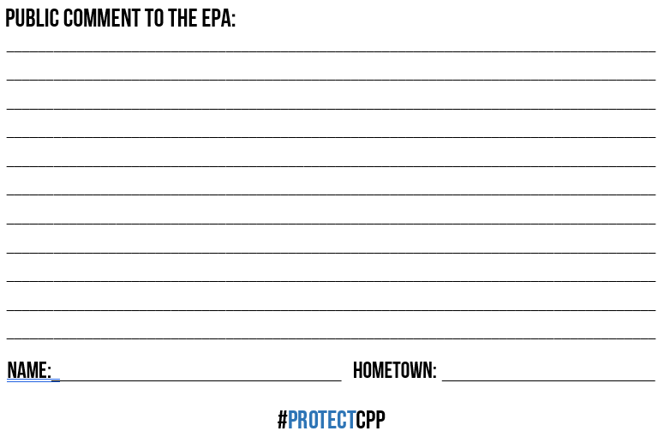

Public Comment to the EPA [PDF]

Public Comment to the EPA [Word Doc]