**Clean Power Plan Rollback Materials**

*Updated August 2018*

**Additional resources:**

Email and Sample Comment Language: [HERE](http://materials.actonclimate.com/asset/3369/)

State-specific CPP Job Impacts: [HERE](https://docs.google.com/document/d/1ShVXMncVgHD7RiDJRLSglJAb4s4xiWZFkWxni-esqBY/edit?usp=sharing)

**High-res Graphics:** [HERE](http://materials.actonclimate.com/search/?published_end=&q=&extensions_exclude=&extensions_include=&published_start=&search_folder=&tags_include=480&tags_include=83&tags_include=4&page=3)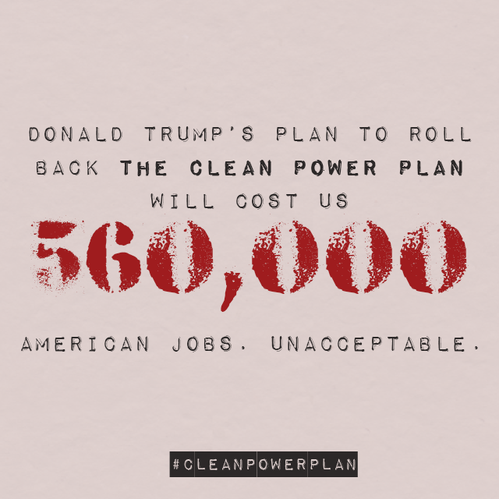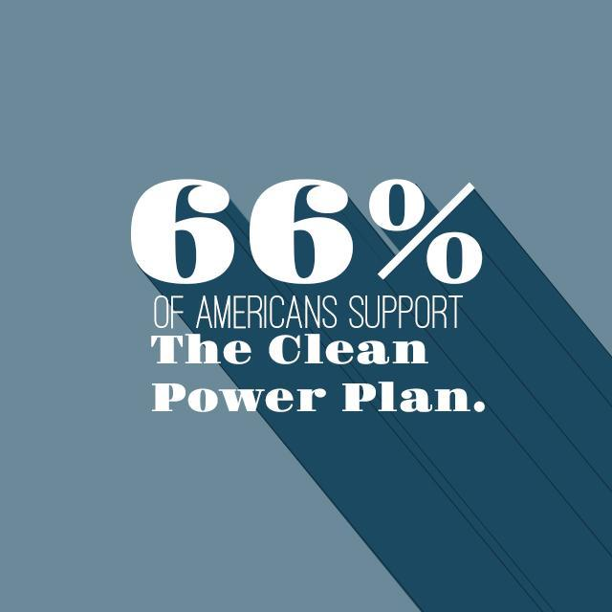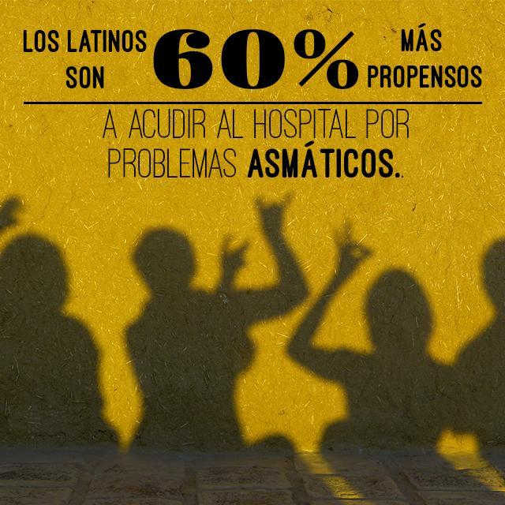

**Leaked Plan Social**

**TWITTER:**

* .@EPAAWheeler and @realDonaldTrump are expected to unveil the #DirtyPowerScam this week – one of their most blatant attacks on our health and environment yet. #ProtectCPP<https://politi.co/2Bcld5z>
* As wildfires fueled by climate change rage in the West and floods threaten homes in the East, @EPAAWheeler and @realDonaldTrump are set to roll back one of our best chances to address climate change. #DirtyPowerScam #ProtectCPP<https://politi.co/2Bcld5z>
* 🚨🚨🚨 @EPAAWheeler and @realDonaldTrump are set to release their #DirtyPowerScam this week. #ProtectCPP (via @politico)<https://politi.co/2Bcld5z>
* .@EPAAWheeler and @realDonaldTrump’s #DirtyPowerScam is “a recipe for abandoning the effort to take on one of the world’s most urgent problems.” #ProtectCPP<https://politi.co/2Bcld5z>

**FACEBOOK:**

* [TAG] Acting EPA Administrator Andrew Wheeler and [TAG] Donald J. Trump are expected to unveil the #DirtyPowerScam this week – one of their most blatant attacks on our health and environment yet. #ProtectCPP<https://politi.co/2Bcld5z>
* 🚨🚨🚨 [TAG] Acting EPA Administrator Andrew Wheeler and [TAG] Donald J. Trump are set to release their #DirtyPowerScam this week. #ProtectCPP (via [TAG] POLITICO)<https://politi.co/2Bcld5z>

**National Social**

**TWITTER**:

* .@realDonaldTrump and @EPAAWheeler are being reckless. Gutting the Clean Power Plan would cost us up to 560k American jobs by 2030.#ProtectCPP #DirtyPowerScam <https://www.e2.org/wp-content/uploads/2017/06/FINAL-CPP-jobs-report-6.21.17.pdf>
* The Clean Power Plan would support up to $52 BILLION in GDP growth by 2030, but @EPAAWheeler wants to replace it with his #DirtyPowerScam.#ProtectCPP <https://www.e2.org/wp-content/uploads/2017/06/FINAL-CPP-jobs-report-6.21.17.pdf>
* UNACCEPTABLE: Gutting the Clean Power Plan will cost us 560,000 American jobs.#ProtectCPP #DirtyPowerScam [https://www.e2.org/wp-content/uploads/2017/0e6/FINAL-CPP-jobs-report-6.21.17.pdf](https://www.e2.org/wp-content/uploads/2017/06/FINAL-CPP-jobs-report-6.21.17.pdf)
* Replacing the Clean Power Plan with the #DirtyPowerScam could cause up to 3,600 premature deaths by 2030. So much for making America great again. #ProtectCPP
* .@realDonaldTrump and @EPAAWheeler are working together on the #DirtyPowerScam – which could increase the risk of asthma attacks for our children. #ProtectCPP

**FACEBOOK:**

* [TAG] Donald J. Trump and [TAG] Acting Administrator Wheeler’s plan to gut the Clean Power Plan and replace it with their #DirtyPowerScam could cost us 560,000 American jobs by 2030.#ProtectCPP <https://www.e2.org/wp-content/uploads/2017/06/FINAL-CPP-jobs-report-6.21.17.pdf>
* The #CleanPowerPlan would support up to $52 BILLION in GDP growth by 2030. By pushing their #DirtyPowerScam, [TAG] Donald J. Trump and [TAG] Acting Administrator Wheeler are ignoring the chance to create American jobs.#ProtectCPP <https://www.e2.org/wp-content/uploads/2017/06/FINAL-CPP-jobs-report-6.21.17.pdf>

**Impacts on** **African American Communities**

**TWITTER:**

* 83% of African Americans support the Clean Power Plan – @EPAAWheeler’s push to replace it with his #DirtyPowerScam is out of line. #ProtectCPP http://www.baltimoresun.com/news/opinion/oped/bs-ed-rggi-wdc-20161006-story.html
* 1 in 6 black children suffers from asthma, and @EPAAWheeler’s #DirtyPowerScam won’t let them breathe any easier. #ProtectCPP <http://www.aafa.org/page/burden-of-asthma-on-minorities.aspx>
* 68% of African Americans live near polluting coal power plants. @EPAAWheeler: we can’t afford your #DirtyPowerScam. #ProtectCPP <http://www.dallasweekly.com/news/national/article_ad6ce6ec-d72c-11e4-8ecd-1337fc769c4c.html>

**FACEBOOK:**

* [TAG] Donald Trump’s and [TAG] Acting Administrator Wheeler’s attempts to replace the Clean Power Plan with their #DirtyPowerScam don’t take into account the 83% of African Americans who support these lifesaving pollution standards. We deserve better. #ProtectCPP <http://www.baltimoresun.com/news/opinion/oped/bs-ed-rggi-wdc-20161006-story.html>
* 1 in 6 black children suffers from asthma – [TAG] Donald Trump and [TAG] Acting Administrator Wheeler’s #DirtyPowerScam ignores their need to breathe clean air in favor of lining polluters’ pockets. #ProtectCPP <http://www.aafa.org/page/burden-of-asthma-on-minorities.aspx>
* Black children are over 7 times more likely to die from asthma attacks than white children, and [TAG] Acting Administrator Wheeler’s #DirtyPowerScam won’t let them breathe any easier. #ProtectCPP <https://minorityhealth.hhs.gov/omh/browse.aspx?lvl=4&lvlid=15>

**Impacts on Latinx Communities**

**TWITTER:**

* Any attempt to dismantle the Clean Power Plan ignores the 70% of Latinos who want aggressive climate action. #ProtectCPP #DirtyPowerScam <http://www.huffingtonpost.com/latino-decisions/latino-voters-strongly-op_b_14562028.html>
* UNACCEPTABLE: @EPAAWheeler’s #DirtyPowerScam ignores Latino communities ready to #ActOnClimate. #ProtectCPP <http://www.huffingtonpost.com/latino-decisions/latino-voters-strongly-op_b_14562028.html>
* Latinos are 60% more likely to visit the hospital for asthma than white people. We can’t afford the #DirtyPowerScam. #ProtectCPP <https://minorityhealth.hhs.gov/omh/browse.aspx?lvl=4&lvlid=60>
* We can’t afford @EPAAWheeler’s #DirtyPowerScam – many Latino farmworkers are at increased risk from extreme heat. #ProtectCPP <https://www.nrdc.org/media/2016/161013>

**FACEBOOK:**

* UNACCEPTABLE: Any attempt to dismantle the #CleanPowerPlan goes against the 70% of Latinos who want aggressive climate action. We cannot be ignored. #ProtectCPP <http://www.huffingtonpost.com/latino-decisions/latino-voters-strongly-op_b_14562028.html>
* Latinos are 60% more likely to visit the hospital for asthma than white people. [TAG] Donald J. Trump and [TAG] Acting Administrator Wheeler’s #DirtyPowerScam ignores them. #ProtectCPP <https://minorityhealth.hhs.gov/omh/browse.aspx?lvl=4&lvlid=60>
* [TAG] Donald Trump and [TAG] Acting Administrator Wheeler – we can’t afford the #DirtyPowerScam. Many Latino farmworkers are at increased risk from extreme heat made worse by climate change. #ProtectCPP <https://www.nrdc.org/media/2016/161013>

**Spanish Translations**

**Impacts on Latinx Communities**

**TWITTER:**

* Cualquier intento por eliminar el Plan de Energía Limpia es un plan nefasto que favorece a los contaminadores e ignora el hecho de que 70% de los latinos están a favor de la acción climática. #ProtectCPP #DirtyPowerScam <http://www.huffingtonpost.com/latino-decisions/latino-voters-strongly-op_b_14562028.html>
* INACEPTABLE: El nefasto plan de @EPAAWheeler ignora que la comunidad latina está preparada para tomar #acciónclimática. #ProtectCPP #DirtyPowerScam <http://www.huffingtonpost.com/latino-decisions/latino-voters-strongly-op_b_14562028.html>
* Los latinos son 60% más propensos en acudir al hospital por motivo del asma que sus pares blancos. No nos conviene el plan nefasto de @EPAAWheeler. #DirtyPowerScam #ProtectCPP <https://minorityhealth.hhs.gov/omh/browse.aspx?lvl=4&lvlid=60>
* A la comunidad latina no le conviene el nefasto plan de @EPAAWheeler, empezando por los trabajadores agrícolas que ya sufren mayor riesgo de exposición al calor extremo y sus efectos. #DirtyPowerScam #ProtectCPP <https://www.nrdc.org/media/2016/161013>

**FACEBOOK:**

* INACEPTABLE: Cualquier intento por eliminar el Plan de Energía Limpia va en contra del hecho de que 70% de los latinos están a favor de la acción climática. No podemos ser ignorados. #ProtectCPP <http://www.huffingtonpost.com/latino-decisions/latino-voters-strongly-op_b_14562028.html>
* Los latinos son 60% más propensos en acudir al hospital por motivo del asma que sus pares blancos. El nefasto plan de [TAG] Donald J. Trump y [TAG] Acting Administrator Wheeler los deja mal parados. #DirtyPowerScam #ProtectCPP <https://minorityhealth.hhs.gov/omh/browse.aspx?lvl=4&lvlid=60>
* [TAG] Donald J. Trump y [TAG] Acting Administrator Wheeler: no nos conviene su nefasto plan para eliminar el Plan de Energía Limpia. Muchos trabajadores agrícolas latinos sufren mayor riesgo de exposición al calor extremo y sus efectos. #DirtyPowerScam #ProtectCPP <https://www.nrdc.org/media/2016/161013>