State-Specific Social Guidance
CO | ME | MO | MT | NV | NH | OH | PA | VA
National Hashtags: #DefendClimate, #ActOnClimate
Methane: #CutMethane, #CleanAir4Kids
Cars: #CleanerCars
REMINDER: Preview graphics are available in this document, but if you are interested in using them on social media, please go to the Materials Hub to download them in high quality. Please reach out to Marcy (msutter@cacampaign.com) if you need a login.

Colorado Social and Graphics

Twitter:
- Clean air is vital for the 101k CO kids diagnosed with asthma. When we #CutMethane, we help protect their health. https://bit.ly/2HKsSrC
- Climate change fuels the wildfires that threaten Colorado’s forests and families. We must stand together to #DefendClimate and protect our state. https://53eig.ht/2JTb4e2
- Outdoor recreation employs more than 200,000 Coloradans and generates billions in tax revenue. Climate change puts our economy at risk. #DefendClimate https://bit.ly/2I7qlKK
- Solar jobs in CO grew by 13% last year – we depend on the clean energy economy. #DefendClimate. https://bit.ly/2HWJiM1
- The solar industry is creating jobs for Coloradans. Just one more reason we must #DefendClimate. https://bit.ly/2HWJiM1
- Colorado is already moving forward to lower vehicle emissions. Our state knows that #CleanerCars protect our health. https://bit.ly/2ut9Qjk

Facebook:
- Clean air is vital for the 101,570 Colorado children diagnosed with asthma. When we #CutMethane, we help protect their health. https://bit.ly/2HKsSrC
- Climate change fuels the wildfires that threaten Colorado’s forests and families. We must stand together to #DefendClimate and protect our state. https://53eig.ht/2JTb4e2
- The outdoor recreation industry employs more than 200,000 Coloradans and generates billions in tax revenue. Climate change puts our economy at risk. https://bit.ly/2I7qlKK
- Solar jobs in Colorado grew by 13% last year. Coloradans depend on the clean energy economy – we need our representatives in Washington to #DefendClimate. https://bit.ly/2HWJiM1
- Colorado is already moving forward to lower vehicle emissions. Our state knows that #CleanerCars protect our health. https://bit.ly/2ut9Qjk
Suggested Graphics: (High quality on the Materials Hub)
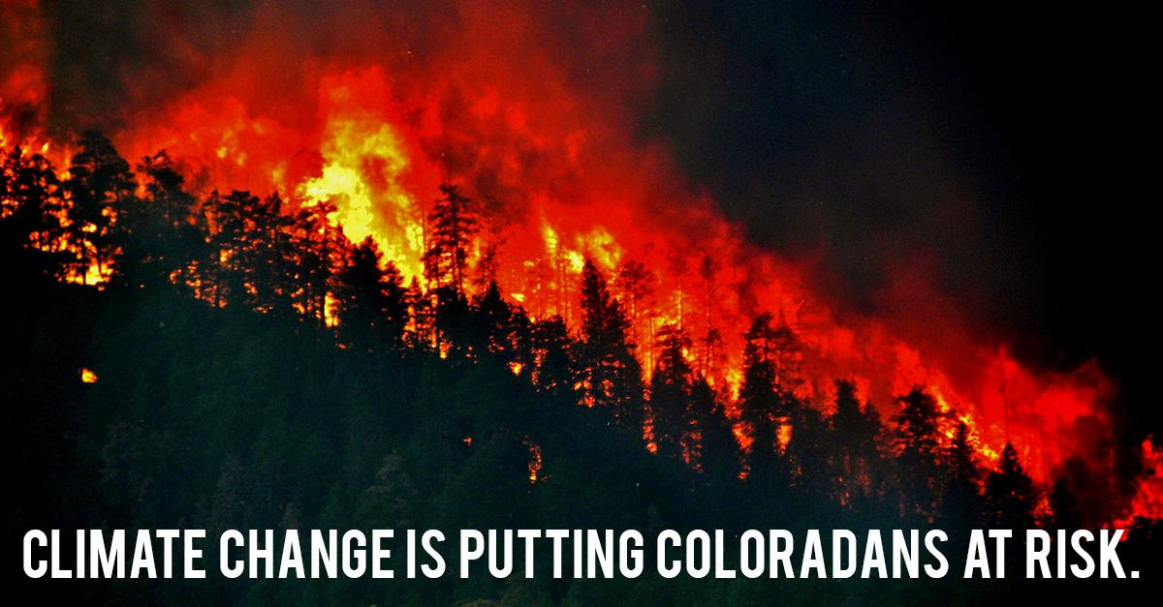
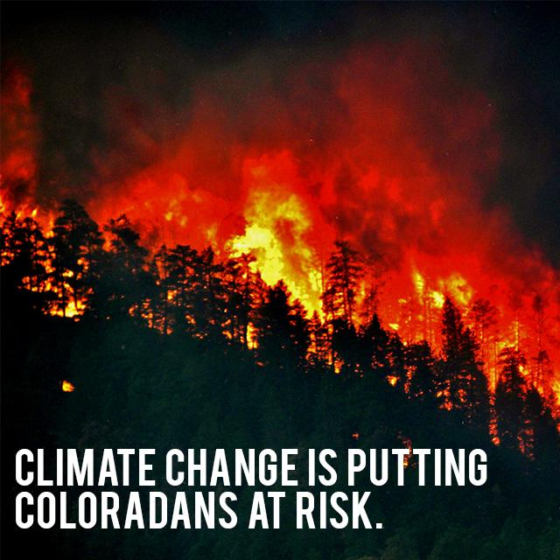

Maine Social and Graphics

Twitter:
- The outdoor recreation industry employs 76,000 Mainers and generates millions in tax revenue. Climate change puts our economy at risk. #DefendClimate https://bit.ly/2JMQ251
- Asthma impacts 18,758 Maine children. When we #CutMethane, we help protect their health. https://bit.ly/2JLeXRK
- Warmer temps caused by climate change increase the spread of Lyme Disease. We must #DefendClimate. http://bangordailynews.com/2017/06/28/outdoors/meet-the-scientists-who-go-looking-for-ticks-so-fewer-mainers-get-sick/
- 76% of Mainers support limiting carbon pollution. We’re ready to #DefendClimate. https://bit.ly/2m3ygNE
- The solar industry in Maine grew by 24% in 2017. Our state benefits when we #DefendClimate. https://bit.ly/2M0Jzji

Facebook:
- The outdoor recreation industry employs 76,000 Mainers and generates millions in tax revenue. Climate change puts Maine’s economy at risk. #DefendClimate https://bit.ly/2JMQ251
- Warmer winters fueled by climate change are causing the tick population to surge. These ticks don’t just spread Lyme Disease – they’re also devastating our moose herds. http://bangordailynews.com/2014/05/09/outdoors/maine-to-reduce-moose-hunt-permits-by-25-percent-because-winter-ticks-take-toll-on-herd/
- 76% of Mainers support limiting dangerous carbon pollution. Let’s tell our representatives to #DefendClimate and stand up for Maine’s environment. https://bit.ly/2m3ygNE
- Clean air is vital for the 18,758 Maine children who are suffering from asthma. When we #CutMethane, we help protect their health. https://bit.ly/2JLeXRK
- In 2017 alone, Maine’s solar industry grew by 24%. Let’s #DefendClimate and support an industry that benefits our state’s economy. https://bit.ly/2M0Jzji

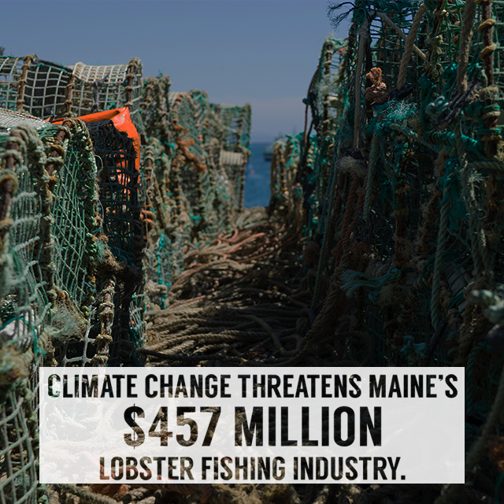
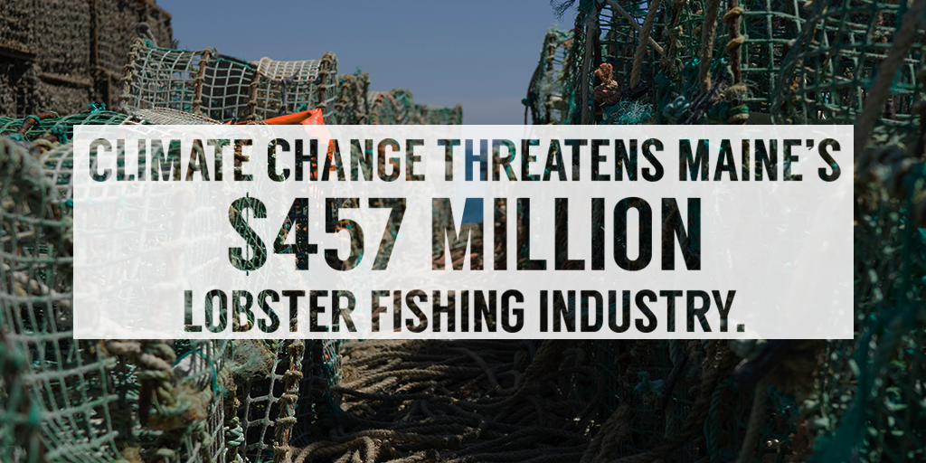
Suggested Graphics: (High quality on the Materials Hub)

Missouri Social and Graphics
TWITTER:
- Flooding in the Ozarks in 2017 cost Missouri $86 million. Climate change can make flooding like this more frequent and severe. #DefendClimate https://bit.ly/2LYFmg2
- Clean air is vital for the 120K Missouri kids suffering from asthma. When we #CutMethane, we help protect their health. https://bit.ly/2HLBlKc
- The solar industry in MO grew by 9% in 2017. Our state benefits when we #DefendClimate. https://bit.ly/2JLT0qq
- The outdoor recreation industry employs 133,000 Missourians and generates millions in tax revenue. Climate change puts Missouri’s economy at risk. #DefendClimate https://bit.ly/2JYPMz3
FACEBOOK:
- Flooding in the Ozarks in 2017 cost Missouri $86 million. Climate change can make flooding like this more frequent and severe. #DefendClimate https://bit.ly/2LYFmg2
- Clean air is vital for the 120,015 Missouri kids suffering from asthma. When we #CutMethane, we help protect their health. https://bit.ly/2HLBlKc
- The outdoor recreation industry employs 133,000 Missourians and generates millions in tax revenue. Climate change puts Missouri’s economy at risk. #DefendClimate https://bit.ly/2JYPMz3
- The solar industry in Missouri grew by 9% in 2017. Our state benefits when we #DefendClimate. https://bit.ly/2JLT0qq
Suggested Graphics: (High quality on the Materials Hub)
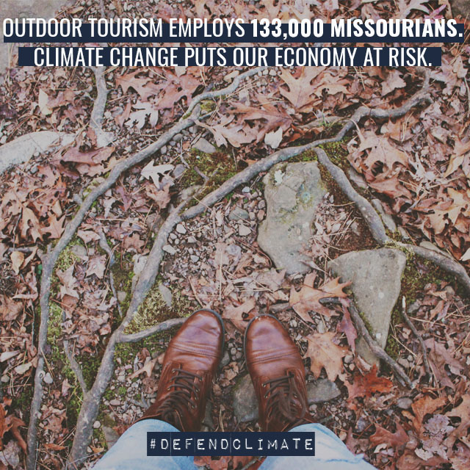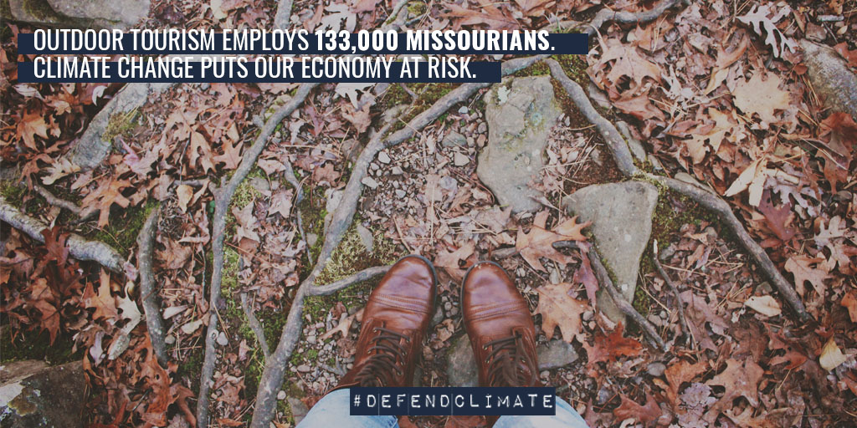

Montana Social and Graphics

Twitter:
- Warmer temperatures and drier summers are withering the future for Montana’s farmers. Agricultural losses to climate change could total $736 million per year. #DefendClimate https://bit.ly/2leUlY2
- Last year’s fire season cost Montana $240 million in tourist spending. We must #DefendClimate to protect our land and economy from large scale wildfires. https://bit.ly/2I1roaV
- Clean air is vital for the 13,560 Montana kids diagnosed with asthma. When we #CutMethane, we help protect their health. https://bit.ly/2JOsvfx
- The outdoor recreation industry employs 71,000 Montanans and generates millions in tax revenue. Climate change puts Montana’s economy at risk. #DefendClimate https://bit.ly/2JMLjA8
- The glaciers in Montana’s Glacier National Park have shrunk by 83% in the last 50 years. Climate change could destroy these natural wonders. #DefendClimate https://nyti.ms/2rR9JvR
- Native Americans face increased risk from climate change, threatening traditions and ways of life that have existed for thousands of years. #DefendClimate https://bit.ly/1nJcUgU
- The solar industry in Montana grew by 24% in 2017. Our state benefits when we #DefendClimate. https://bit.ly/2My6zat

Facebook:
- The glaciers in Montana’s Glacier National Park have shrunk by 83% in the last 50 years. Climate change could destroy these natural wonders. #DefendClimate https://nyti.ms/2rR9JvR
- Clean air is vital for the 13,560 children in Montana diagnosed with asthma. When we #CutMethane, we help protect their health. https://bit.ly/2JOsvfx
- Native Americans face increased risk from climate change, threatening traditions and ways of life that have existed for thousands of years. #DefendClimate https://bit.ly/1nJcUgU
- The outdoor recreation industry employs 71,000 Montanans and generates millions in tax revenue. Climate change puts Montana’s economy at risk. #DefendClimate https://bit.ly/2JMLjA8
- Warmer temperatures and drier summers are withering the future for Montana’s farmers. Agricultural losses to climate change could total $736 million per year. #DefendClimate https://bit.ly/2leUlY2
- In 2017 alone, the solar industry grew by 24%. When we #DefendClimate, we push our state towards a clean energy future. https://bit.ly/2My6zat

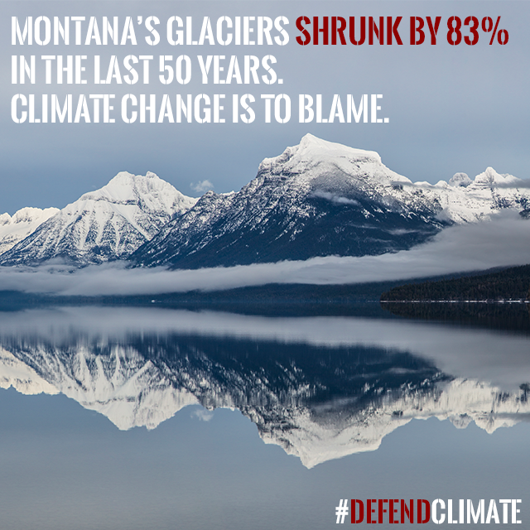
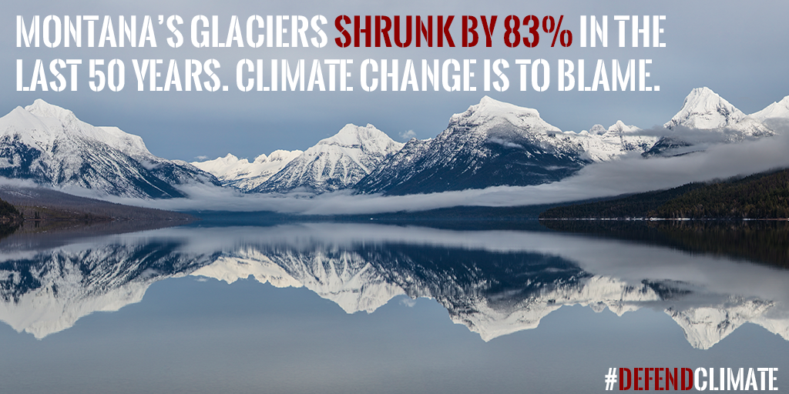
Suggested Graphics: (High quality on the Materials Hub)

Nevada Social and Graphics

Twitter:
- In 2017, wildfires burned 1.33 million acres in Nevada. We must #DefendClimate to protect our communities from dangerous wildfires. https://on.rgj.com/2ysePpM
- The outdoor recreation industry employs 88,000 Nevadans and generates more than $1 billion in tax revenue. Climate change puts Nevada’s economy at risk. #DefendClimate https://bit.ly/2ylZgja
- Clean air is vital for the 44K Nevada kids suffering from asthma. When we #CutMethane, we help protect their health. https://bit.ly/2I7bIHo
- 75% of Nevadans support limiting carbon pollution. We know we must #DefendClimate. https://bit.ly/2m3ygNE
- The solar industry employs more than 6,000 Nevadans. When we #DefendClimate, we contribute to our economic future. https://bit.ly/2M0G50b

Facebook:
- Solar energy supports 6,564 jobs and counting in Nevada, many of which are held by veterans. We have to #DefendClimate to defend the livelihoods of Nevadans who have served our country. https://bit.ly/2M0G50b
- 75% of Nevadans have voiced their support for limiting dangerous carbon pollution. We’re ready to #DefendClimate. https://bit.ly/2m3ygNE
- Clean air is vital for the 44,018 Nevada children suffering from asthma. When we #CutMethane, we help protect their health. https://bit.ly/2I7bIHo
- The outdoor recreation industry employs 88,000 Nevadans and generates more than $1 billion in tax revenue. Climate change puts Nevada’s economy at risk. #DefendClimate https://bit.ly/2ylZgja
- In 2017, wildfires burned 1.33 million acres in Nevada. We must #DefendClimate to protect our communities from dangerous wildfires. https://on.rgj.com/2ysePpM

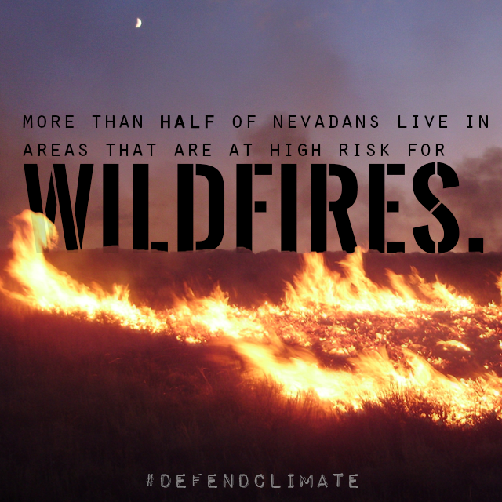
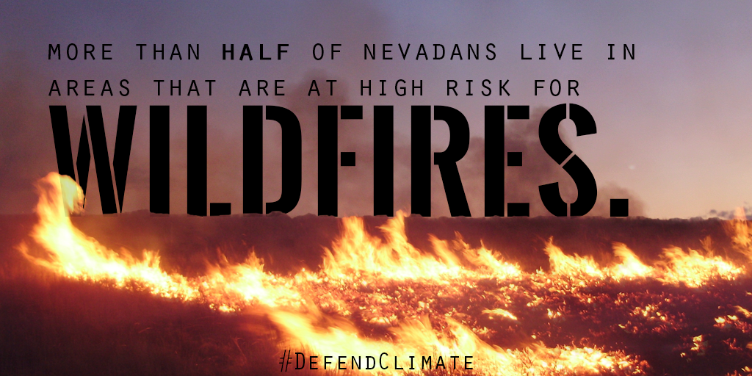
Suggested Graphics: (High quality on the Materials Hub)

New Hampshire Social and Graphics
TWITTER:
- The outdoor recreation industry employs 79,000 Granite Staters and generates millions in tax revenue. Climate change puts New Hampshire’s economy at risk. #DefendClimate https://bit.ly/2K0Yixf
- 75% of Granite Staters support placing limits on dangerous carbon pollution. We’re ready to #DefendClimate. https://bit.ly/2m3ygNE
- Clean air is vital for the 18K NH kids suffering from asthma. When we #CutMethane, we help protect their health. https://bit.ly/2rfNqk0
- More than a thousand Granite Staters are employed by the solar industry. Our state benefits when we #DefendClimate. https://bit.ly/2MCVbdp
- Rising sea levels caused by climate change threaten NH coastal communities and the jobs their residents rely on. We must #DefendClimate. http://www.nhcrhc.org/wp-content/uploads/2016-CRHC-final-report.pdf
FACEBOOK:
- The outdoor recreation industry employs 79,000 Granite Staters and generates millions in tax revenue. Climate change puts New Hampshire’s economy at risk. #DefendClimate https://bit.ly/2K0Yixf
- Warmer winters fueled by climate change are causing the tick population to surge. These ticks don’t just spread Lyme Disease – they’re also devastating our moose herds. http://www.wildlife.state.nh.us/wildlife/moose-study.html
- Rising sea levels caused by climate change threaten NH coastal communities, which are home to over 100,000 jobs. To defend them, we must #DefendClimate. http://www.nhcrhc.org/wp-content/uploads/2016-CRHC-final-report.pdf
- Clean air is vital for the 18,790 New Hampshire children suffering from asthma. When we #CutMethane, we help protect their health. https://bit.ly/2rfNqk0
- More than a thousand Granite Staters are employed by the solar industry. Our state benefits when we #DefendClimate. https://bit.ly/2MCVbdp
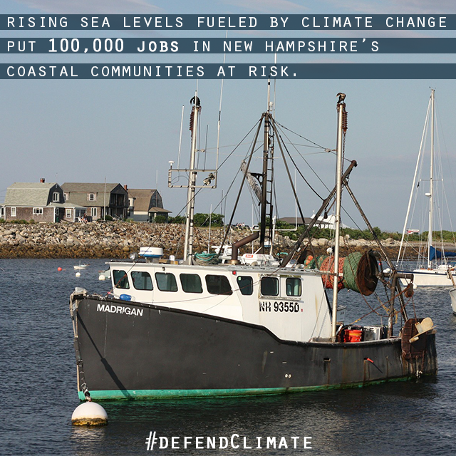
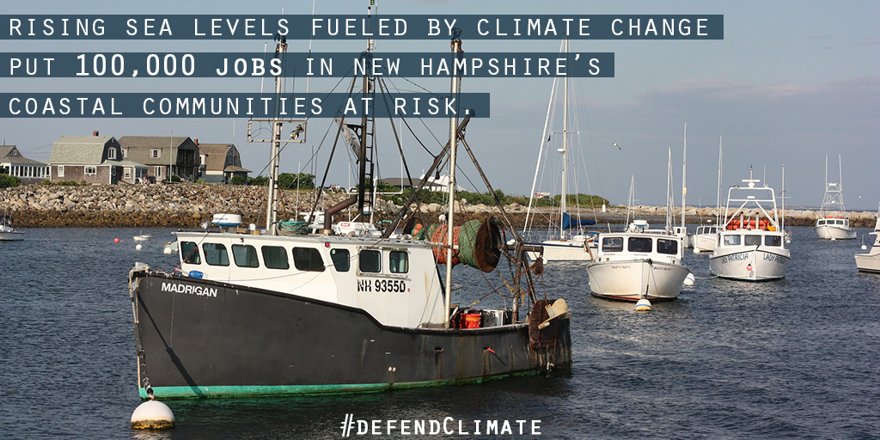
Suggested Graphics: (High quality on the Materials Hub)

Ohio Social and Graphics

Ohio

Twitter:
- Clean air is vital for the 179K Ohio kids suffering from asthma. When we #CutMethane, we help protect their health. https://bit.ly/2rdYG0W
- 1 in 6 OH families struggle to put food on the table, and climate change makes it even harder. We must #DefendClimate. https://bit.ly/2rdYG0W
- Algal blooms caused by rising temps in Lake Erie put a $2 billion fishing industry at risk. We need to #DefendClimate. https://news.osu.edu/news/2015/12/16/eriecentury/
- The outdoor recreation industry employs 215,000 Ohioans and generates more than $1 billion in tax revenue annually. Climate change puts Ohio’s economy at risk. #DefendClimate https://bit.ly/2leSdj0
- The solar industry employs 6,518 Ohioans and counting. Our state benefits when we work to #DefendClimate. https://bit.ly/2I1K5Lx
- The solar industry provides jobs for OH veterans. To defend their livelihoods, we must #DefendClimate. https://bit.ly/2I1K5Lx

Facebook:
- The outdoor recreation industry employs 215,000 Ohioans and generates more than $1 billion in tax revenue annually. Climate change puts Ohio’s economy at risk. #DefendClimate https://bit.ly/2leSdj0
- Rising water temperatures in Lake Erie fueled by climate change are causing algal blooms that put our state’s $2 billion fishing industry at risk. We must #DefendClimate in order to defend Ohio workers. https://news.osu.edu/news/2015/12/16/eriecentury/
- The solar industry alone employs 6,518 Ohioans and counting. We need to #DefendClimate to build Ohio’s clean energy economy. https://bit.ly/2I1K5Lx
- 1 in 6 Ohio families struggles to put food on the table, and climate change makes it even more difficult. To protect our families, we must #DefendClimate. http://www.cleveland.com/weather/blog/index.ssf/2016/10/impacts_of_climate_change_on_g.html
- Clean air is vital for the 179,389 Ohio children who are suffering from asthma. When we #CutMethane, we help protect their health. https://bit.ly/2rdYG0W
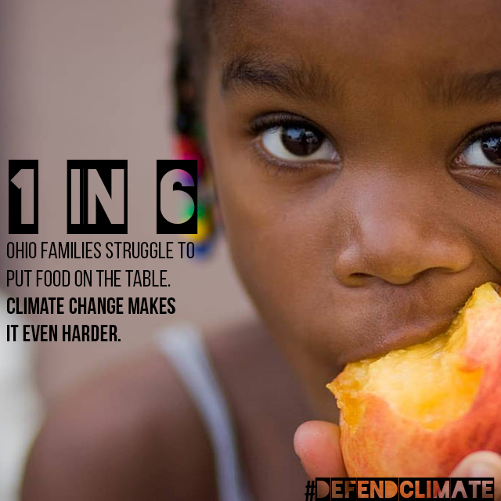
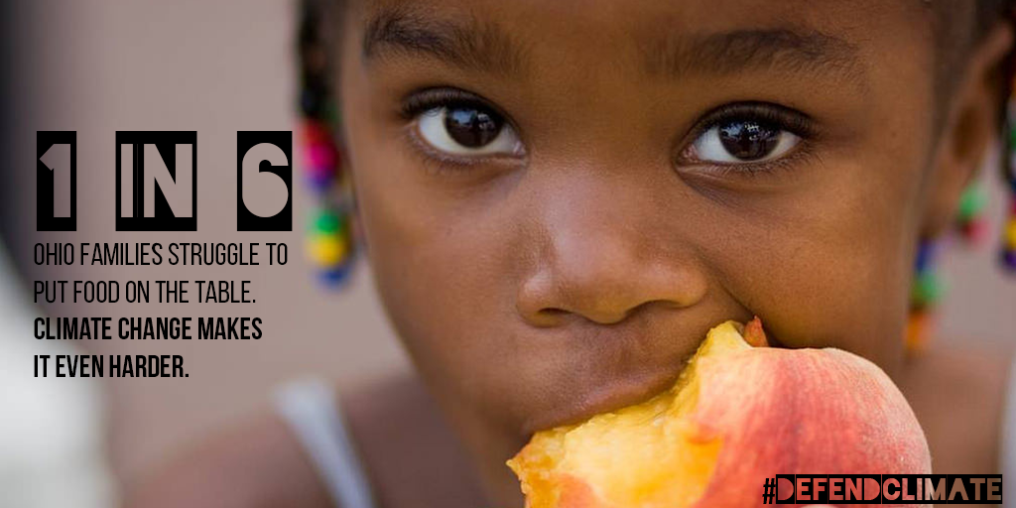
Suggested Graphics: (High quality on the Materials Hub)

Pennsylvania Social and Graphics

Twitter:
- Clean air is vital to the 235K Pennsylvanian kids suffering from asthma. When we #CutMethane, we help protect their health. https://bit.ly/2JMB7mV
- The solar industry provides jobs for vets. When we #DefendClimate, we support those who have served. https://bit.ly/2M0HCTZ
- The Pennsylvania solar industry grew by 25% in 2017. When we #DefendClimate, we provide livelihoods for Pennsylvanians. https://bit.ly/2M0HCTZ
- The outdoor recreation industry employs 251,000 Pennsylvanians and generates more than $1 billion in annual tax revenue. Climate change puts Pennsylvania’s economy at risk. #DefendClimate https://bit.ly/2lk7oaC

Facebook:
- For the 235,008 Pennsylvania children who suffer from asthma, protecting air quality is vital. When we #CutMethane, we help protect their health. https://bit.ly/2JMB7mV
- The solar industry provides jobs for Pennsylvania veterans. Let’s #DefendClimate and protect the jobs of those who have served. https://bit.ly/2M0HCTZ
- The Pennsylvania solar industry grew by 25% in 2017. When we #DefendClimate, we provide livelihoods for Pennsylvanians. https://bit.ly/2M0HCTZ
- The outdoor recreation industry employs 251,000 Pennsylvanians and generates more than $1 billion in annual tax revenue. Climate change puts Pennsylvania’s economy at risk. #DefendClimate https://bit.ly/2lk7oaC

Suggested Graphics: (High quality on the Materials Hub)

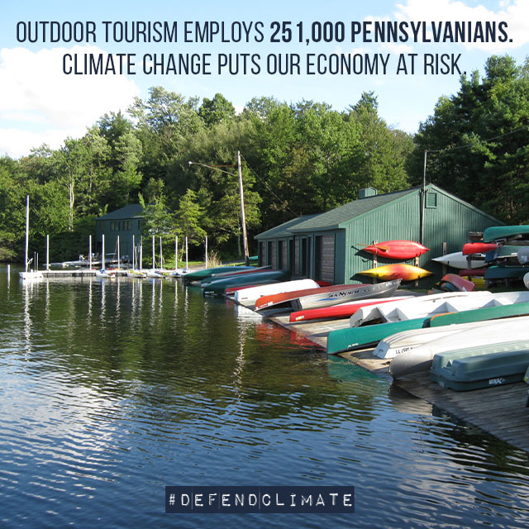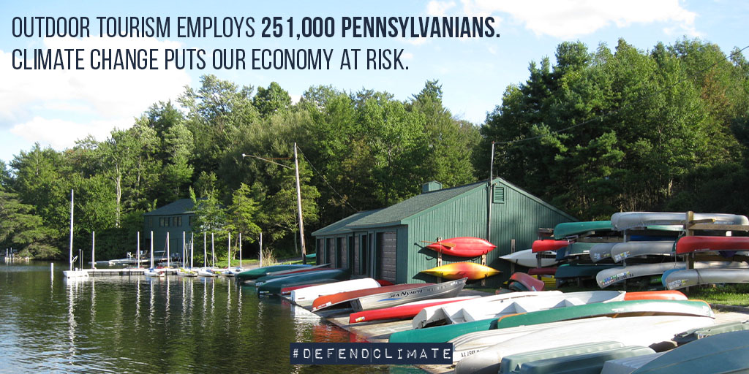

Virginia Social and Graphics

Twitter:
- Clean air is vital for the 150K Virginia kids who suffer from asthma. When we #CutMethane, we help protect their health. https://bit.ly/2omYN6M
- The solar industry employs thousands of Virginians. We must #DefendClimate. https://bit.ly/2MAK6d1
- The growing solar industry in VA provides jobs for veterans. When we #DefendClimate, we protect the livelihoods of those who served. https://bit.ly/2MAK6d1
- The outdoor recreation industry employs 197,000 Virginians and generates more than $1 billion in annual tax revenue. Climate change puts Virginia’s economy at risk. #DefendClimate https://bit.ly/2lj5qY5

Facebook:
- 150,569 Virginia children suffer from asthma. We need clean air to protect their health. Let’s #CutMethane and keep our kids healthy. https://bit.ly/2omYN6M
- The solar industry employs thousands of Virginians and counting. We must #DefendClimate and keep building our state’s clean energy economy. https://bit.ly/2MAK6d1
- Virginia’s growing solar industry provides jobs for veterans. We must #DefendClimate to protect the livelihoods of those who have served our country. https://bit.ly/2MAK6d1
- The outdoor recreation industry employs 197,000 Virginians and generates more than $1 billion in annual tax revenue. Climate change puts Virginia’s economy at risk. #DefendClimate https://bit.ly/2lj5qY5

Suggested Graphics: (High quality on the Materials Hub)

